Contents

Ansible 6

Why Ansible? 6

What is Ansible? 8

Pull Configuration 9

Push Configuration 9

Ansible Architecture 10

Playbooks 11

Inventory Management 15

How Ansible Works in the Real World 15

Alternatives to Ansible 17

History of Ansible 17

Important Terms Used in Ansible 18

What is Configuration Management 18

How Ansible Works? 18

Installing Ansible 20

Install and Configure Ubuntu on VirtualBox 20

Install Ubuntu 20.04 in VirtualBox 23

Setting Up Full Screen For Ubuntu Virtual Machine In VirtualBox 27

Install Google Chrome on Ubuntu 28

Ansible Installation Process 28

Control Machine Requirements 28

Install Ansible on Linux - Centos/RedHat systems 29

Install Ansible on Ubuntu/Debian systems 29

Install Ansible on Windows 29

Enabling Ubuntu on Windows 10 – WSL (*Windows Subsystem for Linux*) 29

Run Ansible on Windows 10: Using Cygwin 31

Run Ansible on Windows 10: Using a Linux VM 36

YAML Basics 47

Understanding YAML 47

key-value pair 47

Representing List 47

List inside Dictionaries 48

List of Dictionaries 48

Some common words related to Ansible. 49

Setting up Test Environments 50

1. Introduction 50

2. Setup Ansible Controller 50

3. Create Target Machines 52

4. Install Ansible 53

5. Provide Access to the Target VMs from the Controller 54

5.1 Create the Public Key Pair on the Controller 54

5.2 Copy Public ssh keys to Target VMs using ssh 55

5.3 Authenticating to Your Ubuntu Server Using SSH Keys 56

5.4 Disabling Password Authentication on Your Server 56

6. Create the Inventory (hosts) File 57

7. Testing Connectivity to Nodes 57

Connecting as a Different User 58

8. Create an Ansible Playbook 58

9. Run the Playbook 58

Creating a File with Content 59

Creating Multiple Files 59

Creating a Directory 60

Removing Files 60

Removing Multiple Files 60

Host Inventory File 62

Inventory basics: formats, hosts, and groups 62

Default groupsℑ 62

Hosts in multiple groups 63

Grouping groups: parent/child group relationshipsℑ 63

Adding variables to inventory 64

Assigning a variable to one machine: host variables 65

Inventory aliases 65

Defining variables in INI format 66

Assigning a variable to many machines: group variables 66

Inheriting variable values: group variables for groups of groups 67

Inventory setup examples 67

Example: One inventory per environment 68

Ansible Playbooks 69

Playbook Structure 69

Create a Playbook 69

The Different YAML Tags 70

name 70

hosts 70

vars 70

tasks 70

Ansible Playbooks Demos 70

Creating and Running your First Ansible Playbook 71

How To Define Tasks in Ansible Playbooks 73

How To Use Variables in Ansible Playbooks 74

How To Access System Information (Facts) in Ansible Playbooks 75

How To Use Conditionals in Ansible Playbooks 77

How To Use Loops in Ansible Playbooks 80

Understanding Privilege Escalation in Ansible Playbooks 81

How To Install and Manage System Packages in Ansible Playbooks 83

How To Create and Use Templates in Ansible Playbooks 86

How To Define and Use Handlers in Ansible Playbooks 88

How To Deploy a Static HTML Website with Ansible on Ubuntu 20.04 (Nginx) 91

Examples 97

One playbook with one play 97

Two plays for two hosts 99

Task Calls Upon Another Task 100

Ad-hoc Commands 102

Parallelism and Shell Commands 102

File Transfer 102

Transferring file to many servers/machines 102

Creating new directory 102

Deleting whole directory and files 102

Managing Packages 103

Gathering Facts 103

More Ad-hoc Commands 103

Hosts Accessible 103

Copy File 104

Install a package via the yum module on two Centos hosts 105

Remove the previously installed ncdu package 107

Gather some facts about the system 109

Dry-run p4.yml playbook 109

Run p4.yml playbook with password authentication for all hosts 109

Ansible Roles 110

Creating a New Role 111

Role Structure 111

Usage 111

Options 111

Creating a Role Directory 111

Utilizing Roles in Playbook 112

Breaking a Playbook into a Role 113

Output 113

Ansible Variables 123

Usage of variable - {{Output}} 123

Exception Handling in Playbooks 124

Loops 124

Blocks 125

Conditionals 125

Ansible Facts 126

Ansible Modules 127

Ansible - Advanced Execution 128

How to Limit Execution by Tasks 128

How to Limit Execution by Hosts 128

Alternate Solution 129

Running the Playbook 129

Playbook targeting a single host 129

Ansible Troubleshooting 130

Debug and Register 130

Use Verbosity 130

Important Points 130

Solution 130

Common Playbook Issues 131

Hands-on Lab 133

1. Create an inventory 134

2. Creating a Directory Structure and your Playbook 134

3. Run it 135

4. Extend the Playbook 136

5. Extend the playbook more: copy files 136

6. From 1 to Many 137

7. Adding Variables to the Mix 137

8. Decide what to do - using conditionals 139

9. Using Loops 140

10. Templates 140

References 142

# Ansible

**Ansible** is an open-source automation and orchestration tool for software provisioning, configuration management, and software deployment. Ansible can easily run and configure Unix-like systems as well as Windows systems to provide infrastructure as code. It contains its own declarative programming language for system configuration and management.

Ansible is an Infrastructure as Code tool used for managing and monitoring remote servers. It is one of the key tools you would have in your DevOps environment.

Ansible is popular for its simplicity of installation, ease of use in what concerns the connectivity to clients, its lack of agent for Ansible clients and the multitude of skills. It functions by connecting via SSH to the clients, so it doesn’t need a special agent on the client-side, and by pushing modules to the clients, the modules are then executed locally on the client-side and the output is pushed back to the Ansible server.

Since it uses SSH, it can very easily connect to clients using SSH-Keys, simplifying though the whole process. Client details, like hostnames or IP addresses and SSH ports, are stored in files called inventory files. Once you have created an inventory file and populated it, ansible can use it.

## Why Ansible?

Here are some important pros/benefits of using Ansible:

* One of the most significant advantages of Ansible is that it is free to use by everyone.
* It does not need any special system administrator skills to install and use Ansible, and the official documentation is very comprehensive.
* Its modularity regarding plugins, modules, inventories, and playbooks make Ansible the perfect companion to orchestrate large environments.
* Ansible is very lightweight and consistent, and no constraints regarding the operating system or underlying hardware are present.
* It is also very secure due to its agentless capabilities and due to the use of OpenSSH security features.
* Another advantage that encourages the adoption of Ansible is its smooth learning curve determined by the comprehensive documentation and easy to learn structure and configuration.

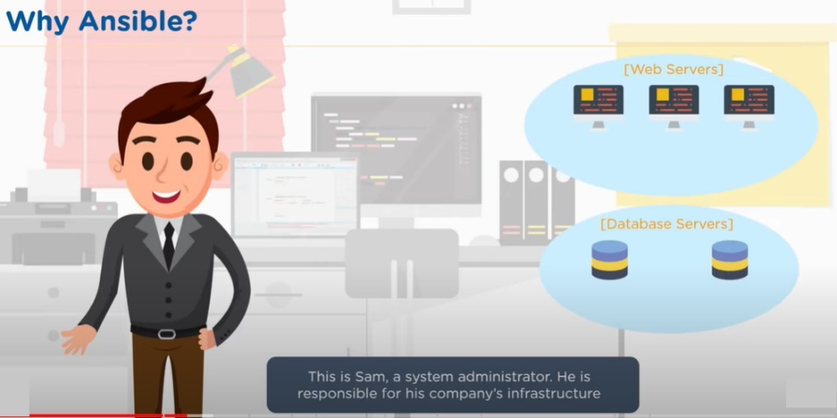

This is on the operations side of the DevOps equation.

Some of the services Sam must maintain could be webservers running Apache, database servers etc.

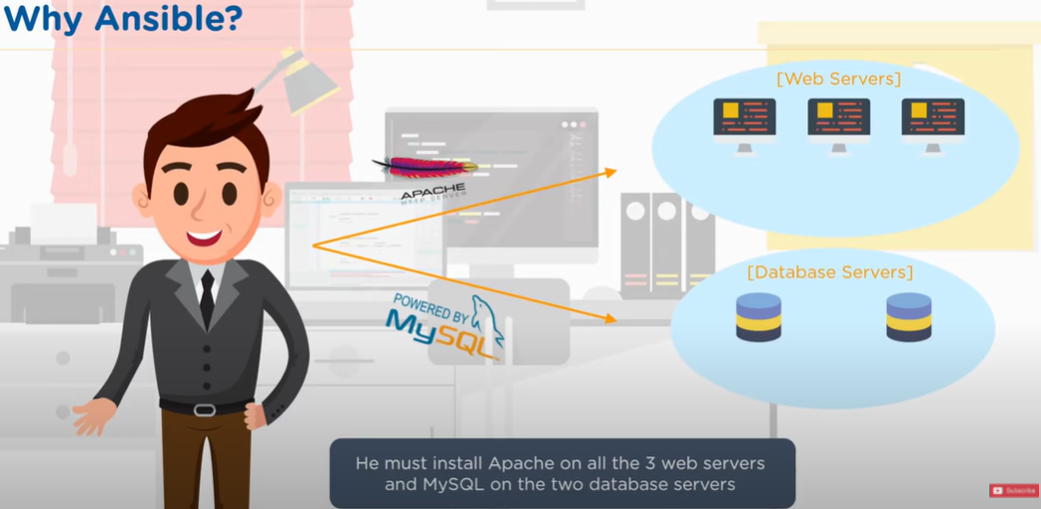

Having a few servers is easy to maintain. Wouldn’t take much time either.

But what if the number of servers increases, which is a reality? Then it gets tricky.

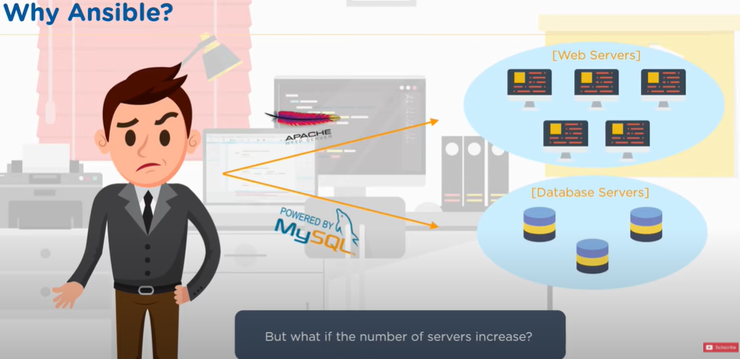

The same task must be repeated multiple times. Moreover, humans are prone to make errors. If done manually, there is a good chance that all servers are not setup identically.

This is where Ansible comes to the rescue and helps you become an efficient operations team!

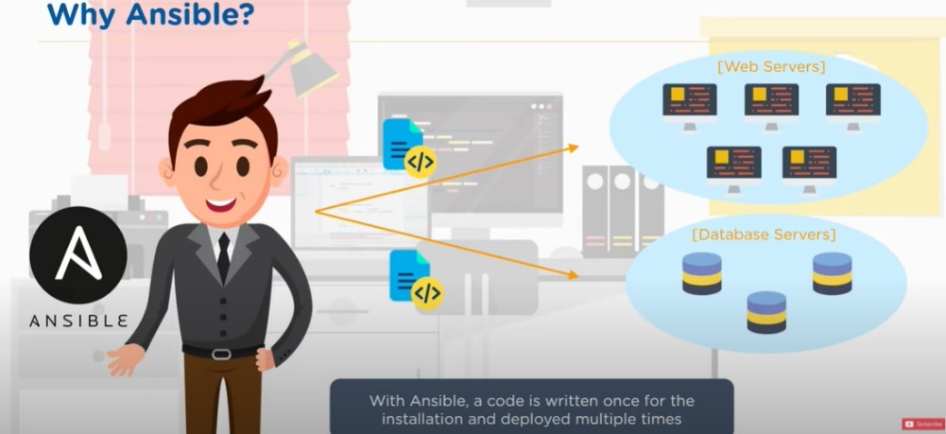

With Ansible, code is written once for the installation and deployed multiple times. Write one script and then each script can be executed and have a consistent environment.

So now, Sam, the DevOps person, can work on more productive tasks rather than the repetitive ones.

## What is Ansible?

Ansible allows you to create and control three key areas that you would have within your operations environment.

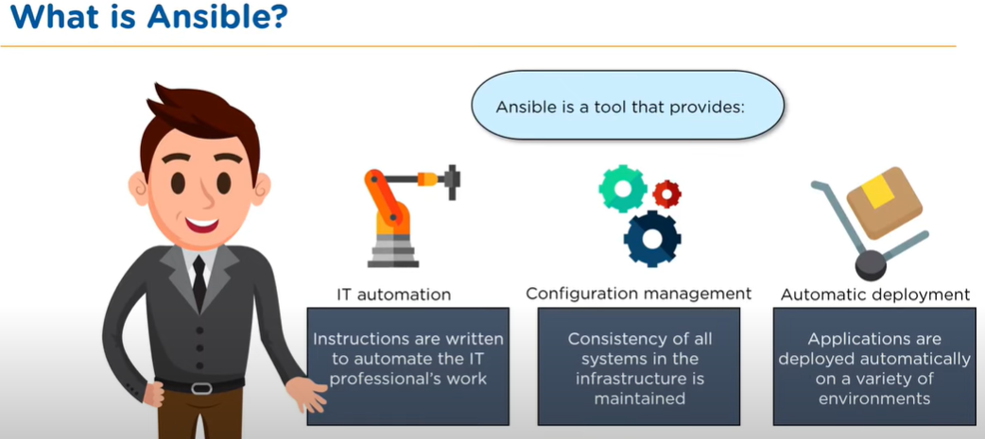

First, there is IT Automation. So, you can actually write instructions that automate the IT setup that you would typically do manually in the past.

The second is the Configuration and having consistent configuration. Imagine setting up hundreds of Apache servers and being able to guarantee with precision that each of those Apache servers is setup identically.

And then finally, you want to be able to automate the deployment so that as you scale up your server environment, you can just push out instructions that can deploy automatically different servers.

The bottom line is, you want to be able to speed up and make your operations team more efficient.

### Pull Configuration

There are 2 different ways to setup environments for server farms.

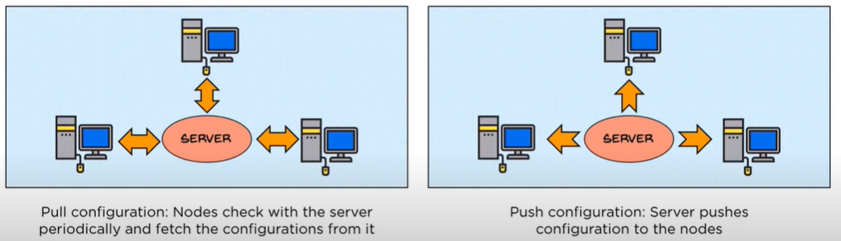

One is to have a key server that has all the instructions on and then on each of the servers that connect to that main master server, you would have a piece of software known as a client, installed on each of those servers that would communicate to the main master server and then we periodically either update or change the config of the slave/worker server.

This is known as a “Pull Configuration”.

### Push Configuration

An alternative is a push configuration. And the push config is slightly different. The main difference is as with a pull config, you have a master server where you actually put up the instructions, but unlike the pull config, where you have a client installed on each of the services, with a push config, you actually have no client installed on the remote servers.

You simply are pushing out the config to those servers and forcing a restructure or a fresh clean installation in that environment.

So, Ansible is one of those second environs where it is a push config server and this contrasts other popular products like Chef and Puppet, which have a master-slave architecture with a master server connecting with a client on a remote slave environment where you would then be pushing out the update, as well you’re pushing out the service and the structure of the server to remote hardware and you are just putting it onto the hardware, irrelevant of the structure that’s out there.

And there are some significant advantages that you have in that you’re not having to have the extra overhead weight of a client installed on those remote servers, having to constantly communicate back to the master environment.

## Ansible Architecture

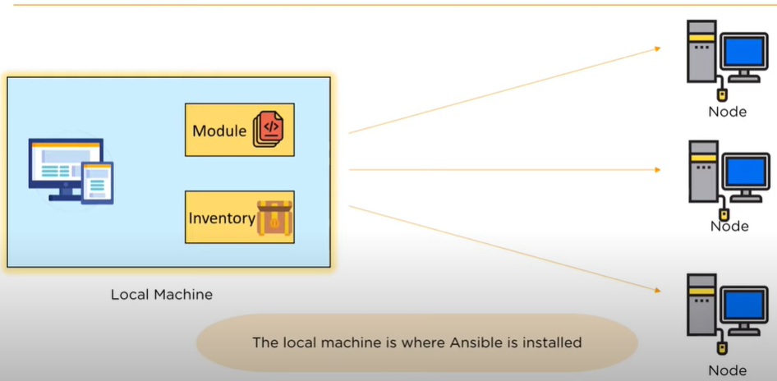

The **Local Machine** is where you will have all your instructions and really the power of the control that you would be pushing out to the remote servers. So the local machine is where you will be starting and doing all of your work.

Connected from the local machine, are all the different **nodes** pushing out the difference configs that you would setup on the local machine.

The configs that you would write, you would write those in code within a module. So, you do this on your local machine for creating these modules and each of these modules is actually consistent **playbooks**

The local machine also has a second job, and that job is to manage the inventory of the nodes that you have in your environment.

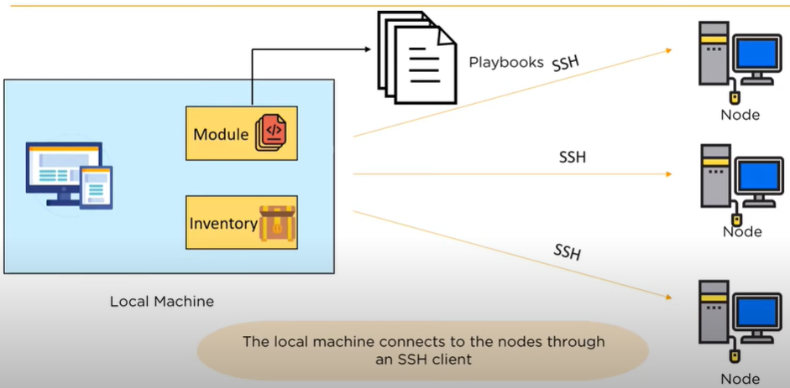

The local machine is able to connect to each of the different nodes that you would have in your hardware network through **SSH clients** or a secure client.

Let’s take a look at some of the different elements within the architecture. First, let’s take a look at **Playbooks** that you would write and create for the Ansible environments.

### Playbooks

The core of Ansible is the Playbook.

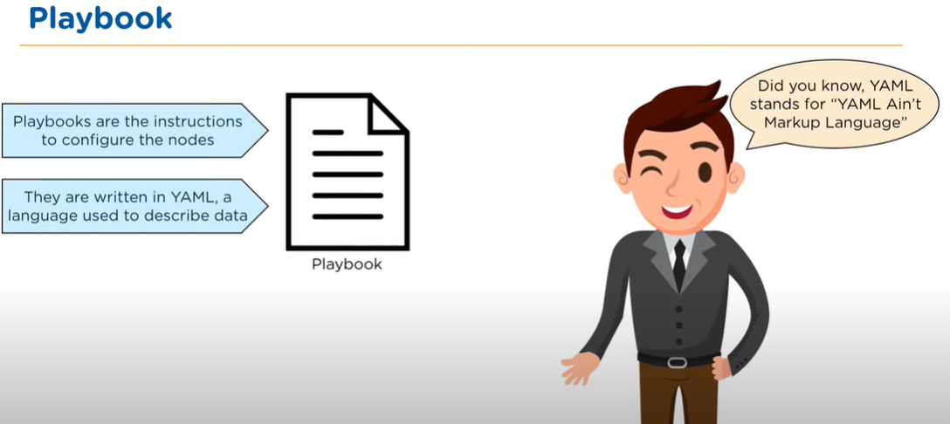

This is where you create the instructions that you write to define the architecture of your hardware. So, the Playbook is really just a set of instructions that configure the different nodes that you have and each of those set of instructions in a language called **YAML**. This is a standard language used for config server environments.

YAML (/ˈjæməl/, rhymes with *camel*) was first proposed by Clark Evans in 2001, who designed it together with Ingy döt Netand Oren Ben-Kiki. Originally YAML was said to mean *Yet Another Markup Language*, because it was released in an era that saw a proliferation of markup languages for presentation and connectivity (HTML, XML, SGML, etc). Its initial name was intended as a tongue-in-cheek reference to the technology landscape, referencing its purpose as a markup language with the yet another construct, but it was then repurposed as *YAML Ain't Markup Language*, a recursive acronym, to distinguish its purpose as data-oriented, rather than document markup.

* Here is a sample playbook structure:

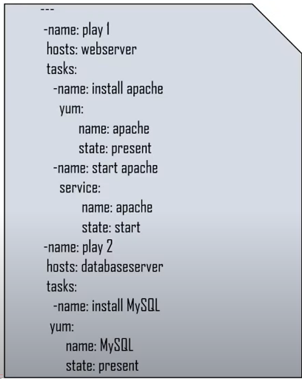

* You start off your YAML script with **3 dashes (---)** and that indicates the **start** of a script.

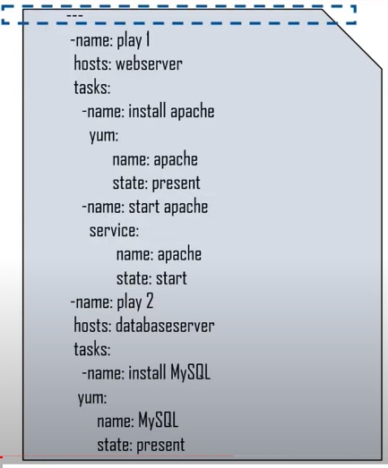

* Then the script itself is actually consistent of two distinct **plays**. At the top, we have “Play 1” and below that, we have “Play 2”.

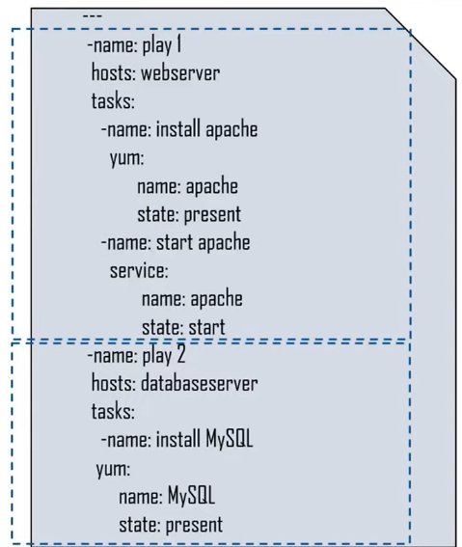

* Within each of those plays, we define which **nodes** are we targeting. So, here we have a web server in the top play and in the second play, we have a database server that we are targeting.

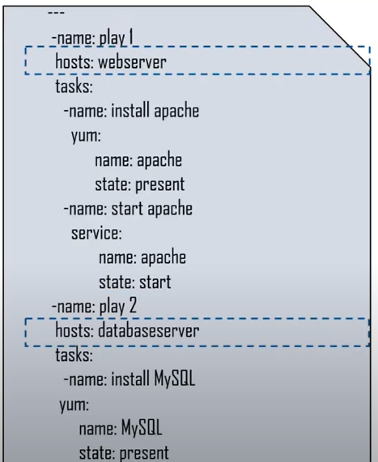

* And then within each of those server environments, we have the specific **tasks** that we are looking to execute.

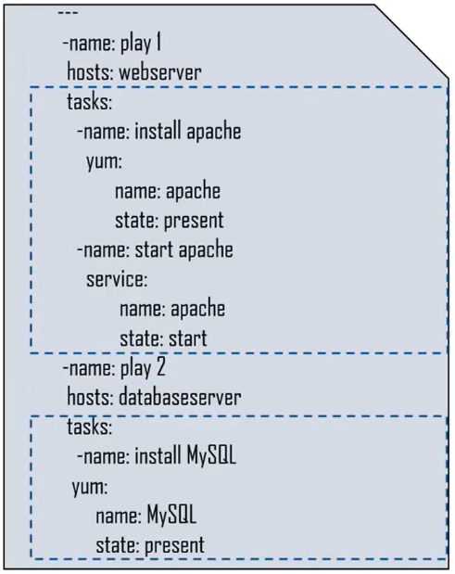

So, let’s step through some of these tasks.

* We have an “install apache” task, a “start apache” task and have an “install MySQL” task.

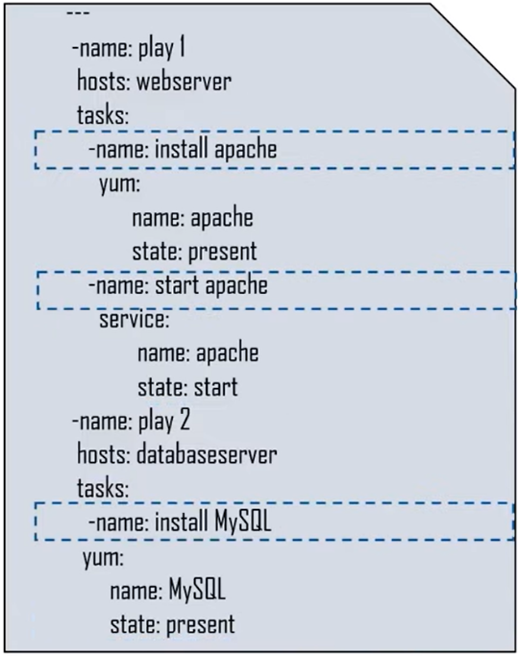

* When we do that, we are going to execute specific set of instructions and those instructions can include installing Apache, and then setting the state of the Apache environments or starting the Apache environment and setting up and running the MySQL environment.

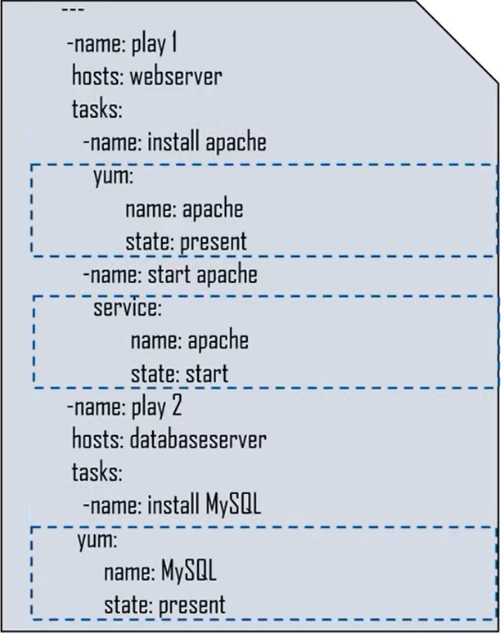

So, this really isn’t too complicated and that’s the really good thing about YAML is it is really designed to make it easy for you as an Operations Lead to be able to configure the environments that you want to consistently create.

Let’s take a step back. We have 2 hosts, a “webserver” and a “databaseserver”. Where do these names come from? This takes us into our next stage and the second part of working with Ansible, which is the Inventory Management part of Ansible.

### Inventory Management

The inventory part of Ansible is where we maintain the structure of our network environment. So, what we do here is part of the structure in creating different nodes is we’ve had to create two different nodes here. We have a “webserver” node and a “databaseserver” node.

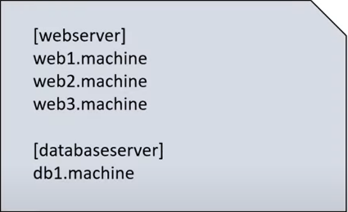

And under webserver node, we have the names that we are pointing to specific machines within that environment. So, when we write our script, all we have to do is refer to either webserver or database server, and the different servers will have the instructions from the YAML script executed on them.

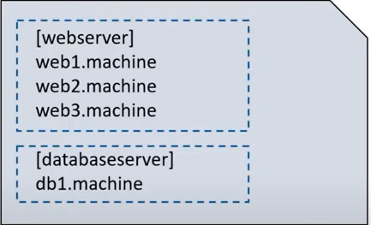

This makes it really easy for you to be able to just point to new services without having to write out complex instructions.

## How Ansible Works in the Real World

* You will have the Ansible software installed on the local machine. It connects to the different nodes within your network.

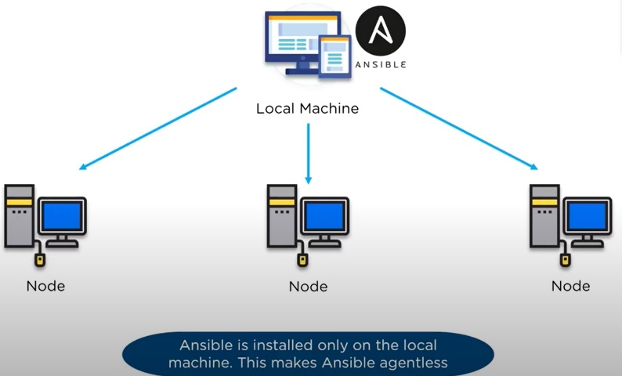

* On the local machine, you will have your playbook, which is the set of instructions for how to setup the remote nodes and then to identify how you’re going to connect those nodes, you will have an inventory.

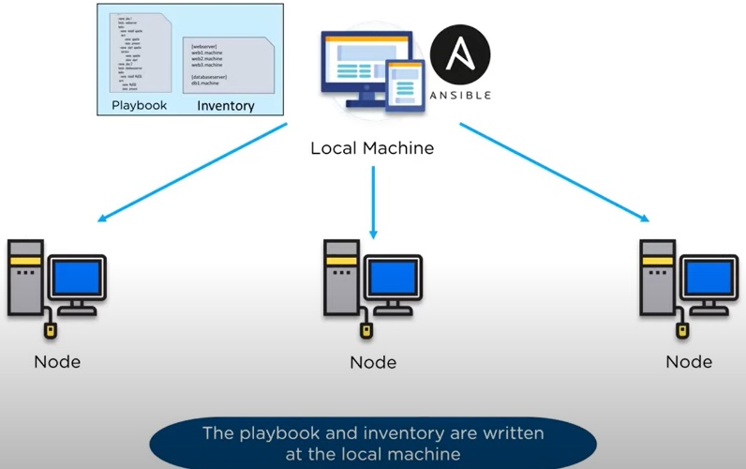

* We use secure SSH connections to each of the servers, so we are encrypting the communication to those servers

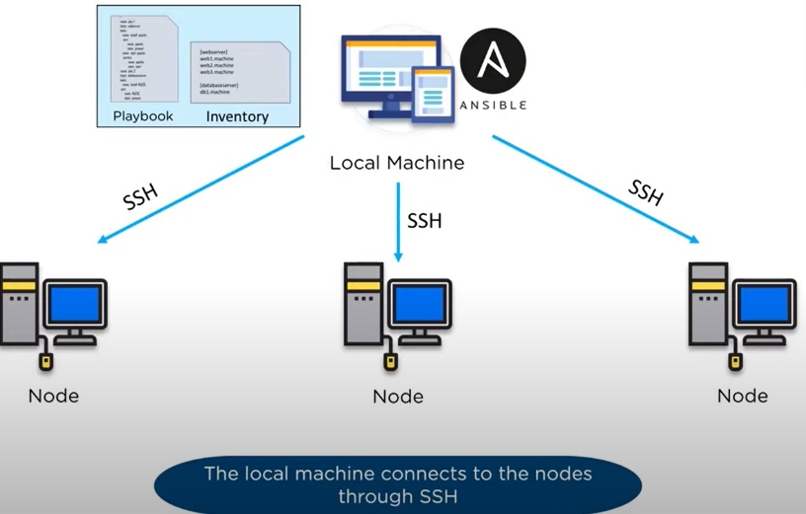

* We are able to grab some basic facts on each server so we understand how we can then push out the playbook each server and configure that server remotely.

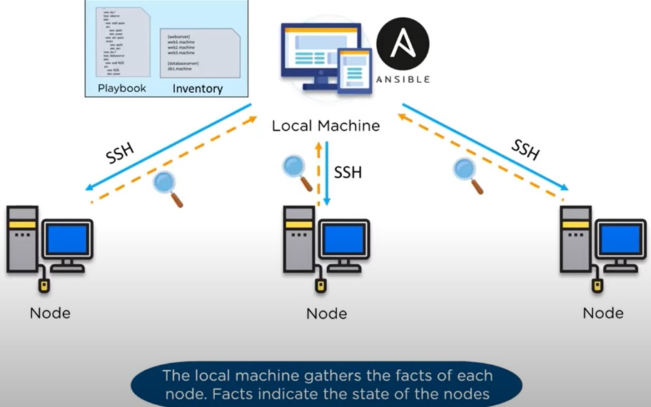

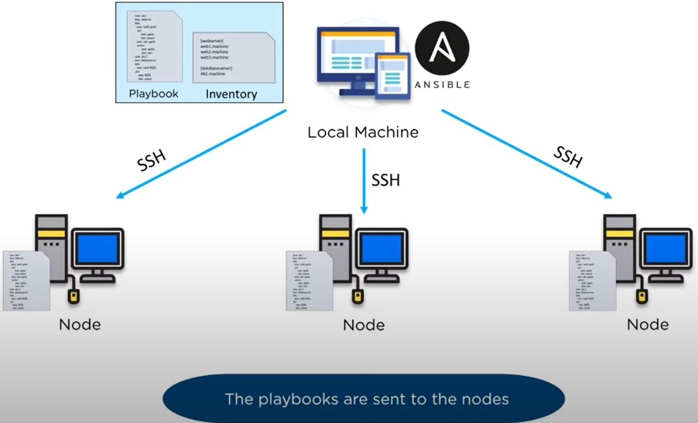

* The end goal is to have an environment that is consistent.

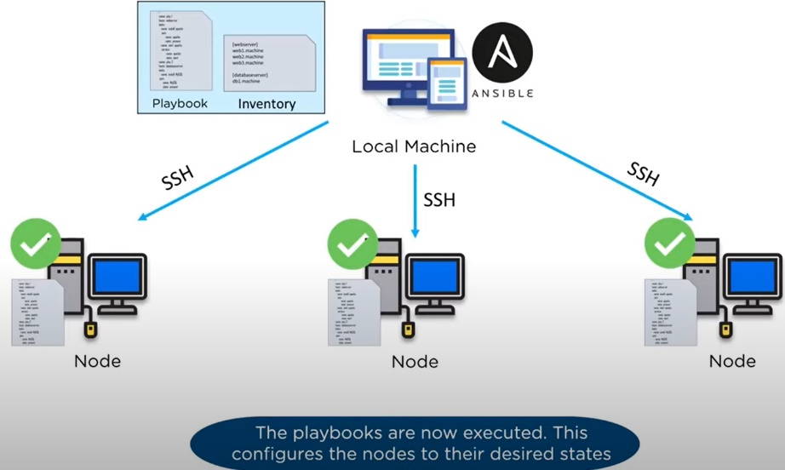

## Alternatives to Ansible

While there are many alternative to Ansible (Chef, Puppet) out there that do the same thing with some differences, Ansible managed to rise above all of them with its simplicity, improved security, and most important its smooth learning curve. Due to these qualities and fast adoption of Ansible, we created a tutorial full of examples so you can have an even more seamless first experience in working with Ansible.

## History of Ansible

Here, are important landmarks from the history of ansible:

* In February 2012 the Ansible project began. It was first developed by Michael DeHaan, the creator of Cobbler and Func (Fedora Unified Network Controller).
* Initially called AnsibleWorks Inc, the company funding the ansible tool was acquired in 2015 by RedHat and later on, along with RedHat, moved under the umbrella of IBM.
* In the present, Ansible comes included in distributions like Fedora Linux, RHEL, Centos and Oracle Linux.

## Important Terms Used in Ansible

* **Host**: A remote machine managed by Ansible.
* **Group:**Several hosts grouped together that share a common attribute.
* **Ansible server**: The machine where Ansible is installed and from which all tasks and playbooks will be ran.
* **Module**: Basically, a module is a command or set of similar Ansible commands meant to be executed on the client-side.
* **Task**: A task is a section that consists of a single procedure to be completed.
* **​​Playbooks**: An ordered list of tasks along with its necessary parameters that define a recipe to configure a system.
* **YAML:**A popular and simple data format that is very clean and understandable by humans.
* **Role:** A way of organizing tasks and related files to be later called in a playbook.
* **Fact**: Information fetched from the client system from the global variables with the gather-facts operation.
* **Inventory**: File containing data about the ansible client servers. Defined in later examples as hosts file.
* **Play**: Execution of a playbook.
* **Handler**: Task which is called only if a notifier is present.
* **Notifier**: Section attributed to a task which calls a handler if the output is changed.
* **Tag**: Name set to a task which can be used later on to issue just that specific task or group of tasks.

## What is Configuration Management

Configuration management in terms of Ansible means that it maintains configuration of the product performance by keeping a record and updating detailed information which describes an enterprise’s hardware and software.

Such information typically includes the exact versions and updates that have been applied to installed software packages and the locations and network addresses of hardware devices. For e.g. If you want to install the new version of **WebLogic/WebSphere** server on all of the machines present in your enterprise, it is not feasible for you to manually go and update each and every machine.

You can install WebLogic/WebSphere in one go on all of your machines with Ansible playbooks and inventory written in the most simple way. All you have to do is list out the IP addresses of your nodes in the inventory and write a playbook to install WebLogic/WebSphere. Run the playbook from your control machine & it will be installed on all your nodes.

## How Ansible Works?

The picture given below shows the working of Ansible.

**Ansible works** by connecting to your nodes and pushing out small programs, called "**Ansible** modules" to them. **Ansible** then executes these modules (over SSH by default), and removes them when finished. Your library of modules can reside on any machine, and there are no servers, daemons, or databases required.

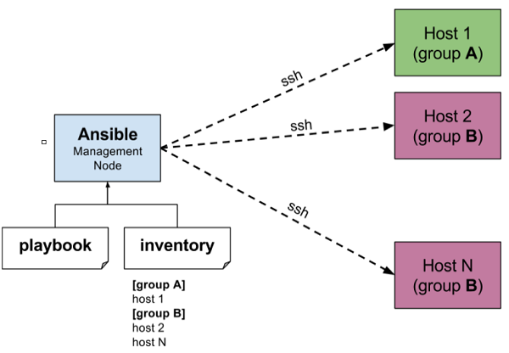

The management node in the above picture is the controlling node (managing node) which controls the entire execution of the playbook. It’s the node from which you are running the installation. The inventory file provides the list of hosts where the Ansible modules needs to be run and the management node does a SSH connection and executes the small modules on the hosts machine and installs the product/software.

**Beauty** of Ansible is that it removes the modules once those are installed so effectively it connects to host machine , executes the instructions and if it’s successfully installed removes the code which was copied on the host machine which was executed.

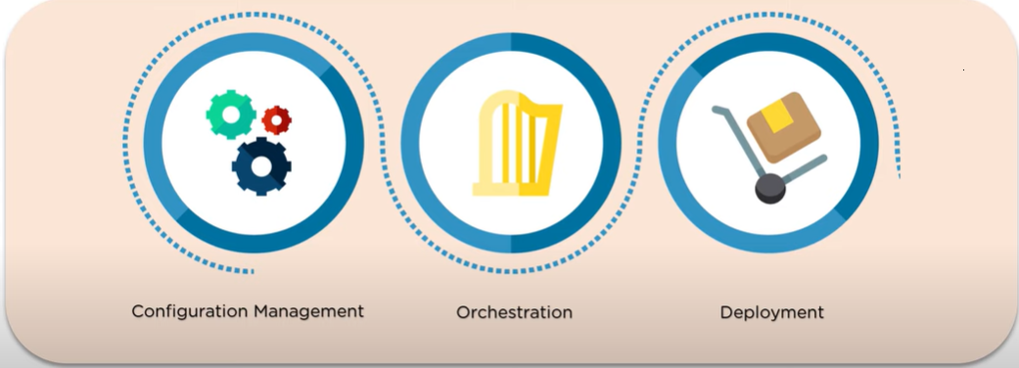

# Installing Ansible

## Install and Configure Ubuntu on VirtualBox

<https://thelinuxuser.com/install-ubuntu-20-04/>

Download a copy of [Oracle VM VirtualBox](https://www.virtualbox.org/) and install it. Once done, launch it and you will get the home screen.

Click on **New** to get the option of creating a Virtual Machine.

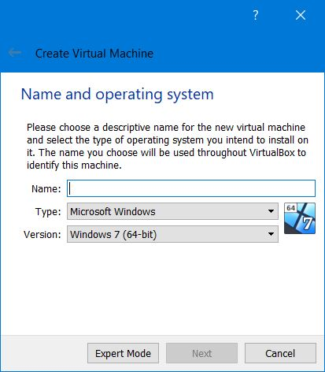

Type Ubuntu in the Name section and it will auto detect the Type and version. Click on **Next**to get select **Memory Size** you want to assign to the Virtual Machine.

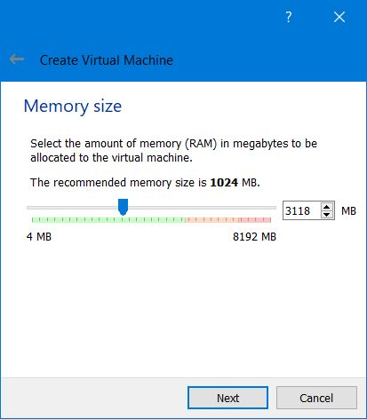

Make sure to assign sufficient RAM to VM and leave sufficient for your base machine. Clicking on Next takes you to Hard disk option. Keep the default setting of **Create a virtual hard disk now** and continue.

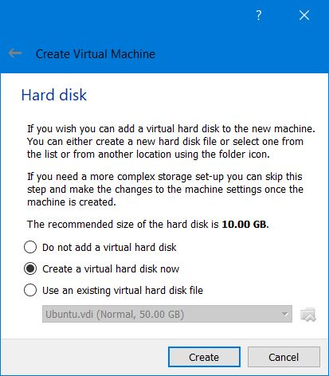

In the Hard disk file type, choose the default **VDI (VirtualBox Disk Image)** and continue.

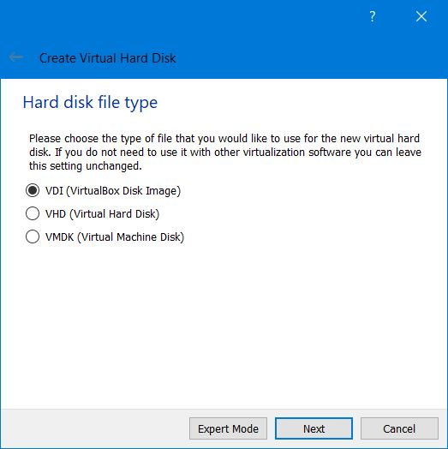

I choose **Dynamically allocated** option for Storage on physical hard disk.

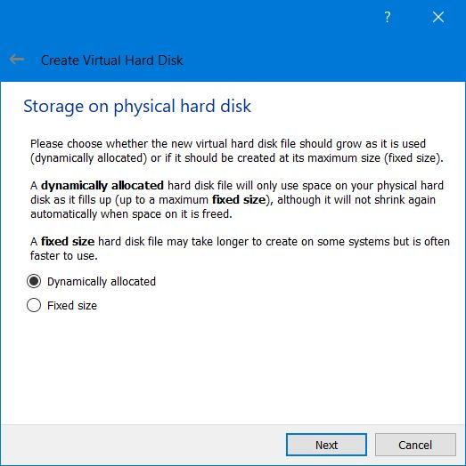

In the next screen, choose the File location for your VM and the hard disk size. The Size is the maximum your VM can use so make sure you select sufficient storage.

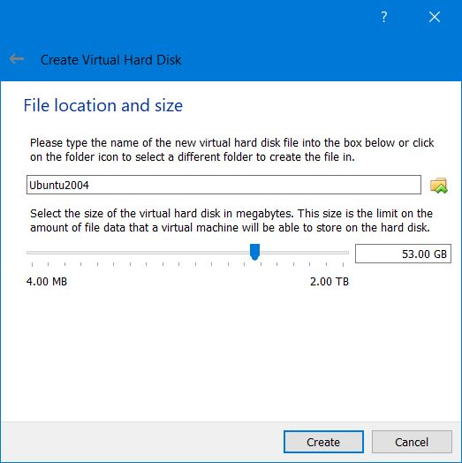

Click on **Create**to complete the set up. In the left panel of Home Screen, you can now see the Ubuntu 20.04 option.

You will need the downloaded 20.04 ISO to install Ubuntu 20.04 in VirtualBox.

Start the Virtual Machine you just created. You will get the option to select start up disk. Click on folder icon and select the ISO you have downloaded.

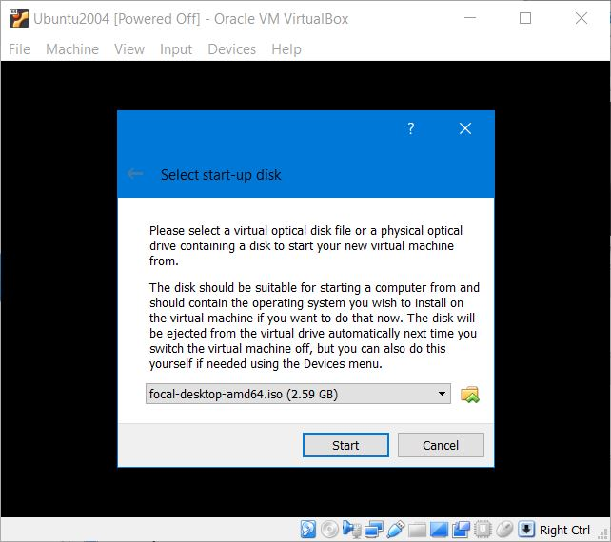

Once done and started, it will take couple of minutes to boot into Welcome screen of Ubuntu 20.04. You have two options, either to **Try Ubuntu**without installing or to**Install Ubuntu**.

### Install Ubuntu 20.04 in VirtualBox

Since our purpose is to install Ubuntu 20.04 in VirtualBox and there is no way it can screw your base machine, click on the second option to continue.

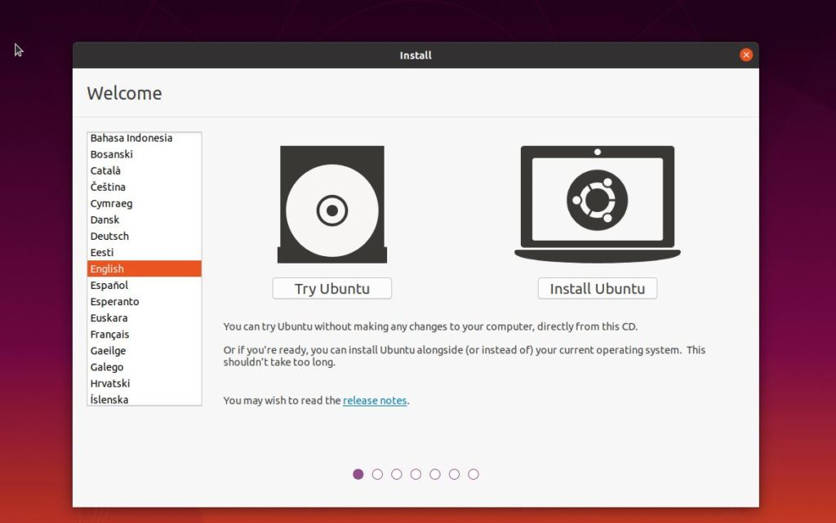

Select Keyboard layout in the next screen.

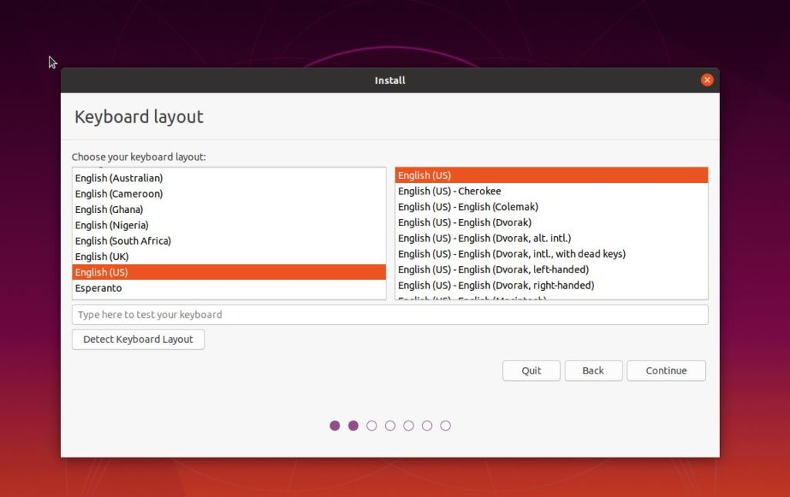

In next screen, you would be asked some preferences. I will suggest to go with Normal Installation and marking both the options in **Other Options**. It will download and update your Ubuntu to latest during installation and install third party software which are needed for daily tasks. Trust me, it will save a lot of efforts later.

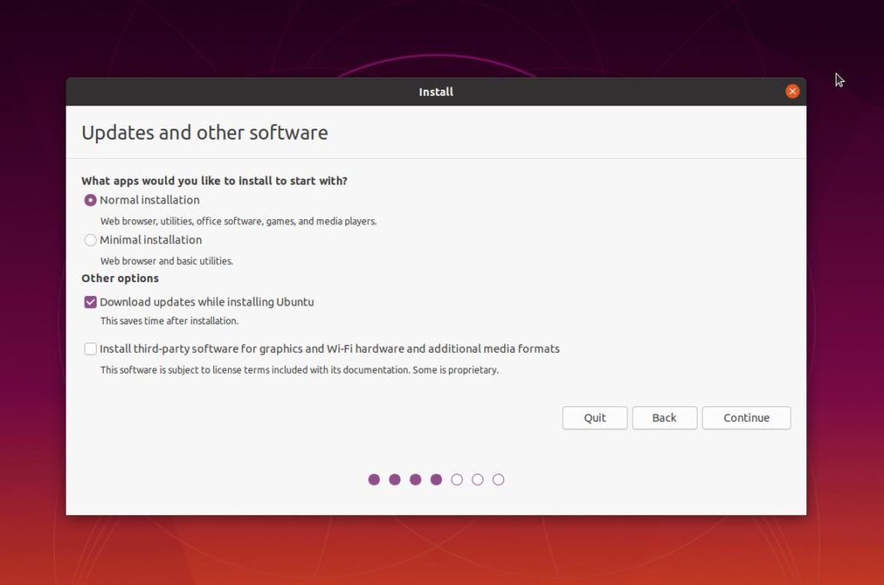

In the installation type, choose **Erase disk and install Ubuntu**. Since we are installing Ubuntu 20.04 in VirtualBox, this will just erase the virtual disk we have created. This step is limited for VirtualBox. If you are trying to dual boot, you will have to choose **Something else**. It will present you a warning, ignore it and continue.

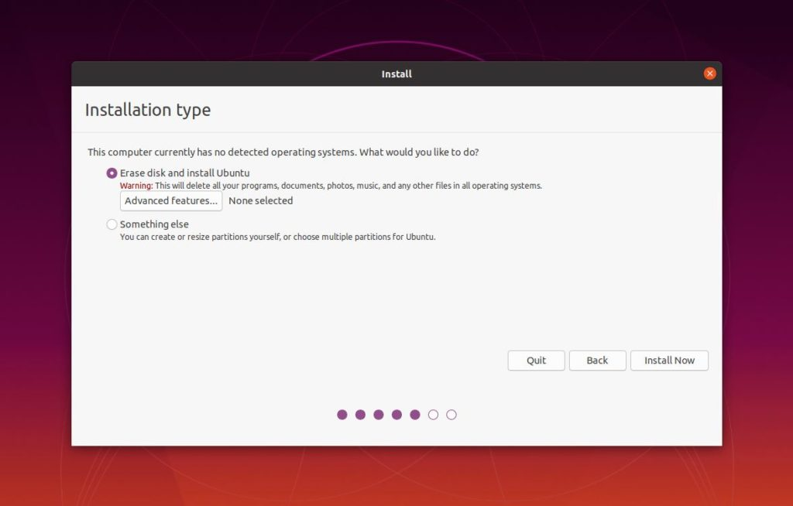

In the next screen, select your geographical location.

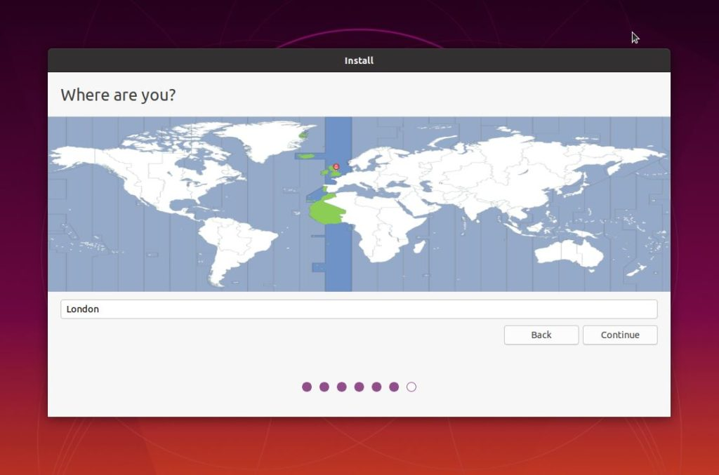

Fill up the system details in the next screen which includes a username, root passwords and option to login automatically.

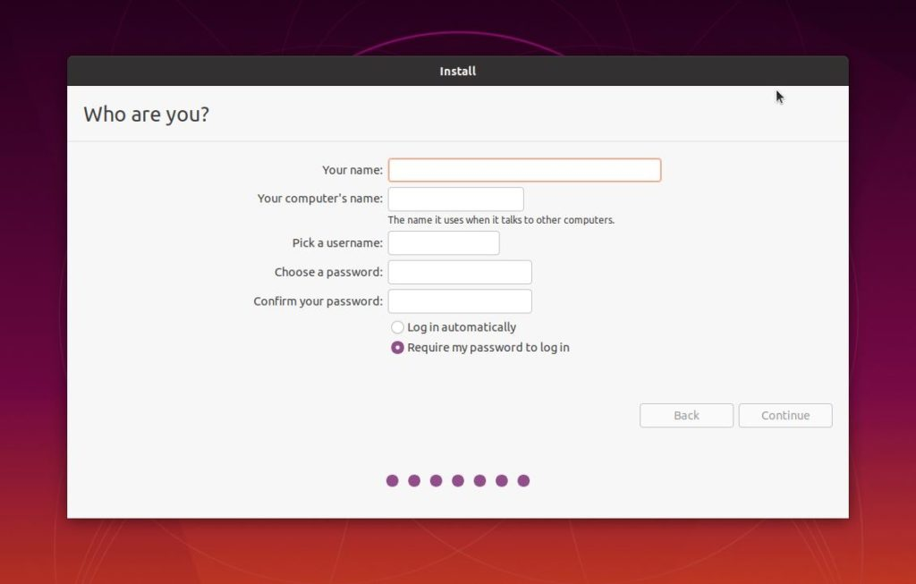

Once done, click on Continue to start the installation. It took 10 min for me but may vary depending on your internet speed and system resources.

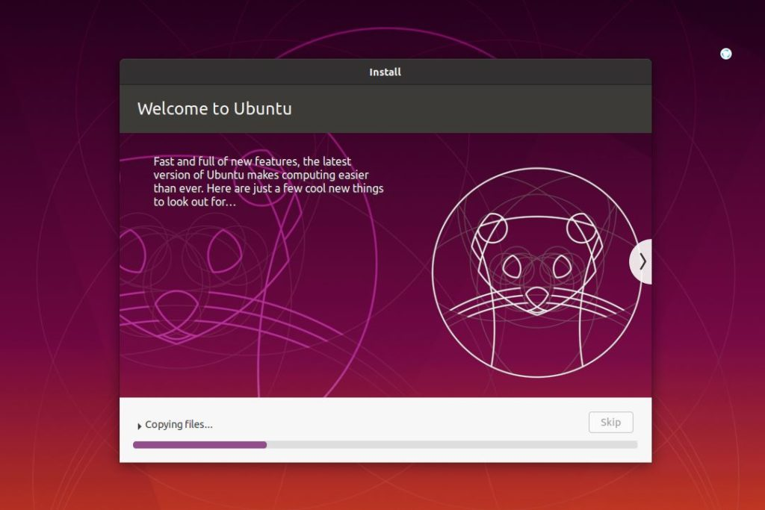

Once installation completes, restart your system to boot directly into the Ubuntu 20.04.

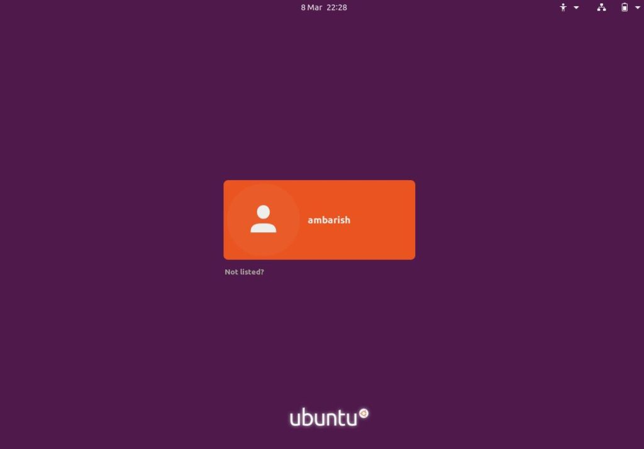

Congratulations! You have successfully installed Ubuntu 20.04 in VirtualBox.

**Note**: If there is an error that says, “kernel panic not syncing fatal exception in interrupt”, try the following:

* + 1. Change the vCPU (Processor) of the VM to 2 (if it is 1).
    2. Disable all of these in “Turn Windows Feature on or off”:
       - Hyper-V
       - Virtual Machine Platform
       - Windows Hypervisor platform
       - Container

Then, restart your machine and try starting the VM again.

This error occurs if you install Docker.

### Setting Up Full Screen For Ubuntu Virtual Machine In VirtualBox

After logging in, you may notice that your Ubuntu desktop screen looks small that hides some parts of opened applications.

Hence, this step is dedicated to fixing the small screen problems for Ubuntu in VirtualBox.

To resolve the issue, you will need to install Guest Addition software comprised of device drivers and system apps. It basically helps the Ubuntu virtual machine to integrate closer with the host operating system and configure various settings.

To do the same, go to the Ubuntu virtual machine menu bar > devices > insert guest additions CD. Click on run to give permission to install VirtualBox Guest Addition software.

This helps to mount the Guest Additions ISO file inside the virtual machine. You can now go to the menu bar > view > full screen and your desktop will switch to a large screen.

For further screen configuration, you can also go to Ubuntu settings and change the resolution accordingly.

### Install Google Chrome on Ubuntu

#### Downloading Google Chrome

Open your terminal either by using the Ctrl+Alt+T keyboard shortcut or by clicking on the terminal icon.

Use [wget](https://linuxize.com/post/wget-command-examples/) to download the latest Google Chrome .deb package :

wget https://dl.google.com/linux/direct/google-chrome-stable_current_amd64.debCopy

#### Installing Google Chrome

Installing packages on Ubuntu requires administrative privileges. Running the following command as a user with sudo privileges to install Chrome .deb package on your system:

sudo apt install ./google-chrome-stable_current_amd64.debCopy

When prompted, enter your user password, and the installation will start.

At this point, you have Chrome installed on your Ubuntu system.

#### Starting Google Chrome

In the Activities search bar type “Google Chrome” and click on the icon to launch the application:

Chrome can also be launched from the command-line by typing google-chrome.

## Ansible Installation Process

Mainly, there are two types of machines when we talk about deployment −

* **Control machine** − Machine from where we can manage other machines.
* **Remote machine** − Machines which are handled/controlled by control machine.

There can be multiple remote machines which are handled by one control machine. So, for managing remote machines we have to install Ansible on control machine.

## Control Machine Requirements

Ansible can be run from any machine with Python 2 (versions 2.6 or 2.7) or Python 3 (versions 3.5 and higher) installed.

**Note** − Windows does not support control machine.

By default, Ansible uses **ssh** to manage remote machine.

Ansible does not add any database. It does not require any daemons to start or keep it running. While managing remote machines, Ansible **does not** leave any software installed or running on them. Hence, there is no question of how to upgrade it when moving to a new version.

Ansible can be installed on control machine which have above mentioned requirements in different ways. You can install the latest release through Apt, yum, pkg, pip, OpenCSW, pacman, etc.

## Install Ansible on Linux - Centos/RedHat systems

**Step 1)** Install EPEL repo

[root@ansible-server ~]# sudo yum install epel-release

**Step 2) Install ansible package**

[root@ansible-server ~]# sudo yum install -y ansible

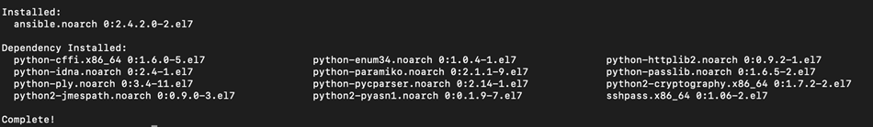

## Install Ansible on Ubuntu/Debian systems

**Step 1)** Perform an update to the packages

$ sudo apt update

**Step 2)** Install the software-properties-common package

$ sudo apt install software-properties-common

**Step 3)** Install ansible personal package archive

$ sudo apt-add-repository ppa:ansible/ansible

**Step 4)** Install ansible

$ sudo apt update

$ sudo apt install ansible

## Install Ansible on Windows

<https://phoenixnap.com/kb/install-ansible-on-windows#htoc-method-3-enabling-ubuntu-on-windows>

Ansible is an Infrastructure as Code tool used for managing and monitoring remote servers.

Ansible requires a Linux-based system to run. This can be a problem if you want to use its features on a Windows 10 system. However, there are ways to install Ansible on Windows.

### Enabling Ubuntu on Windows 10 – WSL (*Windows Subsystem for Linux*)

Use the Windows Subsystem for Linux to start up the Ubuntu terminal without setting up a virtual machine:

1. Open the **Start** menu and search for Turn Windows features on or off. Click on the shortcut when it appears.

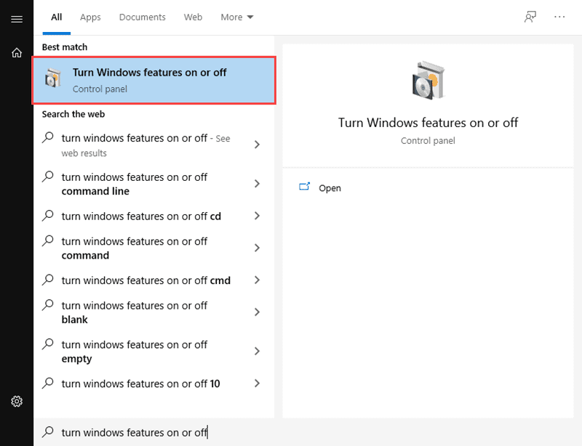

1. Scroll down through the list of features until you see Windows Subsystem for Linux. Click on the checkbox, and then click **OK** to enable the feature.

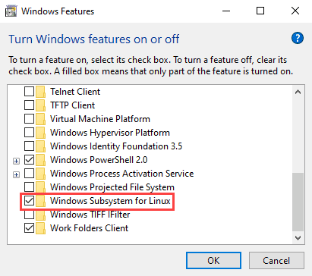

1. Open the Microsoft Store. Search for Ubuntu and click on **Get** to install the latest version.

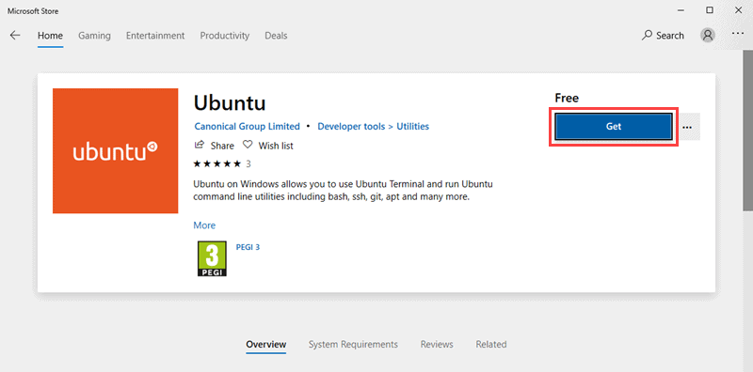

1. 4. Once the installation is complete, click on **Launch** to start up the Ubuntu command terminal.
2. 5. To install Ansible, enter the following set of commands:

$ sudo apt-get update

$ sudo apt-get install software-properties-common

$ sudo apt-add-repository ppa:ansible/ansible

$ sudo apt-get update

$ sudo apt-get install ansible -y

After running the above line of code, you are ready to manage remote machines through Ansible. Just run ansible –version to check the version and just to check whether Ansible was installed properly or not.

### Run Ansible on Windows 10: Using Cygwin

Cygwin is a POSIX-compatible environment that lets you run tools and code designed for Unix-like operating systems on Microsoft Windows.

Even though the default Cygwin installation contains hundreds of tools for Unix-based systems, Ansible is not one of them. You must manually add Ansible during the installation process.

To install Ansible on Windows using Cygwin, follow these steps:

1. Download the [Cygwin installation file](https://cygwin.com/setup-x86_64.exe) (<https://cygwin.com/setup-x86_64.exe>) This file is compatible with both the 32-bit and 64-bit versions of Windows 10. It automatically installs the right version for your system.
2. Run the Cygwin installation file. On the starting screen of the installation wizard, click **Next** to continue.

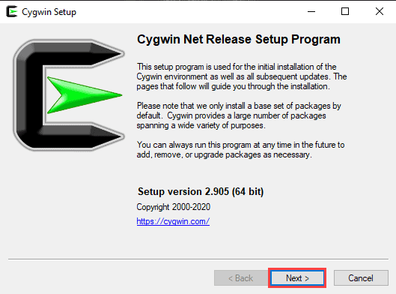

1. Select **Install from Internet** as the download source and click **Next**.

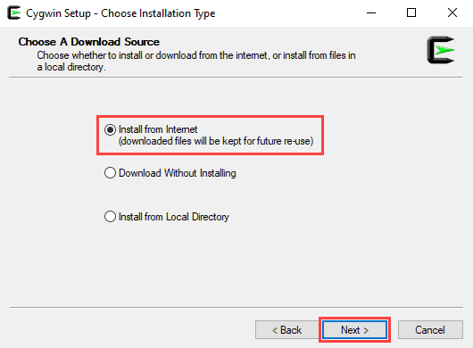

1. In the *Root Directory* field, specify where you want the application installed, then click **Next**.

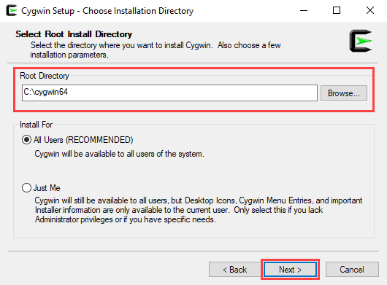

1. In the *Local Package Directory* field, select where you want to install your Cygwin packages, then click **Next**.

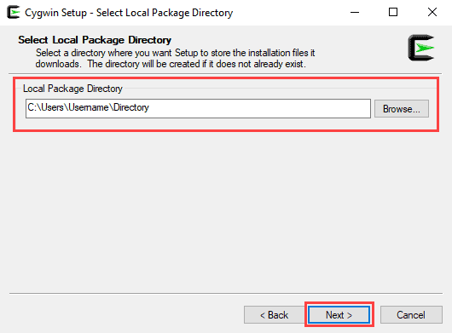

1. Choose the appropriate Internet connection option.

If you aren’t using a proxy, select **Direct Connection**.

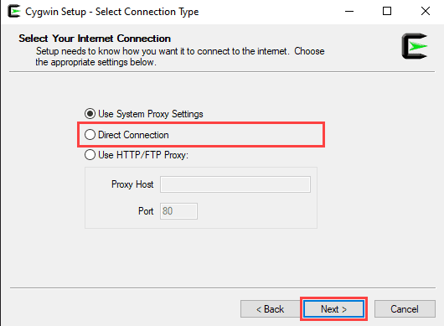

If you are using a proxy, select **Use System Proxy Settings** or enter the proxy settings manually with the **Use HTTP/FTP Proxy.**

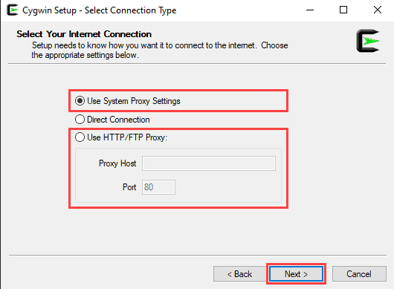

Click **Next** to continue.

1. Choose one of the available mirrors to download the installation files, then click **Next**.

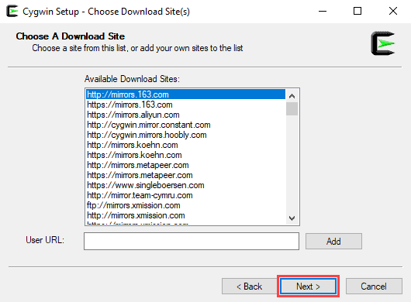

1. On the *Select Packages* screen, change the **View** option to **Full** and type ‘ansible’ in the search bar.

Select both **Ansible** and **Ansible Doc** by checking the boxes under *Src?* and click **Next** to continue.

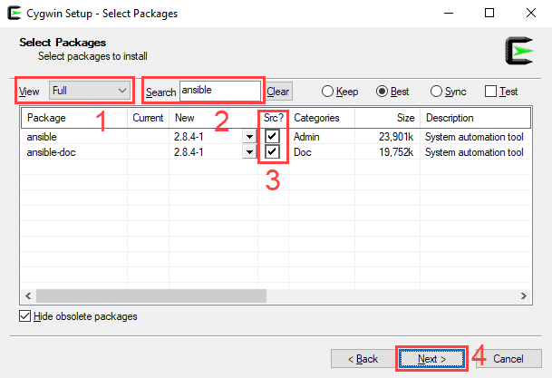

1. This screen lets you review the installation settings. To confirm and begin the install process, click on **Next**.

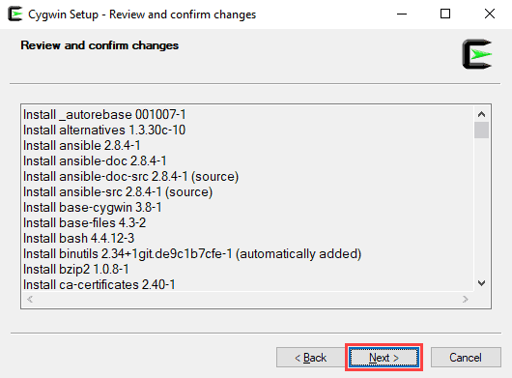

1. The install wizard will download and install all the selected packages, including Ansible.
2. Once the installation is complete, select whether you want to add a Cygwin desktop and Start Menu icon, then click on **Finish** to close the wizard.

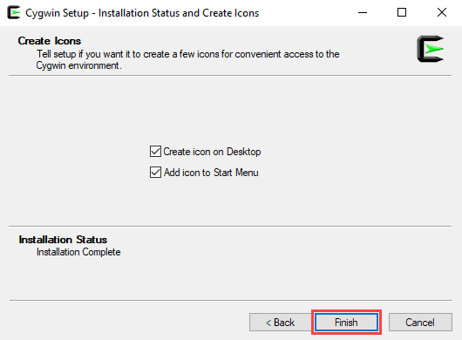

### Run Ansible on Windows 10: Using a Linux VM

Another way to install Ansible on Windows 10 is to use a virtualization tool and a Linux virtual box.

In this example, we will use Oracle VM VirtualBox to set up an Ubuntu virtual machine and install Ansible.

#### Step 1: Setting Up VirtualBox

1. Download the [VirtualBox installation file](https://download.virtualbox.org/virtualbox/6.1.14/VirtualBox-6.1.14-140239-Win.exe):

(<https://download.virtualbox.org/virtualbox/6.1.14/VirtualBox-6.1.14-140239-Win.exe>)

1. Run the VirtualBox installation file.

On the starting screen of the installation wizard, click **Next** to continue.

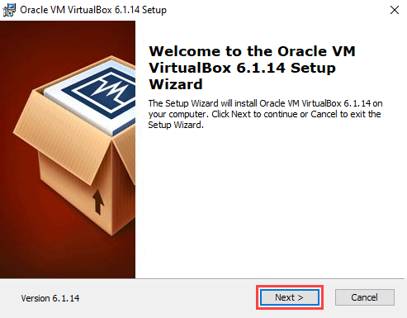

1. Use this screen to select which features of VirtualBox you want to install. This is also where you can set the install location. Click **Next** to continue.

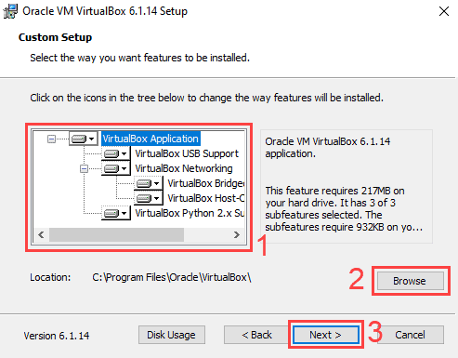

1. Choose whether you want to add Desktop, Start Menu, and Quick Launch Bar shortcuts and add file associations. Click **Next** to continue.

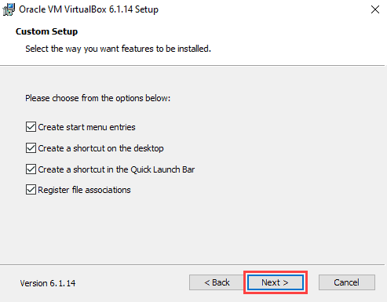

1. A new screen will warn you that the install wizard needs to reset your network connection. Click **Yes** to continue.

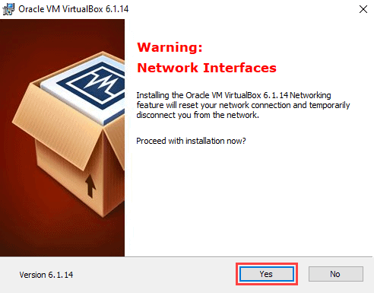

1. On the next screen, click **Install** to begin the installation process.

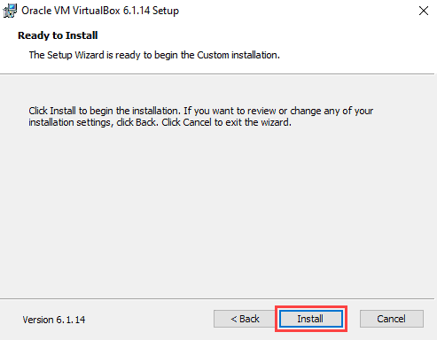

1. The install wizard might prompt you to add a VirtualBox USB device. Click **Yes** to continue.
2. Click **Finish** to complete the installation.

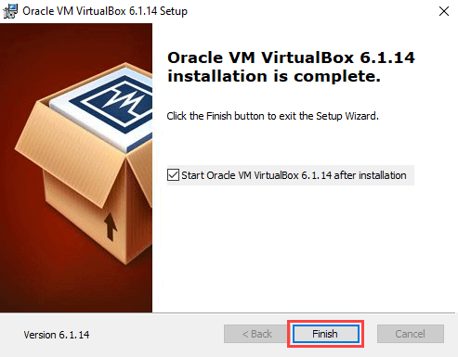

#### Step 2: Creating an Ubuntu 20.04 Virtual Box

1. Download the [Ubuntu 20.04 desktop image](https://releases.ubuntu.com/) (<https://releases.ubuntu.com/>).
2. On the VirtualBox starting screen, click **New**.

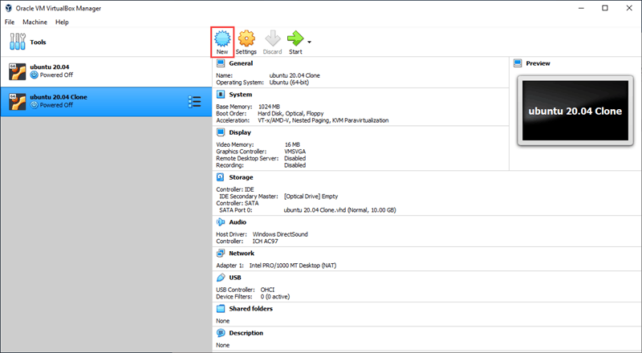

1. Type in the name of your virtual machine. If the name contains the word ‘Ubuntu’, the operating system dropdown menu will automatically update to Ubuntu (64-bit). If not, you can select the operating system manually using the dropdown menu. Click **Next** to continue.

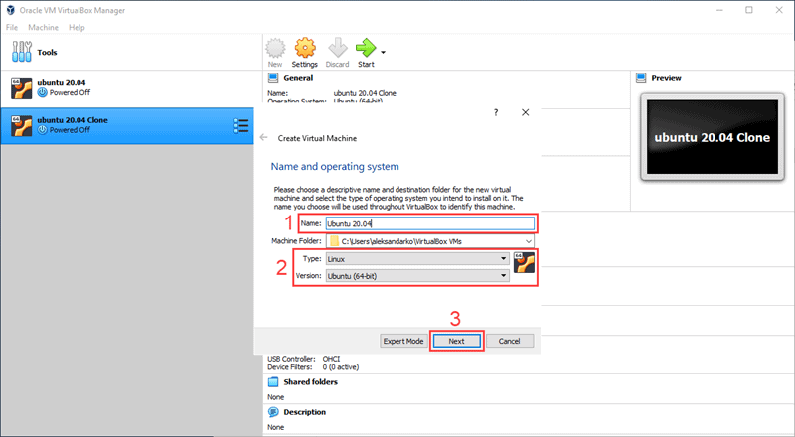

1. Set the amount of RAM you want the virtual machine to have.

Click **Next** to continue.

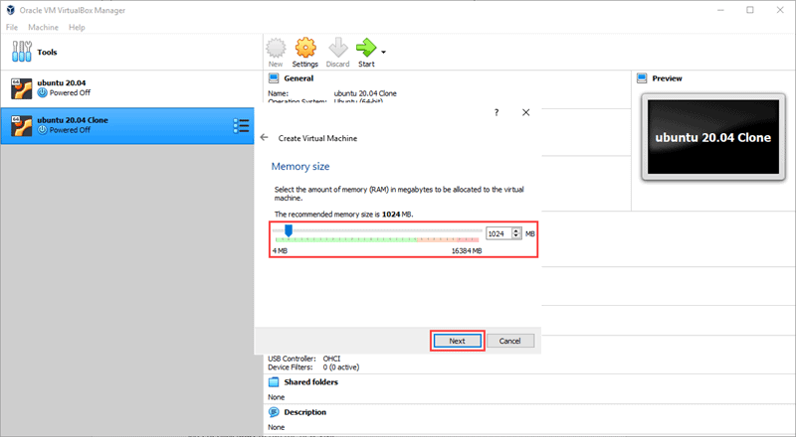

**Note:** By default, Oracle VM VirtualBox assigns 1024MB of RAM to every virtual box. Make sure you assign enough RAM to your new virtual box, or it will not work properly.

1. Select a hard disk option for your virtual machine.

Choose **Create a virtual hard disk now** if you are creating a brand new VM. Click **Create** to continue.

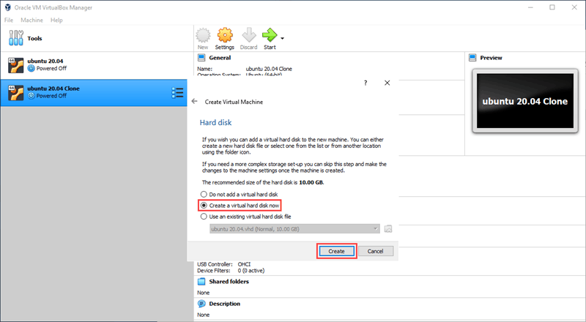

1. Choose the type of virtual hard disk you want to create. Click **Next**.

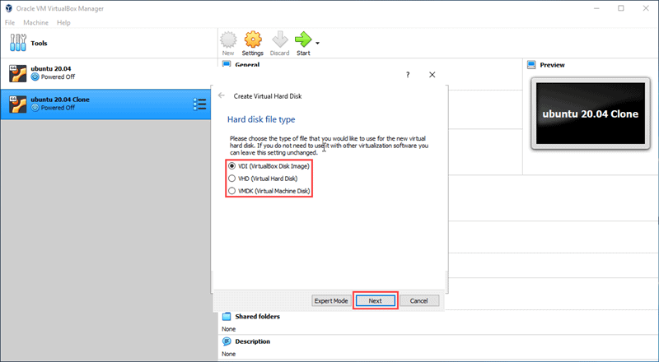

1. Choose if the new virtual hard disk has a fixed amount of space or if you want it to allocate space dynamically. Select **Fixed size** and click **Next**.

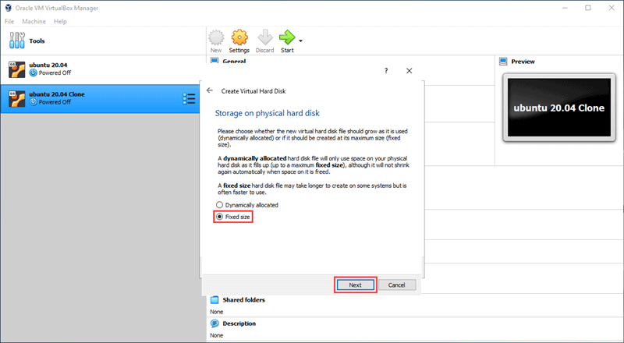

1. Select the location of the virtual hard disk on your computer and enter the size limit.

For this example, we will set the size limit to 10GB. Click **Create** to continue.

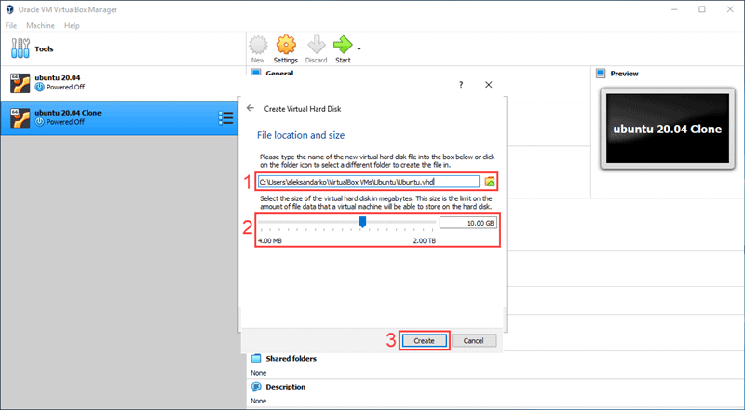

**Note:** Just like with RAM, you need to make sure you assign enough hard disk space to your virtual machine. VirtualBox sets the fixed-size hard disk at 10GB by default.

1. Select the new virtual machine you just created on the left-hand side of the VirtualBox starting screen. Click **Start** to run the new VM.

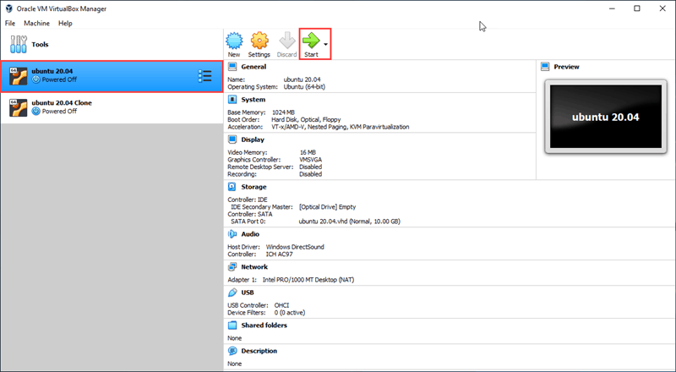

1. VirtualBox will prompt you to select a start-up disk. Click on the button next to the drop-down menu to open the optical **Disk Selector**.

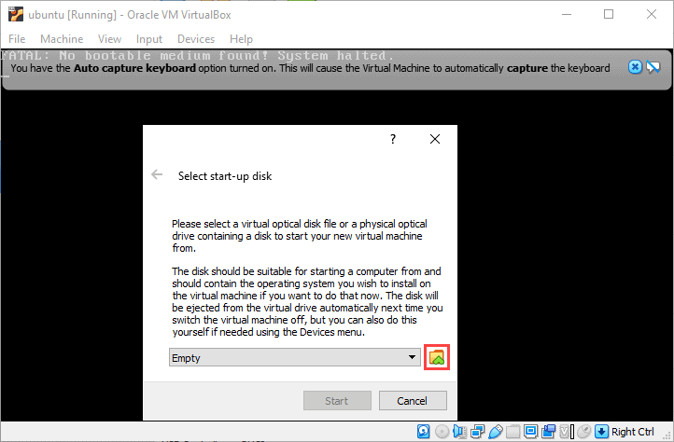

1. In the **Optical Disk Selector**, click **Add**.

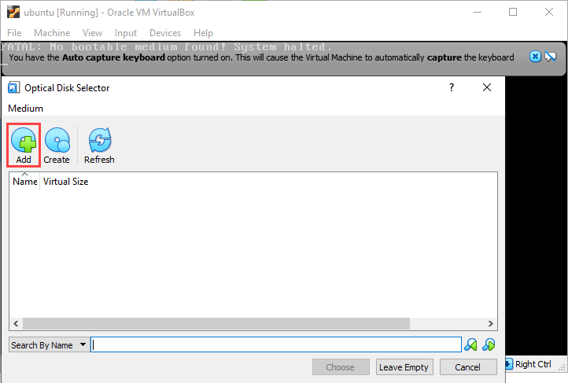

1. Find the Ubuntu 20.04 desktop image you downloaded in a previous step. Select the image and click **Open**.

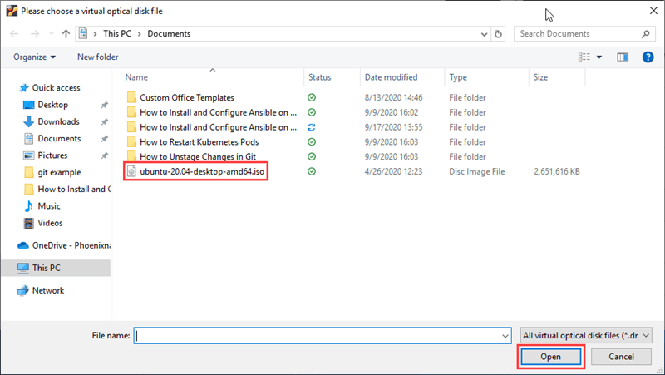

1. In the **Optical Disk Selector**, highlight the image you just added and click **Choose**.

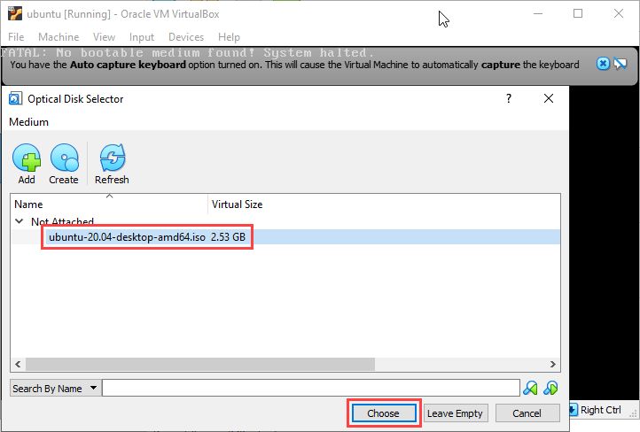

1. Click **Start** to begin the install process for Ubuntu 20.04.

#### Step 3: Installing Ansible

1. Once you are done installing Ubuntu 20.04, open the command terminal.
2. In the command terminal, enter the following command:

$ sudo apt update

This command refreshes the system’s package index and allows you to Install Ansible.

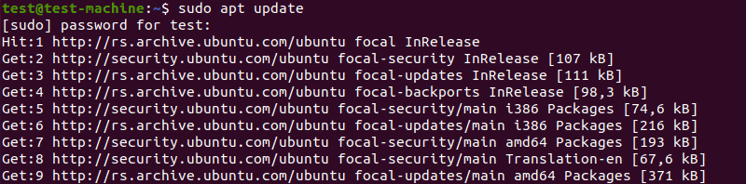

1. To install Ansible, use the command:

$ sudo apt install ansible -y



The rest of the install process is automated.

After you install it on your virtual machine, you can [configure Ansible](https://phoenixnap.com/kb/install-ansible-ubuntu-20-04) by setting up the [hosts inventory file](https://phoenixnap.com/kb/ansible-create-file) and checking the connections.

After running the above line of code, you are ready to manage remote machines through Ansible. Just run ansible --version to check the version and just to check whether Ansible was installed properly or not.

# YAML Basics

YAML Tutorial for DevOps: <https://youtu.be/1uFVr15xDGg>

YAML (/ˈjæməl/, rhymes with *camel*) was first proposed by Clark Evans in 2001, who designed it together with Ingy döt Netand Oren Ben-Kiki. Originally YAML was said to mean *Yet Another Markup Language*, because it was released in an era that saw a proliferation of markup languages for presentation and connectivity (HTML, XML, SGML, etc). Its initial name was intended as a tongue-in-cheek reference to the technology landscape, referencing its purpose as a markup language with the yet another construct, but it was then repurposed as *YAML Ain't Markup Language*, a recursive acronym, to distinguish its purpose as data-oriented, rather than document markup.

Ansible uses YAML syntax for expressing Ansible playbooks. This chapter provides an overview of YAML. Ansible uses YAML because it is very easy for humans to understand, read and write when compared to other data formats like XML and JSON.

Every **YAML** file optionally starts with “---” and ends with “...”.

## Understanding YAML

In this section, we will learn the different ways in which the YAML data is represented.

### key-value pair

YAML uses simple key-value pair to represent the data. The dictionary is represented in key: value pair.

**Note** − There should be space between : and value.

**Example: A student record**

--- #Optional YAML start syntax

james:

name: james john

rollNo: 34

div: B

sex: male

… #Optional YAML end syntax

#### Abbreviation

You can also use abbreviation to represent dictionaries.

**Example**

James: {name: james john, rollNo: 34, div: B, sex: male}

### Representing List

We can also represent List in YAML. Every element(member) of list should be written in a new line with same indentation starting with “- “ (- and space).

**Example**

---

countries:

- America

- China

- Canada

- Iceland

…

#### Abbreviation

You can also use abbreviation to represent lists.

**Example**

Countries: [‘America’, ‘China’, ‘Canada’, ‘Iceland’]

### List inside Dictionaries

We can use list inside dictionaries, i.e., value of key is list.

**Example**

---

james:

name: james john

rollNo: 34

div: B

sex: male

likes:

- maths

- physics

- english

…

### List of Dictionaries

We can also make list of dictionaries.

**Example**

---

- james:

name: james john

rollNo: 34

div: B

sex: male

likes:

- maths

- physics

- english

- robert:

name: robert richardson

rollNo: 53

div: B

sex: male

likes:

- biology

- chemistry

…

YAML uses “|” to include newlines while showing multiple lines and “>” to suppress newlines while showing multiple lines. Due to this we can read and edit large lines. In both the cases intendentation will be ignored.

We can also represent **Boolean** (True/false) values in YAML. where **boolean** values can be case insensitive.

**Example**

---

- james:

name: james john

rollNo: 34

div: B

sex: male

likes:

- maths

- physics

- english

result:

maths: 87

chemistry: 45

biology: 56

physics: 70

english: 80

passed: TRUE

messageIncludeNewLines: |

Congratulation!!

You passed with 79%

messageExcludeNewLines: >

Congratulation!!

You passed with 79%

## Some common words related to Ansible.

* **Service/Server** − A process on the machine that provides the service.
* **Machine** − A physical server, vm(virtual machine) or a container.
* **Target machine** − A machine we are about to configure with Ansible.
* **Task** − An action(run this, delete that) etc managed by Ansible.
* **Playbook** − The yml file where Ansible commands are written and yml is executed on a machine.

# Setting up Test Environments

<https://mydeveloperplanet.com/2022/05/04/how-to-setup-an-ansible-test-environment/>

<https://www.youtube.com/watch?v=qoliqxGvX84>

When you want to experiment with Ansible, you will need to setup a test environment. In this blog, you will create a test environment containing one controller and two target machines. This will give you a good setup for experimenting with Ansible without breaking a real machine.

## 1. Introduction

With [Ansible](https://www.ansible.com/), you can automate repetitive IT tasks and because it is automated, it will also prevent you from making mistakes. Especially when you have to configure several similar environments. The other main advantage is that the configuration is maintained in files and therefore extremely suitable for adding the configuration to version control (e.g., Git). However, in every learning path you need to be able to experiment in order to make mistakes and to learn. In this blog, you will setup an Ansible controller machine and two target machines running in VirtualBox. The Ansible Controller will be the machine where to run the Ansible playbooks from and the target machines will be where tasks can be executed. The test setup looks as follows.

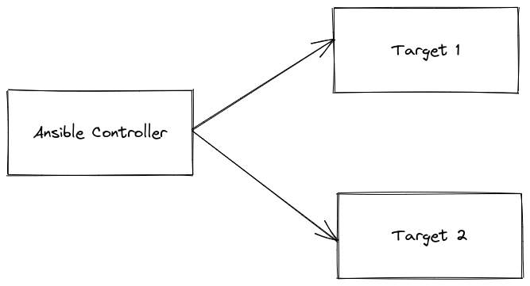

The sources for this post are available at [GitHub](https://github.com/mydeveloperplanet/MyAnsiblePlanet).

## 2. Setup Ansible Controller

The machines will be created as Virtual Machines (VMs) and as virtualization platform you will use [VirtualBox](https://www.virtualbox.org/). Install VirtualBox on your host machine when it is not yet installed.

You can create a machine from scratch and install an operating system (OS) yourself, but for testing purposes, it is easier to retrieve an already installed image from [osboxes.org](https://www.osboxes.org/).

Navigate to **VM IMAGES – VirtualBox Images** and choose for Ubuntu, the OS you will use for setting up the environment. Download the **Ubuntu 20.04.4 Focal Fossa** version. After downloading the file, unzip it.

Create in VirtualBox a new machine via **Machine – New…** Fill in the following and click the **Next** button:

* Name: Controller
* Type: Linux
* Version: Ubuntu (64-bit)

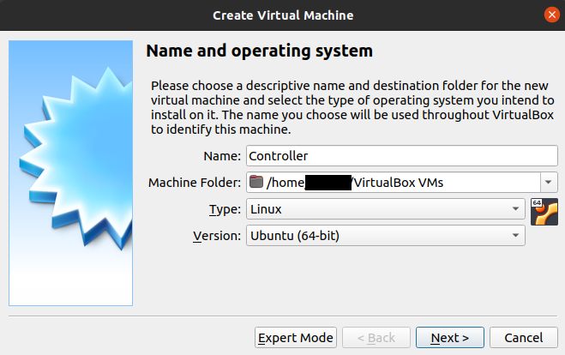

Set the memory size to 4 GB and click the **Next** button.

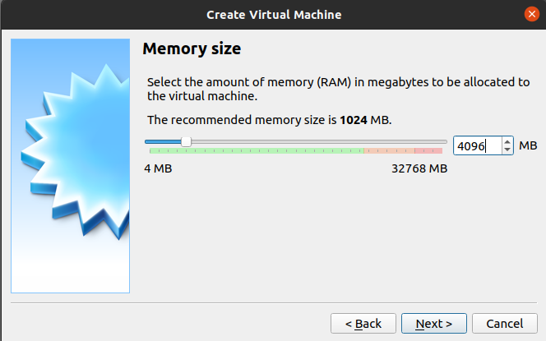

Choose for **Use an existing virtual hard disk file** and select the .vdi file you downloaded and unzipped. Click the **Create** button.

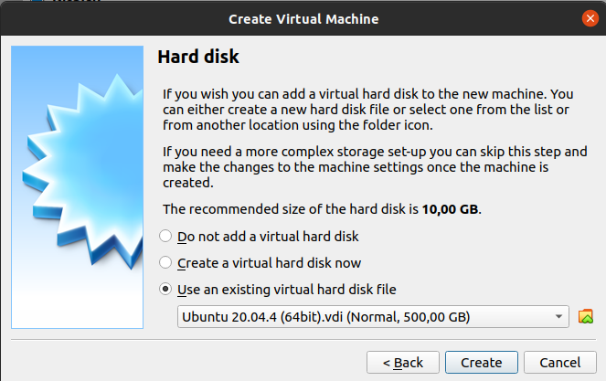

Select the VM in VirtualBox and click the **Settings** button. Navigate to **Network** in the left menu and change in the **Adapter_1** tab **Attached to** into **Bridged Adapter**. Click the **OK** button.

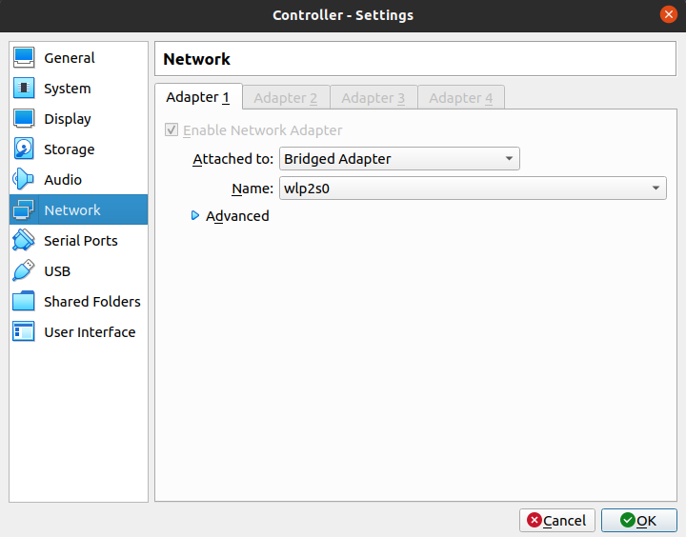

Start the VM and login with username **osboxes** and password **osboxes.org**. After successful login, verify whether you have internet connection (just try to search something in the browser in the VM). Run the software updates in Ubuntu and also update libraries in a terminal window.

|  |
| --- |
| $ sudo apt-get upgrade |

Retrieve the IP address of the VM. You can do so by hovering over the network icon at the right bottom of the VM or by executing the following command in a terminal window.

|  |
| --- |
| $ ip a |

Install openssh-server in order to be able to connect via SSH from your host to the VM.

|  |
| --- |
| $ sudo apt install openssh-server |

As a last step, try to connect from your host to the VM via a terminal window, and replace the IP address with the IP address of your Controller VM.

|  |
| --- |
| $ ssh osboxes@192.168.2.2 |

Shutdown the VM.

## 3. Create Target Machines

In this section the two target machines will be created. In VirtualBox, right-click the Ansible Controller and choose **Clone…** Fill in the following and click the **Next** button:

* Name: Target1
* MAC Address Policy: Generate new MAC addresses for all network adapters

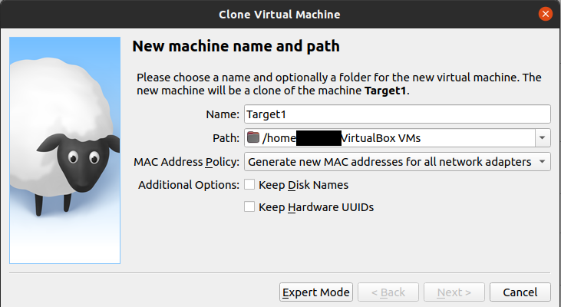

Choose for **Linked clone** (you can also choose for a full clone, but when it is only for testing purposes, there is no harm for chosing a linked clone). Click the **Clone** button.

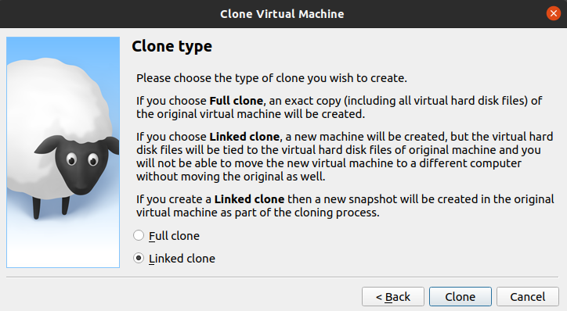

Again, log in to the VM, retrieve the IP address and try to SSH to the VM from your host.

Lastly, create in a similar way a Target2 machine.

## 4. Install Ansible

The controller needs an Ansible installation in order to be able to run playbooks from the Ansible controller. Several options are available for installing Ansible, these can be found in the [documentation](https://docs.ansible.com/ansible/latest/installation_guide/intro_installation.html). The steps below were successfully executed inside the controller VM. The third command did not really execute successfully or it took too long. Nevertheless, the installation seems to be successful.

|  |
| --- |
| $ sudo apt update  $ sudo apt install software-properties-common  $ sudo add-apt-repository --yes --update ppa:ansible/ansible  $ sudo apt install ansible |

Verify whether the Ansible installation was successful.

|  |
| --- |
| $ ansible --version  ansible [core 2.12.4]    config file = /etc/ansible/ansible.cfg    configured module search path = ['/home/osboxes/.ansible/plugins/modules', '/usr/share/ansible/plugins/modules']    ansible python module location = /home/osboxes/.local/lib/python3.8/site-packages/ansible    ansible collection location = /home/osboxes/.ansible/collections:/usr/share/ansible/collections    executable location = /usr/bin/ansible    python version = 3.8.10 (default, Mar 15 2022, 12:22:08) [GCC 9.4.0]    jinja version = 3.1.1    libyaml = True |

## 5. Provide Access to the Target VMs from the Controller

<https://www.digitalocean.com/community/tutorials/how-to-set-up-ssh-keys-on-ubuntu-20-04>

### 5.1 Create the Public Key Pair on the Controller

On the controller, run the following command:

$ ssh-keygen

After entering the command, you should see the following output:

Output

Generating public/private rsa key pair.

Enter file in which to save the key (/your_home/.ssh/id_rsa):

Press enter to save the key pair into the .ssh/ subdirectory in your home directory, or specify an alternate path.

If you had previously generated an SSH key pair, you may see the following prompt:

Output

/home/your_home/.ssh/id_rsa already exists.

Overwrite (y/n)?

If you choose to overwrite the key on disk, you will **not** be able to authenticate using the previous key anymore. Be very careful when selecting yes, as this is a destructive process that cannot be reversed.

You should then see the following prompt:

Output

Enter passphrase (empty for no passphrase):

Here you optionally may enter a secure passphrase, which is highly recommended. A passphrase adds an additional layer of security to prevent unauthorized users from logging in.

You should then see the output similar to the following:

Output

Your identification has been saved in /your_home/.ssh/id_rsa

Your public key has been saved in /your_home/.ssh/id_rsa.pub

The key fingerprint is:

SHA256:/hk7MJ5n5aiqdfTVUZr+2Qt+qCiS7BIm5Iv0dxrc3ks user@host

The key's randomart image is:

+---[RSA 3072]----+

| .|

| + |

| + |

| . o . |

|o S . o |

| + o. .oo. .. .o|

|o = oooooEo+ ...o|

|.. o *o+=.*+o....|

| =+=ooB=o.... |

+----[SHA256]-----+

You now have a public and private key that you can use to authenticate. The next step is to place the public key on your server so that you can use SSH-key-based authentication to log in.

### 5.2 Copy Public ssh keys to Target VMs using ssh

We can do this by using the cat command to read the contents of the public SSH key on our local computer and piping that through an SSH connection to the remote server.

On the other side, we can make sure that the ~/.ssh directory exists and has the correct permissions under the account we’re using.

We can then output the content we piped over into a file called authorized_keys within this directory. We’ll use the >> redirect symbol to append the content instead of overwriting it. This will let us add keys without destroying previously added keys.

The full command looks like this:

cat ~/.ssh/id_rsa.pub | ssh asingala@192.168.0.104 "mkdir -p ~/.ssh && touch ~/.ssh/authorized_keys && chmod -R go= ~/.ssh && cat >> ~/.ssh/authorized_keys"

You may see the following message:

Output

The authenticity of host '203.0.113.1 (203.0.113.1)' can't be established.

ECDSA key fingerprint is fd:fd:d4:f9:77:fe:73:84:e1:55:00:ad:d6:6d:22:fe.

Are you sure you want to continue connecting (yes/no)? yes

This means that your local computer does not recognize the remote host. This will happen the first time you connect to a new host. Type yes and press ENTER to continue.

Afterwards, you should be prompted to enter the remote user account password:

Output

username@203.0.113.1's password:

After entering your password, the content of your id_rsa.pub key will be copied to the end of the authorized_keys file of the remote user’s account.

Repeat the above steps to copy the key to any other target servers. Make sure you provide the correct connection credentials, for e.g.; asingala@192.168.0.106.

### 5.3 Authenticating to Your Ubuntu Server Using SSH Keys

If you have successfully completed one of the procedures above, you should be able to log into the remote host without providing the remote account’s password.

The basic process is the same:

ssh username@remote_host

If this is your first time connecting to this host (if you used the last method above), you may see something like this:

Output

The authenticity of host '203.0.113.1 (203.0.113.1)' can't be established.

ECDSA key fingerprint is fd:fd:d4:f9:77:fe:73:84:e1:55:00:ad:d6:6d:22:fe.

Are you sure you want to continue connecting (yes/no)? yes

This means that your local computer does not recognize the remote host. Type “yes” and then press ENTER to continue.

If you did not supply a passphrase for your private key, you will be logged in immediately. If you supplied a passphrase for the private key when you created the key, you will be prompted to enter it now (note that your keystrokes will not display in the terminal session for security). After authenticating, a new shell session should open for you with the configured account on the Ubuntu server.

If key-based authentication was successful, continue on to learn how to further secure your system by disabling password authentication.

### 5.4 Disabling Password Authentication on Your Server

If you were able to log into your account using SSH without a password, you have successfully configured SSH-key-based authentication to your account. However, your password-based authentication mechanism is still active, meaning that your server is still exposed to brute-force attacks.

Before completing the steps in this section, make sure that you either have SSH-key-based authentication configured for the **root** account on this server, or preferably, that you have SSH-key-based authentication configured for a non-root account on this server with sudo privileges. This step will lock down password-based logins, so ensuring that you will still be able to get administrative access is crucial.

Once you’ve confirmed that your remote account has administrative privileges, log into your remote server with SSH keys, either as **root** or with an account with sudo privileges. Then, open up the SSH daemon’s configuration file:

sudo nano /etc/ssh/sshd_config

Inside the file, search for a directive called PasswordAuthentication. This line may be commented out with a # at the beginning of the line. Uncomment the line by removing the #, and set the value to no. This will disable your ability to log in via SSH using account passwords:

/etc/ssh/sshd_config

. . .

PasswordAuthentication no

. . .

Save and close the file when you are finished by pressing CTRL+X, then Y to confirm saving the file, and finally ENTER to exit nano. To actually activate these changes, we need to restart the sshd service:

sudo systemctl restart ssh

As a precaution, open up a new terminal window and test that the SSH service is functioning correctly before closing your current session:

ssh username@remote_host

Once you have verified your SSH service is functioning properly, you can safely close all current server sessions.

The SSH daemon on your Ubuntu server now only responds to SSH-key-based authentication. Password-based logins have been disabled.

## 6. Create the Inventory (hosts) File

Create a new folder and then create a file named “hosts” in that new folder:

$ mkdir ~/first_ansible_demo

$ cd ~/first_ansible_demo

$ vi hosts

In the hosts file, add the target node details as follows:

[web]

node1 ansible_host=192.168.0.104

node2 ansible_host=192.168.0.106

Save the file.

## 7. Testing Connectivity to Nodes

To test that Ansible is able to connect and run commands and playbooks on your nodes, you can use the following command from the folder where you created the hosts inventory file:

cd ~/first_ansible_demo

ansible all -m ping

OR

ansible all -i ./hosts -m ping

The ping module will test if you have valid credentials for connecting to the nodes defined in your inventory file, in addition to testing if Ansible is able to run Python scripts on the remote server. A pong reply back means Ansible is ready to run commands and playbooks on that node.

### Connecting as a Different User

By default, Ansible tries to connect to the nodes as your current system user, using its corresponding SSH keypair. To connect as a different user, append the command with the -u flag and the name of the intended user:

ansible all -m ping -u sammy

OR

ansible all -i ./hosts -m ping -u sammy

## 8. Create an Ansible Playbook

In the same folder, create a file named “playbook1.yml” and add the following contents to the file:

---

- hosts: node1

tasks:

- name: create empty file.

file:

path: "/home/asingala/demo1.txt"

state: touch

become: true

The file above has the following components:

* **hosts:** Defines on which remote hosts from your Ansible inventory file you want to execute the task. All means that every host receives the command, but you can also enter the name of a host category or one individual host.
* **tasks:** Announces that the remote host needs to perform a task.
* **name**: Lets you define a name for the task. The name is for your reference only and has no influence on the task itself.
* **file**: Engages Ansible’s file module to create a new file.
* **path**: Defines the path for the new file on the remote host’s hard drive.
* **state**: Similar to the touch command in the Ubuntu terminal, entering **touch**creates an empty file in the location you chose.

## 9. Run the Playbook

Run the playbook with the command:

$ ansible-playbook ./playbook1.yml -i ./hosts

You will get an error saying “missing sudo password”.

Change the playbook and add the highlighted line:

---

- hosts: node1

tasks:

- name: create empty file.

file:

path: "/home/asingala/demo1.txt"

state: touch

become_user: asingala

become: true

Re-run the playbook:

$ ansible-playbook ./playbook1.yml -i ./hosts

Connect to the target (node1) and check if the file was created in the specified folder.

## Creating a File with Content

If you want to create a new file with content, you can first use the method above to create an empty file, and then use the **blockinfile** or **lineinfile** module to insert content.

A quicker way is to use the **copy** module. Even though this module is used to copy a file from the control node to the remote host, you can include the **content** parameter to instantly add content to an empty file.

Use this configuration in your playbook:

---

- hosts: all

tasks:

- name: Creating a file with content

copy:

dest: "/your path"

content: |

line 01

line 02

In the file, we used:

* **copy**: Engages Ansible’s copy module.
* **dest**: Defines the path for your new file.
* **content**: This parameter will add **line 01** and **line 02** as the content of the new file.

## Creating Multiple Files

You can create multiple files by using a single task in an Ansible playbook.

Use the following configuration to create multiple files:

---

- hosts: all

tasks:

- name: Create multiple files

file:

path: "{{ item }}"

state: touch

with_items:

- test01.txt

- test02.txt

- test03.txt

- test04.txt

In the configuration file above, we defined:

* **path**: The **"{{ item }}"** value means that Ansible will create a separate path for each respective file. By default, these files go in the Home folder of the remote host. Define a different path by using **/your_folder_path/"{{ item }}"**.
* **with_items**: This parameter is used to start a list of files to create. List as many files as you want. In our example, we created a list of four files titled test.

## Creating a Directory

Creating a new directory uses the same configuration as when creating an empty file. The only difference is that under the **state** parameter, you enter **directory**as the value:

---

- hosts: all

tasks:

- name: Creating a new directory

file:

path: "/home/asingala/dummy"

state: directory

## Removing Files

Ansible playbooks can also remove existing files. To do this, set the **state** parameter to **absent**:

---

- hosts: all

tasks:

- name: Removing a file

file:

path: "/home/asingala/demo1.txt"

state: absent

## Removing Multiple Files

---

- hosts: all

tasks:

- name: Removing multple files

file:

path: "/home/asingala/{{ item }}"

state: absent

with_items:

- test01.txt

- test02.txt

- test03.txt

- test04.txt

# Host Inventory File

a.k.a. Hosts File.

<https://docs.ansible.com/ansible/latest/inventory_guide/intro_inventory.html>

<https://www.digitalocean.com/community/tutorials/how-to-set-up-ansible-inventories>

<https://linuxbuz.com/linuxhowto/what-is-ansible-inventory-and-how-it-works>

## [Inventory basics: formats, hosts, and groups](https://docs.ansible.com/ansible/latest/inventory_guide/intro_inventory.html#id4)

You can create your inventory file in one of many formats, depending on the inventory plugins you have. The most common formats are INI and YAML. A basic INI /etc/ansible/hosts might look like this:

mail.example.com

[webservers]

foo.example.com

bar.example.com

[dbservers]

one.example.com

two.example.com

three.example.com

The headings in brackets are group names, which are used in classifying hosts and deciding what hosts you are controlling at what times and for what purpose. Group names should follow the same guidelines as [Creating valid variable names](https://docs.ansible.com/ansible/latest/playbook_guide/playbooks_variables.html#valid-variable-names).

Here’s that same basic inventory file in YAML format:

**all:**

**hosts:**

**mail.example.com:**

**children:**

**webservers:**

**hosts:**

**foo.example.com:**

**bar.example.com:**

**dbservers:**

**hosts:**

**one.example.com:**

**two.example.com:**

**three.example.com:**

## [Default groups](https://docs.ansible.com/ansible/latest/inventory_guide/intro_inventory.html#id5)[ℑ](https://docs.ansible.com/ansible/latest/inventory_guide/intro_inventory.html#default-groups)

Even if you do not define any groups in your inventory file, Ansible creates two default groups: all and ungrouped. The all group contains every host. The ungrouped group contains all hosts that don’t have another group aside from all. Every host will always belong to at least 2 groups (all and ungrouped or all and some other group). For example, in the basic inventory above, the host mail.example.com belongs to the all group and the ungrouped group; the host two.example.com belongs to the all group and the dbservers group. Though all and ungrouped are always present, they can be implicit and not appear in group listings like group_names.

### [Hosts in multiple groups](https://docs.ansible.com/ansible/latest/inventory_guide/intro_inventory.html#id6)

You can (and probably will) put each host in more than one group. For example a production webserver in a datacenter in Atlanta might be included in groups called [prod] and [atlanta] and [webservers]. You can create groups that track:

* What - An application, stack or microservice (for example, database servers, web servers, and so on).
* Where - A datacenter or region, to talk to local DNS, storage, and so on (for example, east, west).
* When - The development stage, to avoid testing on production resources (for example, prod, test).

Extending the previous YAML inventory to include what, when, and where would look like this:

**all:**

**hosts:**

**mail.example.com:**

**children:**

**webservers:**

**hosts:**

**foo.example.com:**

**bar.example.com:**

**dbservers:**

**hosts:**

**one.example.com:**

**two.example.com:**

**three.example.com:**

**east:**

**hosts:**

**foo.example.com:**

**one.example.com:**

**two.example.com:**

**west:**

**hosts:**

**bar.example.com:**

**three.example.com:**

**prod:**

**hosts:**

**foo.example.com:**

**one.example.com:**

**two.example.com:**

**test:**

**hosts:**

**bar.example.com:**

**three.example.com:**

You can see that one.example.com exists in the dbservers, east, and prod groups.

### [Grouping groups: parent/child group relationships](https://docs.ansible.com/ansible/latest/inventory_guide/intro_inventory.html#id7)[ℑ](https://docs.ansible.com/ansible/latest/inventory_guide/intro_inventory.html#grouping-groups-parent-child-group-relationships)

You can create parent/child relationships among groups. Parent groups are also known as nested groups or groups of groups. For example, if all your production hosts are already in groups such as atlanta_prod and denver_prod, you can create a production group that includes those smaller groups. This approach reduces maintenance because you can add or remove hosts from the parent group by editing the child groups.

To create parent/child relationships for groups:

* in INI format, use the :children suffix
* in YAML format, use the children: entry

Here is the same inventory as shown above, simplified with parent groups for the prod and test groups. The two inventory files give you the same results:

**all:**

**hosts:**

**mail.example.com:**

**children:**

**webservers:**

**hosts:**

**foo.example.com:**

**bar.example.com:**

**dbservers:**

**hosts:**

**one.example.com:**

**two.example.com:**

**three.example.com:**

**east:**

**hosts:**

**foo.example.com:**

**one.example.com:**

**two.example.com:**

**west:**

**hosts:**

**bar.example.com:**

**three.example.com:**

**prod:**

**children:**

**east:**

**test:**

**children:**

**west:**

Child groups have a couple of properties to note:

* Any host that is member of a child group is automatically a member of the parent group.
* Groups can have multiple parents and children, but not circular relationships.
* Hosts can also be in multiple groups, but there will only be **one** instance of a host at runtime. Ansible merges the data from the multiple groups.

## [Adding variables to inventory](https://docs.ansible.com/ansible/latest/inventory_guide/intro_inventory.html#id12)

You can store variable values that relate to a specific host or group in inventory. To start with, you may add variables directly to the hosts and groups in your main inventory file.

We document adding variables in the main inventory file for simplicity. However, storing variables in separate host and group variable files is a more robust approach to describing your system policy. Setting variables in the main inventory file is only a shorthand. See [Organizing host and group variables](https://docs.ansible.com/ansible/latest/inventory_guide/intro_inventory.html#splitting-out-vars) for guidelines on storing variable values in individual files in the ‘host_vars’ directory. See [Organizing host and group variables](https://docs.ansible.com/ansible/latest/inventory_guide/intro_inventory.html#splitting-out-vars) for details.

### [Assigning a variable to one machine: host variables](https://docs.ansible.com/ansible/latest/inventory_guide/intro_inventory.html#id13)

You can easily assign a variable to a single host, then use it later in playbooks. You can do this directly in your inventory file.

In INI:

[atlanta]

host1 http_port=80 maxRequestsPerChild=808

host2 http_port=303 maxRequestsPerChild=909

In YAML:

**atlanta:**

**hosts:**

**host1:**

**http_port:** 80

**maxRequestsPerChild:** 808

**host2:**

**http_port:** 303

**maxRequestsPerChild:** 909

Unique values like non-standard SSH ports work well as host variables. You can add them to your Ansible inventory by adding the port number after the hostname with a colon:

badwolf.example.com:5309

Connection variables also work well as host variables:

[targets]

localhost ansible_connection=local

other1.example.com ansible_connection=ssh ansible_user=myuser

other2.example.com ansible_connection=ssh ansible_user=myotheruser

**Note**: If you list non-standard SSH ports in your SSH config file, the openssh connection will find and use them, but the paramiko connection will not.

### [Inventory aliases](https://docs.ansible.com/ansible/latest/inventory_guide/intro_inventory.html#id14)

You can also define aliases in your inventory using host variables:

In INI:

jumper ansible_port=5555 ansible_host=192.0.2.50

In YAML:

**...**

**hosts:**

**jumper:**

**ansible_port:** 5555

**ansible_host:** 192.0.2.50

In this example, running Ansible against the host alias “jumper” will connect to 192.0.2.50 on port 5555. See [behavioral inventory parameters](https://docs.ansible.com/ansible/latest/inventory_guide/intro_inventory.html#behavioral-parameters) to further customize the connection to hosts.

## [Defining variables in INI format](https://docs.ansible.com/ansible/latest/inventory_guide/intro_inventory.html#id15)

Values passed in the INI format using the key=value syntax are interpreted differently depending on where they are declared:

* When declared inline with the host, INI values are interpreted as Python literal structures (strings, numbers, tuples, lists, dicts, booleans, None). Host lines accept multiple key=value parameters per line. Therefore they need a way to indicate that a space is part of a value rather than a separator. Values that contain whitespace can be quoted (single or double). See the [Python shlex parsing rules](https://docs.python.org/3/library/shlex.html#parsing-rules) for details.
* When declared in a :vars section, INI values are interpreted as strings. For example var=FALSE would create a string equal to ‘FALSE’. Unlike host lines, :vars sections accept only a single entry per line, so everything after the = must be the value for the entry.

If a variable value set in an INI inventory must be a certain type (for example, a string or a boolean value), always specify the type with a filter in your task. Do not rely on types set in INI inventories when consuming variables.

Consider using YAML format for inventory sources to avoid confusion on the actual type of a variable. The YAML inventory plugin processes variable values consistently and correctly.

### [Assigning a variable to many machines: group variables](https://docs.ansible.com/ansible/latest/inventory_guide/intro_inventory.html#id16)

If all hosts in a group share a variable value, you can apply that variable to an entire group at once.

In INI:

[atlanta]

host1

host2

[atlanta:vars]

ntp_server=ntp.atlanta.example.com

proxy=proxy.atlanta.example.com

In YAML:

**atlanta:**

**hosts:**

**host1:**

**host2:**

**vars:**

**ntp_server:** ntp.atlanta.example.com

**proxy:** proxy.atlanta.example.com

Group variables are a convenient way to apply variables to multiple hosts at once. Before executing, however, Ansible always flattens variables, including inventory variables, to the host level. If a host is a member of multiple groups, Ansible reads variable values from all of those groups. If you assign different values to the same variable in different groups, Ansible chooses which value to use based on internal [rules for merging](https://docs.ansible.com/ansible/latest/inventory_guide/intro_inventory.html#how-we-merge).

### [Inheriting variable values: group variables for groups of groups](https://docs.ansible.com/ansible/latest/inventory_guide/intro_inventory.html#id17)

You can apply variables to parent groups (nested groups or groups of groups) as well as to child groups. The syntax is the same: :vars for INI format and vars: for YAML format:

In INI:

[atlanta]

host1

host2

[raleigh]

host2

host3

[southeast:children]

atlanta

raleigh

[southeast:vars]

some_server=foo.southeast.example.com

halon_system_timeout=30

self_destruct_countdown=60

escape_pods=2

[usa:children]

southeast

northeast

southwest

northwest

In YAML:

**all:**

**children:**

**usa:**

**children:**

**southeast:**

**children:**

**atlanta:**

**hosts:**

**host1:**

**host2:**

**raleigh:**

**hosts:**

**host2:**

**host3:**

**vars:**

**some_server:** foo.southeast.example.com

**halon_system_timeout:** 30

**self_destruct_countdown:** 60

**escape_pods:** 2

**northeast:**

**northwest:**

**southwest:**

A child group’s variables will have higher precedence (override) a parent group’s variables.

## [Inventory setup examples](https://docs.ansible.com/ansible/latest/inventory_guide/intro_inventory.html#id23)

See also [Sample Ansible setup](https://docs.ansible.com/ansible/latest/tips_tricks/sample_setup.html#sample-setup), which shows inventory along with playbooks and other Ansible artifacts.

### [Example: One inventory per environment](https://docs.ansible.com/ansible/latest/inventory_guide/intro_inventory.html#id24)

If you need to manage multiple environments it’s sometimes prudent to have only hosts of a single environment defined per inventory. This way, it is harder to, for instance, accidentally change the state of nodes inside the “test” environment when you actually wanted to update some “staging” servers.

For the example mentioned above you could have an inventory_test file:

**[dbservers]**

db01.test.example.com

db02.test.example.com

**[appservers]**

app01.test.example.com

app02.test.example.com

app03.test.example.com

That file only includes hosts that are part of the “test” environment. Define the “staging” machines in another file called inventory_staging:

**[dbservers]**

db01.staging.example.com

db02.staging.example.com

**[appservers]**

app01.staging.example.com

app02.staging.example.com

app03.staging.example.com

To apply a playbook called site.yml to all the app servers in the test environment, use the following command:

ansible-playbook -i inventory_test -l appservers site.yml

# Ansible Playbooks

**Ansible Playbooks** are the way of sending commands to remote systems through scripts. Ansible playbooks are used to configure complex system environments to increase flexibility by executing a script to one or more systems. Ansible playbooks tend to be more of a configuration language than a programming language.

Playbooks use the YAML format to define one or more plays. A play is a set of ordered tasks that are arranged in a way to automate a process, such as setting up a web server or deploying an application to production.

In a playbook file, plays are defined as a YAML list. A typical play starts off by determining which hosts are the target of that particular setup. This is done with the hosts directive.

Setting the hosts directive to all is a common choice because you can limit the targets of a play at execution time by running the ansible-playbook command with the -l parameter. That allows you to run the same playbook on different servers or groups without the need to change the playbook file every time.

Ansible playbook commands use YAML format, so there is not much syntax needed, but indentation must be respected. Like the name is saying, a playbook is a collection of plays. Through a playbook, you can designate specific roles to some hosts and other roles to other hosts. By doing so, you can orchestrate multiple servers in very diverse scenarios, all in one playbook.

Playbooks are the files where Ansible code is written. Playbooks are written in YAML format. YAML stands for Yet Another Markup Language. **Playbooks** are one of the core features of Ansible and tell Ansible what to execute. They are like a to-do list for Ansible that contains a list of tasks.

Playbooks contain the steps which the user wants to execute on a particular machine. Playbooks are run sequentially. Playbooks are the building blocks for all the use cases of Ansible.

## Playbook Structure

Each playbook is an aggregation of one or more plays in it. Playbooks are structured using Plays. There can be more than one play inside a playbook.

The function of a play is to map a set of instructions defined against a particular host.

YAML is a strict typed language; so, extra care needs to be taken while writing the YAML files. There are different YAML editors but we will prefer to use a simple editor like notepad++. Just open notepad++ and copy and paste the below yaml and change the language to YAML (Language → YAML).

A YAML starts with --- (3 hyphens)

## Create a Playbook

Let us start by writing a sample YAML file. We will walk through each section written in a yaml file.

---

name: install and configure DB

hosts: testServer

become: yes

vars:

oracle_db_port_value : 1521

tasks:

-name: Install the Oracle DB

yum: <code to install the DB>

-name: Ensure the installed service is enabled and running

service:

name: <your service name>

The above is a sample Playbook where we are trying to cover the basic syntax of a playbook. Save the above content in a file as **test.yml**. A YAML syntax needs to follow the correct indentation and one needs to be a little careful while writing the syntax.

## The Different YAML Tags

Let us now go through the different YAML tags. The different tags are described below:

### name

This tag specifies the name of the Ansible playbook. As in what this playbook will be doing. Any logical name can be given to the playbook.

### hosts

This tag specifies the lists of hosts or host group against which we want to run the task. The hosts field/tag is mandatory. It tells Ansible on which hosts to run the listed tasks. The tasks can be run on the same machine or on a remote machine. One can run the tasks on multiple machines and hence hosts tag can have a group of hosts’ entry as well.

### vars

Vars tag lets you define the variables which you can use in your playbook. Usage is similar to variables in any programming language.

### tasks

All playbooks should contain tasks or a list of tasks to be executed. Tasks are a list of actions one needs to perform. A tasks field contains the name of the task. This works as the help text for the user. It is not mandatory but proves useful in debugging the playbook. Each task internally links to a piece of code called a module. A module that should be executed, and arguments that are required for the module you want to execute.

## Ansible Playbooks Demos

1. <https://www.digitalocean.com/community/tutorials/creating-and-running-your-first-ansible-playbook>
2. <https://www.digitalocean.com/community/tutorials/how-to-define-tasks-in-ansible-playbooks>
3. <https://www.digitalocean.com/community/tutorials/how-to-use-variables-in-ansible-playbooks>
4. <https://www.digitalocean.com/community/tutorials/how-to-access-system-information-facts-in-ansible-playbooks>
5. <https://www.digitalocean.com/community/tutorials/how-to-use-conditionals-in-ansible-playbooks>
6. <https://www.digitalocean.com/community/tutorials/how-to-use-loops-in-ansible-playbooks>
7. <https://www.digitalocean.com/community/tutorials/understanding-privilege-escalation-in-ansible-playbooks>
8. <https://www.digitalocean.com/community/tutorials/how-to-install-and-manage-system-packages-in-ansible-playbooks>
9. <https://www.digitalocean.com/community/tutorials/how-to-create-and-use-templates-in-ansible-playbooks>
10. <https://www.digitalocean.com/community/tutorials/how-to-define-and-use-handlers-in-ansible-playbooks>
11. <https://www.digitalocean.com/community/tutorials/how-to-deploy-a-static-html-website-with-ansible-on-ubuntu-20-04-nginx>

### Creating and Running your First Ansible Playbook

Start by creating a new directory on your home folder where you can save your practice playbooks. First, make sure you’re in your Ubuntu user’s home directory. From there, create a directory named ansible-practice and then navigate into that directory with the cd command:

cd ~

mkdir ansible-practice

cd ansible-practice

If you followed all prerequisites, you should already have a working inventory file. You can copy that file into your new ansible-practice directory now. For instance, if you created your test inventory file in an ansible directory in your home folder, you could copy the file to the new directory with:

cp ~/ansible/inventory ~/ansible-practice/inventory

**Note**: In our case, copy the hosts file from the folder first_ansible_demo.

It looks like this:

[web]

node1 ansible_host=192.168.0.104

node2 ansible_host=192.168.0.106

The command to copy the file:

$ cp ~/first_ansible_demo/hosts ~/ansible-practice/inventory

Next, create a new playbook file:

nano playbook-01.yml

The following playbook defines a play targeting all hosts from a given inventory. It contains a single task to print a debug message.

Add the following content to your playbook-01.yml file:

---

- hosts: all

tasks:

- name: Print message

debug:

msg: Hello Ansible World

Save and close the file when you’re done. If you’re using nano, you can do that by typing CTRL+X, then Y and ENTER to confirm.

To try this playbook on the server(s) that you set up in your inventory file, run ansible-playbook with the same connection arguments you used when running a connection test within the introduction of this series. Here, we’ll be using an inventory file named inventory and the **sammy** user to connect to the remote server, but be sure to change these details to align with your own inventory file and administrative user:

ansible-playbook -i inventory playbook-01.yml

You’ll see output like this:

Output

PLAY [all] ***********************************************************************************

TASK [Gathering Facts] ***********************************************************************

ok: [203.0.113.10]

TASK [Update apt cache] **********************************************************************

ok: [203.0.113.10] => {

"msg": "Hello Ansible World"

}

PLAY RECAP ***********************************************************************************

203.0.113.10 : ok=2 changed=0 unreachable=0 failed=0 skipped=0 rescued=0 ignored=0

You might have noticed that even though you have defined only one task within your playbook, two tasks were listed in the play output. At the beginning of each play, Ansible executes by default an additional task that gathers information — referred to as facts — about the remote nodes. Because facts can be used on playbooks to better customize the behavior of tasks, the fact-gathering task must happen before any other tasks are executed.

To run it on a specific host, use the -l option:

ansible-playbook -i inventory -l node2 playbook-01.yml

### How To Define Tasks in Ansible Playbooks

A task is the smallest unit of action you can automate using an Ansible playbook. Playbooks typically contain a series of tasks that serve a goal, such as to set up a web server, or to deploy an application to remote environments.

Ansible executes tasks in the same order they are defined inside a playbook. Before automating a procedure such as setting up a LEMP (*Linux, nginx, MySQL, PHP*) server, you’ll need to assess which manual steps are necessary and the order in which they must be completed to get everything done. Then, you’ll be able to determine which tasks you’ll need and which modules you can use to reach your goals in less steps.

*Modules* offer shortcuts to execute operations that you would otherwise have to run as raw bash commands. These are also often used to abstract commands across different operating systems.

When you created your first playbook in a previous part of this guide, you defined a single task that outputs a message using debug. Let’s have a look at that playbook once again. You can use the cat command to print the contents of that file for examination:

cat ~/ansible-practice/playbook-01.yml

This playbook contains a single task that prints a message in the output of a play:

~/ansible-practice/playbook-01.yml

---

- hosts: all

tasks:

- name: Print message

debug:

msg: Hello Ansible World

Tasks are defined as a list under the name tasks inside a play, at the same level as the hosts directive that defines the targets for that play. The name property defines the output that will be printed out when that task is about to be executed.

The example task invokes the debug module, which allows you to display messages in a play. These messages can be used to show debug information such as the contents of a variable or the output message returned by a command, for instance.

Each module has its own set of options and properties. The debug module expects a property named msg containing the message to be printed out. Pay special attention to the indentation (2 spaces), since msg must be a property inside debug.

### How To Use Variables in Ansible Playbooks

Ansible supports the use of variables to better customize the execution of tasks and playbooks. This way, it’s possible to use the same playbook with different targets and environments.

Variables can come from different sources, such as the playbook file itself or external variable files that are imported in the playbook. [Special precedence rules](https://docs.ansible.com/ansible/latest/user_guide/playbooks_variables.html#variable-precedence-where-should-i-put-a-variable) will apply when working with multiple variable sources that define a variable with the same name.

To see how variables work in practice, we’ll create a new test playbook that will print the value of two variables, username and home_dir. Create a new file called playbook-02.yml in your ansible-practice directory:

nano ~/ansible-practice/playbook-02.yml

Then add the following lines to the new playbook file:

~/ansible-practice/playbook-02.yml

---

- hosts: all

vars:

- username: sammy

- home: /home/sammy

tasks:

- name: print variables

debug:

msg: "Username: {{ username }}, Home dir: {{ home }}"

Save and close the file when you’re done editing.

The vars section of the playbook defines a list of variables that will be injected in the scope of that play. All tasks, as well as any file or template that might be included in the playbook, will have access to these variables.

To try this playbook on servers from your inventory file, run ansible-playbook with the same connection arguments you’ve used before when running our first example. Again, we’ll be using an inventory file named inventory and the **sammy** user to connect to the remote servers:

ansible-playbook -i inventory playbook-02.yml -u sammy

You’ll see output like this:

Output

PLAY [all] ***********************************************************************************************************************************************************************************

TASK [Gathering Facts] ***********************************************************************************************************************************************************************

ok: [203.0.113.10]

TASK [print variables] ***********************************************************************************************************************************************************************

ok: [203.0.113.10] => {

"msg": "Username: sammy, Home dir: /home/sammy"

}

PLAY RECAP ***********************************************************************************************************************************************************************************

203.0.113.10 : ok=2 changed=0 unreachable=0 failed=0 skipped=0 rescued=0 ignored=0

The print variables task will use the debug module to print the values of the two variables we defined in the vars section of the playbook.

### How To Access System Information (Facts) in Ansible Playbooks

By default, before executing the set of tasks defined in a playbook, Ansible will take a few moments to gather information about the systems that are being provisioned. This information, referred to as facts, contain details such as network interfaces and addresses, the operating system running on remote nodes, and available memory, among other things.

Ansible stores facts in JSON format, with items grouped in nodes. To check what kind of information is available for the systems you’re provisioning, you can run the setup module with an ad hoc command:

ansible all -i inventory -m setup

This command will output an extensive JSON containing information about your server. To obtain a subset of that data, you can use the filter parameter and provide a pattern. For instance, if you’d like to obtain information about all IPv4 addresses in the remote nodes, you can use the following command:

ansible all -i inventory -m setup -a "filter=*ipv4*"

You’ll see output like this:

Output

203.0.113.10 | SUCCESS => {

"ansible_facts": {

"ansible_all_ipv4_addresses": [

"203.0.113.10",

"198.51.100.23"

],

"ansible_default_ipv4": {

"address": "203.0.113.10",

"alias": "eth0",

"broadcast": "203.0.113.255",

"gateway": "203.0.113.1",

"interface": "eth0",

"macaddress": "06:c7:91:16:2e:b7",

"mtu": 1500,

"netmask": "203.0.113.0",

"network": "203.0.113.0",

"type": "ether"

}

},

"changed": false

}

Once you have found the facts that will be useful for your play, you can update your playbook accordingly. As an example, the following playbook will print out the IPv4 address of the default network interface. From the previous command output, we can see that this value is available through ansible_default_ipv4.address in the JSON provided by Ansible.

Create a new file called playbook-03.yml in your ansible-practice directory:

nano ~/ansible-practice/playbook-03.yml

Then add the following lines to the new playbook file:

~/ansible-practice/playbook-03.yml

---

- hosts: all

tasks:

- name: print facts

debug:

msg: "IPv4 address: {{ ansible_default_ipv4.address }}"

Save and close the file when you’re done.

To try this playbook on servers from your inventory file, run ansible-playbook with the same connection arguments you’ve used before when running our first example. Again, we’ll be using an inventory file named inventory and the **sammy** user to connect to the remote servers:

ansible-playbook -i inventory playbook-03.yml

When you run the playbook, you’ll see your remote server’s IPv4 address in the output as expected:

Output

...

TASK [print facts] ***************************************************************************************************************************************************************************

ok: [server1] => {

"msg": "IPv4 address: 203.0.113.10"

}

...

Facts encapsulate important data that you can leverage to better customize your playbooks. To learn more about all the information you can obtain through facts, please refer to the official [Ansible documentation](https://docs.ansible.com/ansible/latest/user_guide/playbooks_vars_facts.html).

### How To Use Conditionals in Ansible Playbooks

In Ansible, you can define conditions that will be evaluated before a task is executed. When a condition is not met, the task is then skipped. This is done with the when keyword, which accepts expressions that are typically based on a variable or a fact.

The following example defines two variables: create_user_file and user. When the create_user_file is evaluated to true, a new file will be created in the home directory of the user defined by the user variable:

Create a new file called playbook-04.yml in your ansible-practice directory:

nano ~/ansible-practice/playbook-04.yml

Then add the following lines to the new playbook file:

~/ansible-practice/playbook-04.yml

---

- hosts: all

vars:

- create_user_file: yes

- user: sammy

tasks:

- name: create file for user

file:

path: /home/{{ user }}/myfile

state: touch

when: create_user_file

Save and close the file when you’re done editing its contents.

To execute this playbook on servers from your inventory file, run ansible-playbook with the same connection arguments you’ve used before when running other playbooks in this series. Again, we’ll be using an inventory file named inventory and the **sammy** user to connect to the remote servers:

ansible-playbook -i inventory playbook-04.yml -u sammy

When the condition is met, you’ll see a changed status in the play output:

Output

...

TASK [create file for user] *****************************************************************************

changed: [203.0.113.10]

...

If you change the value of create_user_file to no, the condition will be evaluated to false. In this case, you’ll see a skipping status in the play output, indicating that the task was not executed:

Output

...

TASK [create file for user] *****************************************************************************

skipping: [203.0.113.10]

...

A common use for conditionals in the context of Ansible playbooks is to combine them with register, a keyword that creates a new variable and assigns it with the output obtained from a command. This way, you can use any external command to evaluate the execution of a task.

One important thing to notice is that, by default, Ansible will interrupt a play if the command you’re using to evaluate a condition fails. For that reason, you’ll need to include an ignore_errors directive set to yes in said task, and this will make Ansible move on to the next task and continue the play.

The following example will only create a new file in the user home directory in case that file doesn’t exist yet, which we’ll test with an ls command. If the file exists, however, we’ll show a message using the debug module.

Create a new file called playbook-05.yml in your ansible-practice directory:

nano ~/ansible-practice/playbook-05.yml

Then add the following content to the new playbook file:

~/ansible-practice/playbook-05.yml

---

- hosts: all

vars:

- user: sammy

tasks:

- name: Check if file already exists

command: ls /home/{{ user }}/myfile

register: file_exists

ignore_errors: yes

- name: create file for user

file:

path: /home/{{ user }}/myfile

state: touch

when: file_exists is failed

- name: show message if file exists

debug:

msg: The user file already exists.

when: file_exists is succeeded

Save and close the file when you’re done.

Then, run ansible-playbook with the same connection arguments from the previous examples. Here, we’re using an inventory file named inventory and a user named sammy, but you should change these values accordingly:

ansible-playbook -i inventory playbook-05.yml -u sammy

The first time you run this playbook, the command will fail because the file doesn’t exist in that path. The task that creates the file will then be executed, while the last task will be skipped:

...

[secondary_label Output]

TASK [Check if file already exists] *********************************************************************

fatal: [203.0.113.10]: FAILED! => {"changed": true, "cmd": ["ls", "/home/sammy/myfile"], "delta": "0:00:00.004258", "end": "2020-10-22 13:10:12.680074", "msg": "non-zero return code", "rc": 2, "start": "2020-10-22 13:10:12.675816", "stderr": "ls: cannot access '/home/sammy/myfile': No such file or directory", "stderr_lines": ["ls: cannot access '/home/sammy/myfile': No such file or directory"], "stdout": "", "stdout_lines": []}

...ignoring

TASK [create file for user] *****************************************************************************

changed: [203.0.113.10]

TASK [show message if file exists] **********************************************************************

skipping: [203.0.113.10]

...

From the output, you can see that the create file for user task caused a change in the server, which means the file was created. Now, run the playbook again and you’ll get a different result:

ansible-playbook -i inventory playbook-05.yml -u sammy

Output

...

TASK [Check if file already exists] *********************************************************************

changed: [203.0.113.10]

TASK [create file for user] *****************************************************************************

skipping: [203.0.113.10]

TASK [show message if file exists] **********************************************************************

ok: [203.0.113.10] => {

"msg": "The user file already exists."

}

...

If you’d like to learn more about using conditionals in Ansible playbooks, please refer to the [official documentation](https://docs.ansible.com/ansible/latest/user_guide/playbooks_conditionals.html).

### How To Use Loops in Ansible Playbooks

When automating server setup, sometimes you’ll need to repeat the execution of the same task using different values. For instance, you may need to change permissions of multiple files, or create multiple users. To avoid repeating the task several times in your playbook file, it’s better to use loops instead.

In programming, a loop allows you to repeat instructions, typically until a certain condition is met. Ansible offers different looping methods, with the loop keyword being the most recommended option for longer term compatibility.

The following example creates three different files on the /tmp location. It uses the file module within a task that implements a loop using three different values.

Create a new file called playbook-06.yml in your ansible-practice directory:

nano ~/ansible-practice/playbook-06.yml

Then add the following lines to the new playbook file:

~/ansible-practice/playbook-06.yml

---

- hosts: all

tasks:

- name: creates users files

file:

path: /tmp/ansible-{{ item }}

state: touch

loop:

- sammy

- erika

- brian

Save and close the file when you’re done.

Then, run ansible-playbook with the same connection arguments from the previous examples. Again, we’re using an inventory file named inventory and a user named sammy, but you should change these values accordingly:

ansible-playbook -i inventory playbook-06.yml -u sammy

You’ll get output like this, showing each individual item value that was used within the loop:

Output

...

TASK [creates users files] ******************************************************************************

changed: [203.0.113.10] => (item=sammy)

changed: [203.0.113.10] => (item=erika)

changed: [203.0.113.10] => (item=brian)

...

For more detailed information on how to use loops when writing Ansible playbooks, please refer to the [official documentation](https://docs.ansible.com/ansible/latest/user_guide/playbooks_loops.html).

### Understanding Privilege Escalation in Ansible Playbooks

Just as with regular commands that you execute on a terminal, some tasks will require special privileges in order for Ansible to execute them successfully on your remote nodes.

It is important to understand how privilege escalation works in Ansible so that you’re able to execute your tasks with appropriate permissions. By default, tasks will run as the connecting user - this might be either **root** or any regular user with SSH access to the remote nodes in an inventory file.

To run a command with extended permissions, such as a command that requires sudo, you’ll need to include a become directive set to yes in your play. This can be done either as a global setting valid to all tasks in that play, or as an individual instruction applied per task. Depending on how your sudo user is set up within the remote nodes, you may also need to provide the user’s sudo password. The following example updates the apt cache, a task that requires **root** permissions.

Create a new file called playbook-07.yml in your ansible-practice directory:

nano ~/ansible-practice/playbook-07.yml

Then add the following lines to the new playbook file:

~/ansible-practice/playbook-07.yml

---

- hosts: all

become: yes

tasks:

- name: Update apt cache

apt:

update_cache: yes

Save and close the file when you’re done.

ansible-playbook -i inventory playbook-07.yml -K

This will give an error.

To run this playbook, you’ll need to include the -K option within the ansible-playbook command. This will make Ansible prompt you for the sudo password for the specified user.

ansible-playbook -i inventory playbook-07.yml -K

You can also change which user you want to switch to while executing a task or play. To do that, set the become_user directive to the name of the remote user you want to switch to. This is useful when you have several tasks in a playbook that rely on sudo, but also a few tasks that should run as your regular user.

The following example defines that all tasks in this play will be executed with sudo by default. This is set at the play level, right after the hosts definition. The first task creates a file on /tmp using root privileges, since that is the default became_user value. The last task, however, defines its own become_user.

Create a new file called playbook-08.yml in your ansible-practice directory:

nano ~/ansible-practice/playbook-08.yml

Add the following content to the new playbook file:

~/ansible-practice/playbook-08.yml

--

- hosts: all

become: no

vars:

user: "{{ ansible_env.USER }}"

tasks:

- name: Print username.

debug:

msg: "Username is {{ user }}"

- name: Create user file

become_user: "{{ user }}"

file:

path: /tmp/my_file_{{ user }}

state: touch

- name: Create root file

become: yes

file:

path: /tmp/my_file_root

state: touch

Save and close the file when you’re finished.

The ansible_env.USER fact contains the username of the connecting user, which can be defined at execution time when running the ansible-playbook command with the -u option. Throughout this guide, we’re connecting as sammy:

ansible-playbook -i inventory playbook-08.yml -u sammy -K

Output

BECOME password:

PLAY [all] **********************************************************************************************

TASK [Gathering Facts] **********************************************************************************

ok: [203.0.113.10]

TASK [Create root file] *********************************************************************************

changed: [203.0.113.10]

TASK [Create user file] *********************************************************************************

changed: [203.0.113.10]

PLAY RECAP **********************************************************************************************

203.0.113.10 : ok=3 changed=2 unreachable=0 failed=0 skipped=0 rescued=0 ignored=0

When the playbook is finished running, you can log onto the remote node(s) to verify that two new files were created on /tmp, each with different ownership information:

ssh sammy@203.0.113.10

ls -la /tmp/my_file*

Output

-rw-r--r-- 1 root root 0 Apr 14 13:19 /tmp/my_file_root

-rw-r--r-- 1 sammy sudo 0 Apr 14 12:07 /tmp/my_file_sammy

For more detailed information about privilege escalation in Ansible, please refer to the [official documentation](https://docs.ansible.com/ansible/latest/user_guide/become.html).

### How To Install and Manage System Packages in Ansible Playbooks

Automating the installation of required system packages is a common operational task in Ansible playbooks, since a typical application stack requires software from different sources.

The apt module manages system packages on Debian-based operating systems such as Ubuntu, the distribution we’re using on remote nodes throughout this guide. The following playbook will update the apt cache and then make sure Vim is installed on remote nodes.

Create a new file called playbook-09.yml in your ansible-practice directory:

nano ~/ansible-practice/playbook-09.yml

Then add the following lines to the new playbook file:

~/ansible-practice/playbook-09.yml

---

- hosts: all

become: yes

tasks:

- name: Update apt cache and make sure Vim is installed

apt:

name: vim

update_cache: yes

Save and close the file when you’re done.

Notice that we’ve included the become directive in the beginning of the play. This is required since installing packages requires administrative system permissions.

Removing a package is done in a similar way, the only change is that you have to define the package state to absent. The state directive has a default value of present, which will make sure that the package is installed on the system, regardless of the version. The package will be installed if not present. To assure you have the latest version of a package, you can use latest instead. This will cause apt to update the requested package if that is not on their latest version.

For e.g.;

**-** name**:** Install apache httpd but avoid starting it immediately (state=present is optional)

apt**:**

name**:** apache2

state**:** present

**-** name**:** Remove "foo" package

apt**:**

name**:** foo

state**:** absent

**-** name**:** Update the repository cache and update package "nginx" to latest version using default release squeeze-backport

apt**:**

name**:** nginx

state**:** latest

default_release**:** squeeze-backports

update_cache**:** yes

Remember to provide the -K option when running this playbook, since it requires sudo permissions:

ansible-playbook -i inventory playbook-09.yml -u asingala -K

Output

BECOME password:

PLAY [all] **********************************************************************************************

TASK [Gathering Facts] **********************************************************************************

ok: [203.0.113.10]

TASK [Update apt cache and make sure Vim is installed] **************************************************

ok: [203.0.113.10]

PLAY RECAP **********************************************************************************************

203.0.113.10 : ok=2 changed=0 unreachable=0 failed=0 skipped=0 rescued=0 ignored=0

When installing multiple packages, you can use a [loop](https://www.digitalocean.com/community/tutorial_series/how-to-write-ansible-playbooks#how-to-use-loops-in-ansible-playbooks) and provide an array containing the names of the packages you want to install. The following playbook will make sure the packages vim, unzip, and curl are installed and in their latest version.

Create a new file called playbook-10.yml in your ansible-practice directory, on your Ansible control node:

nano ~/ansible-practice/playbook-10.yml

Add the following content to the new playbook file:

~/ansible-practice/playbook-10.yml

---

- hosts: all

become: yes

tasks:

- name: Update apt cache and make sure Vim, Curl and Unzip are installed

apt:

name: "{{ item }}"

update_cache: yes

loop:

- vim

- curl

- unzip

Save and close the file when you have finished.

Then, run ansible-playbook with the same connection arguments from the previous examples, and don’t forget to include the -K option since this playbook requires administrative privileges:

ansible-playbook -i inventory playbook-10.yml -u asingala -K

You’ll see output like this, indicating that the same task run through three iterations using the different values we have provided: vim, curl, and unzip:

Output

BECOME password:

PLAY [all] ***************************************************************************************************************************************

TASK [Gathering Facts] ***************************************************************************************************************************

ok: [203.0.113.10]

TASK [Update apt cache and make sure Vim, Curl and Unzip are installed] **************************************************************************

ok: [203.0.113.10] => (item=vim)

ok: [203.0.113.10] => (item=curl)

changed: [203.0.113.10] => (item=unzip)

PLAY RECAP ***************************************************************************************************************************************

203.0.113.10 : ok=2 changed=1 unreachable=0 failed=0 skipped=0 rescued=0 ignored=0

For more details on how to manage system packages, including how to remove packages and how to use advanced apt options, you can refer to the [official documentation](https://docs.ansible.com/ansible/latest/collections/ansible/builtin/apt_module.html).

### How To Create and Use Templates in Ansible Playbooks

Templates allow you to create new files on the nodes using predefined models based on the [Jinja2 templating](https://docs.ansible.com/ansible/latest/user_guide/playbooks_templating.html) system. Ansible templates are typically saved as .tpl files and support the use of variables, loops, and conditional expressions.

Templates are commonly used to configure services based on variable values that can be set up on the playbook itself, in included variable files, or obtained via [facts](https://www.digitalocean.com/community/tutorial_series/how-to-write-ansible-playbooks#how-to-access-system-information-(facts)-in-ansible-playbooks). This enables you to create more versatile setups that adapt behavior based on dynamic information.

To try it out this feature with a practical example, create a new directory to hold non-playbook files inside your ansible-practice directory:

mkdir ~/ansible-practice/files

Next, create a new template file for an HTML landing page. Later on, we’ll set up a playbook which will configure your remote nodes to serve the landing page with Nginx:

nano ~/ansible-practice/files/landing-page.html.j2

Add the following content to the template file:

~/ansible-practice/files/landing-page.html.j2

<!doctype html>

<html lang="en">

<head>

<meta charset="utf-8">

<title>{{ page_title }}</title>

<meta name="description" content="Created with Ansible">

</head>

<body>

<h1>{{ page_title }}</h1>

<p>{{ page_description }}</p>

</body>

</html>

Save and close the file when you’re done.

This template uses two variables that must be provided whenever the template is applied in a playbook: page_title and page_description.

The following playbook sets up the required variables, installs Nginx, and then applies the specified template to replace the existing, default Nginx landing page located at /var/www/html/index.nginx-debian.html. The last task uses the ufw module to enable tcp access on port 80, in case you have your firewall enabled as recommended in our initial server setup guide.

Create a new file called playbook-11.yml in your ansible-practice directory:

nano ~/ansible-practice/playbook-11.yml

Add the following content to the new playbook file:

~/ansible-practice/playbook-11.yml

---

- hosts: all

become: yes

vars:

page_title: My Landing Page

page_description: This is my landing page description.

tasks:

- name: Install Nginx

apt:

name: nginx

state: latest

- name: Apply Page Template

template:

src: files/landing-page.html.j2

dest: /var/www/html/index.nginx-debian.html

- name: Allow all access to tcp port 80

ufw:

rule: allow

port: '80'

proto: tcp

Remember to provide the -K option if you run this playbook, since it requires sudo permissions:

ansible-playbook -i inventory playbook-11.yml -u sammy -K

Output

BECOME password:

PLAY [all] **********************************************************************************************

TASK [Gathering Facts] **********************************************************************************

ok: [203.0.113.10]

TASK [Install Nginx] ************************************************************************************

changed: [203.0.113.10]

TASK [Apply Page Template] ******************************************************************************

changed: [203.0.113.10]

TASK [Allow all access to tcp port 80] ******************************************************************

changed: [203.0.113.10]

PLAY RECAP **********************************************************************************************

203.0.113.10 : ok=4 changed=3 unreachable=0 failed=0 skipped=0 rescued=0 ignored=0

When the play has finished, you can access the web server’s public IP address from your browser. You’ll see a page like this:



That means your playbook worked as expected, and the default Nginx page was replaced by the template you have created.

### How To Define and Use Handlers in Ansible Playbooks

In a nutshell, handlers are special tasks that only get executed when triggered via the notify directive. Handlers are executed at the end of the play, once all tasks are finished.

In Ansible, handlers are typically used to start, reload, restart, and stop services. If your playbook involves changing configuration files, there is a high chance that you’ll need to restart a service so that the changes take effect. In this case, you’ll need to define a handler for that service and include the notify directive in any tasks that require that service handler.

In [a previous section of this series](https://www.digitalocean.com/community/tutorials/how-to-create-and-use-templates-in-ansible-playbooks), you’ve seen how to use a template to replace the default Nginx page with a custom HTML landing page. In practice, when setting up your Nginx web server, you’re most likely going to include new server block files in your sites-available directory, create symbolic links, or change settings that require a server reload or restart.

Considering such a scenario, this is how a handler to restart the Nginx service would look like:

...

handlers:

- name: Restart Nginx

service:

name: nginx

state: restarted

To trigger this handler, you’ll need to include a notify directive in any task that requires a restart on the Nginx server.

The following playbook replaces the default document root in Nginx’s configuration file using the built-in Ansible module [replace](https://docs.ansible.com/ansible/latest/collections/ansible/builtin/replace_module.html). This module looks for patterns in a file based on a regular expression defined by regexp, and then replaces any matches found with the content defined by replace. The task then sends a notification to the Restart Nginx handler for a restart as soon as possible. What that means is, it doesn’t matter how many times you trigger the restart, it will only happen when all tasks are already finished executing and the handlers start running. Additionally, when no matches are found, no changes are made to the system, and for that reason the handler is not triggered.

Create a new file called playbook-12.yml in your ansible-practice directory:

nano ~/ansible-practice/playbook-12.yml

Add the following lines to the new playbook file:

ansible-practice/playbook-12.yml

---

- hosts: all

become: yes

vars:

page_title: My Second Landing Page

page_description: This is my second landing page description.

doc_root: /var/www/mypage

tasks:

- name: Install Nginx

apt:

name: nginx

state: latest

- name: Make sure new doc root exists

file:

path: "{{ doc_root }}"

state: directory

mode: '0755'

- name: Apply Page Template

template:

src: files/landing-page.html.j2

dest: "{{ doc_root }}/index.html"

- name: Replace document root on default Nginx configuration

replace:

path: /etc/nginx/sites-available/default

regexp: '(\s+)root /var/www/html;(\s+.*)?$'

replace: \g<1>root {{ doc_root }};\g<2>

notify: Restart Nginx

- name: Allow all access to tcp port 80

ufw:

rule: allow

port: '80'

proto: tcp

handlers:

- name: Restart Nginx

service:

name: nginx

state: restarted

Save and close the file when you’re done.

One important thing to keep in mind when using handlers is that they are only triggered when the task that defines the notify trigger causes a change in the server. Taking this playbook into account, the first time it runs the replace task it will change the Nginx configuration file and thus the restart will run. In subsequent executions, however, since the string to be replaced is not present in the file anymore, the task won’t cause any changes and won’t trigger the handler execution.

Remember to provide the -K option if you run this playbook, since it requires sudo permissions:

ansible-playbook -i inventory playbook-12.yml -u sammy -K

Output

BECOME password:

PLAY [all] **********************************************************************************************

TASK [Gathering Facts] **********************************************************************************

ok: [203.0.113.10]

TASK [Install Nginx] ************************************************************************************

ok: [203.0.113.10]

TASK [Make sure new doc root exists] ********************************************************************

changed: [203.0.113.10]

TASK [Apply Page Template] ******************************************************************************

changed: [203.0.113.10]

TASK [Replace document root on default Nginx configuration] *********************************************

changed: [203.0.113.10]

TASK [Allow all access to tcp port 80] ******************************************************************

ok: [203.0.113.10]

RUNNING HANDLER [Restart Nginx] *************************************************************************

changed: [203.0.113.10]

PLAY RECAP **********************************************************************************************

203.0.113.10 : ok=7 changed=4 unreachable=0 failed=0 skipped=0 rescued=0 ignored=0

If you look at the output, you’ll see the “Restart Nginx” handler being executed just before the end of the play. If you go to your browser and access the server’s IP address now, you’ll see the following page:



In the next and final part of this series, we’ll connect all the dots and put together a playbook that automates setting up a remote Nginx server to host a static HTML website.

### How To Deploy a Static HTML Website with Ansible on Ubuntu 20.04 (Nginx)

If you were following along with all parts of this series, at this point you should be familiar with installing system packages, applying templates, and using handlers in Ansible playbooks. In this part of the series, you’ll use what you’ve seen so far to create a playbook that automates setting up a remote Nginx server to host a static HTML website on Ubuntu 20.04.

Start by creating a new directory on your Ansible control node where you’ll set up the Ansible files and a demo static HTML website to be deployed to your remote server. This could be in any location of your choice within your home folder. In this example we’ll use ~/ansible-nginx-demo.

mkdir ~/ansible-nginx-demo

cd ~/ansible-nginx-demo

Next, copy your existing inventory file into the new directory. In this example, we’ll use the same inventory you set up at the beginning of this series:

cp ~/ansible-practice/inventory .

This will copy a file named inventory from a folder named ansible-practice in your home directory, and save it to the current directory.

Obtaining the Demo Website

For this demonstration, we’ll use a static HTML website that is the subject of our [How To Code in HTML](https://www.digitalocean.com/community/tutorial_series/how-to-build-a-website-with-html) series. Start by downloading the demo website files by running the following command:

curl -L https://github.com/do-community/html_demo_site/archive/refs/heads/main.zip -o html_demo.zip

You’ll need unzip to unpack the contents of this download. To make sure you have this tool installed, run:

sudo apt install unzip

Then, unpack the demo website files with:

unzip html_demo.zip

This will create a new directory called html_demo_site-main on your current working directory. You can check the contents of the directory with an ls -la command:

ls -la html_demo_site-main

Output

total 28

drwxrwxr-x 3 sammy sammy 4096 sep 18 2020 .

drwxrwxr-x 5 sammy sammy 4096 mrt 25 15:03 ..

-rw-rw-r-- 1 sammy sammy 1289 sep 18 2020 about.html

drwxrwxr-x 2 sammy sammy 4096 sep 18 2020 images

-rw-rw-r-- 1 sammy sammy 2455 sep 18 2020 index.html

-rw-rw-r-- 1 sammy sammy 1079 sep 18 2020 LICENSE

-rw-rw-r-- 1 sammy sammy 675 sep 18 2020 README.md

#### Creating a Template for Nginx’s Configuration

You’ll now set up the Nginx template that is necessary to configure the remote web server. Create a new folder within your ansible-demo directory to hold non-playbook files:

mkdir files

Then, open a new file called nginx.conf.j2:

nano files/nginx.conf.j2

This template file contains an Nginx server block configuration for a static HTML website. It uses three variables: document_root, app_root, and server_name. We’ll define these variables later on when creating the playbook. Copy the following content to your template file:

~/ansible-nginx-demo/files/nginx.conf.j2

server {

listen 80;

root {{ document_root }}/{{ app_root }};

index index.html index.htm;

server_name {{ server_name }};

location / {

default_type "text/html";

try_files $uri.html $uri $uri/ =404;

}

}

Save and close the file when you’re done.

#### Creating a New Ansible Playbook

Next, we’ll create a new Ansible playbook and set up the variables that we’ve used in the previous section of this guide. Open a new file named playbook.yml:

nano playbook.yml

This playbook starts with the hosts definition set to all and a become directive that tells Ansible to run all tasks as the **root** user by default (the same as manually running commands with sudo). Within this playbook’s var section, we’ll create three variables: server_name, document_root, and app_root. These variables are used in the Nginx configuration template to set up the domain name or IP address that this web server will respond to, and the full path to where the website files are located on the server. For this demo, we’ll use the ansible_default_ipv4.address fact variable because it contains the remote server’s public IP address, but you can replace this value with your server’s hostname in case it has a domain name properly configured within a DNS service to point to this server:

~/ansible-nginx-demo/playbook.yml

---

- hosts: all

become: yes

vars:

server_name: "{{ ansible_default_ipv4.address }}"

document_root: /var/www/html

app_root: html_demo_site-main

tasks:

You can keep this file open for now. The next sections will walk you through all tasks that you’ll need to include in this playbook to make it fully functional.

Installing Required Packages

The following task will update the apt cache and then install the nginx package on remote nodes:

~/ansible-nginx-demo/playbook.yml

. . .

- name: Update apt cache and install Nginx

apt:

name: nginx

state: latest

update_cache: yes

#### Uploading Website Files to Remote Nodes

The next task will use the copy built-in module to upload the website files to the remote document root. We’ll use the document_root variable to set the destination on the server where the application folder should be created.

~/ansible-nginx-demo/playbook.yml

. . .

- name: Copy website files to the server's document root

copy:

src: "{{ app_root }}"

dest: "{{ document_root }}"

mode: preserve

#### Applying and Enabling the Custom Nginx Configuration

We’ll now apply the Nginx template that will configure the web server to host your static HTML file. After the configuration file is set at /etc/nginx/sites-available, we’ll create a symbolic link to that file inside /etc/nginx-sites-enabled and notify the Nginx service for a posterior restart. The entire process will require two separate tasks:

~/ansible-nginx-demo/playbook.yml

. . .

- name: Apply Nginx template

template:

src: files/nginx.conf.j2

dest: /etc/nginx/sites-available/default

notify: Restart Nginx

- name: Enable new site

file:

src: /etc/nginx/sites-available/default

dest: /etc/nginx/sites-enabled/default

state: link

notify: Restart Nginx

#### Allowing Port 80 on UFW

Next, include the task that enables tcp access on port 80:

~/ansible-nginx-demo/playbook.yml

. . .

- name: Allow all access to tcp port 80

ufw:

rule: allow

port: '80'

proto: tcp

. . .

#### Creating a Handler for the Nginx Service

To finish this playbook, the only thing left to do is to set up the Restart Nginx handler:

~/ansible-nginx-demo/playbook.yml

. . .

handlers:

- name: Restart Nginx

service:

name: nginx

state: restarted

#### Running the Finished Playbook

Once you’re finished including all the required tasks in your playbook file, it will look like this:

~/ansible-nginx-demo/playbook.yml

---

- hosts: all

become: yes

vars:

server_name: "{{ ansible_default_ipv4.address }}"

document_root: /var/www

app_root: html_demo_site-main

tasks:

- name: Update apt cache and install Nginx

apt:

name: nginx

state: latest

update_cache: yes

- name: Copy website files to the server's document root

copy:

src: "{{ app_root }}"

dest: "{{ document_root }}"

mode: preserve

- name: Apply Nginx template

template:

src: files/nginx.conf.j2

dest: /etc/nginx/sites-available/default

notify: Restart Nginx

- name: Enable new site

file:

src: /etc/nginx/sites-available/default

dest: /etc/nginx/sites-enabled/default

state: link

notify: Restart Nginx

- name: Allow all access to tcp port 80

ufw:

rule: allow

port: '80'

proto: tcp

handlers:

- name: Restart Nginx

service:

name: nginx

state: restarted

To execute this playbook on the server(s) that you set up in your inventory file, run ansible-playbook with the same connection arguments you’ve used when running a connection test within the introduction of this series. Here, we’ll be using an inventory file named inventory and the **sammy** user to connect to the remote server. Because the playbook requires sudo to run, we’re also including the -K argument to provide the remote user’s sudo password when prompted by Ansible:

ansible-playbook -i inventory playbook.yml -u sammy -K

You’ll see output like this:

Output

BECOME password:

PLAY [all] **********************************************************************************************

TASK [Gathering Facts] **********************************************************************************

ok: [203.0.113.10]

TASK [Update apt cache and install Nginx] ***************************************************************

ok: [203.0.113.10]

TASK [Copy website files to the server's document root] *************************************************

changed: [203.0.113.10]

TASK [Apply Nginx template] *****************************************************************************

changed: [203.0.113.10]

TASK [Enable new site] **********************************************************************************

ok: [203.0.113.10]

TASK [Allow all access to tcp port 80] ******************************************************************

ok: [203.0.113.10]

RUNNING HANDLER [Restart Nginx] *************************************************************************

changed: [203.0.113.10]

PLAY RECAP **********************************************************************************************

203.0.113.10 : ok=7 changed=3 unreachable=0 failed=0 skipped=0 rescued=0 ignored=0

Once the playbook is finished, if you go to your browser and access your server’s hostname or IP address you should now see the following page:



Congratulations, you have successfully automated the deployment of a static HTML website to a remote Nginx server, using Ansible.

If you make changes to any of the files in the demo website, you can run the playbook again and the copy task will make sure any file changes are reflected in the remote host. Because Ansible has an idempotent behavior, running the playbook multiple times will not trigger changes that were already made to the system.

## Examples

To have all the details precise before continuing with Ansible playbook examples, we must first define a task. These are the interface to ansible modules for roles and playbooks.

### One playbook with one play

Now, let’s learn Ansible playbook through an example with one playbook with one play, containing multiple tasks as below:

---

- hosts: group1

tasks:

- name: Install lldpad package

yum:

name: lldpad

state: latest

- name: check lldpad service status

service:

name: lldpad

state: started

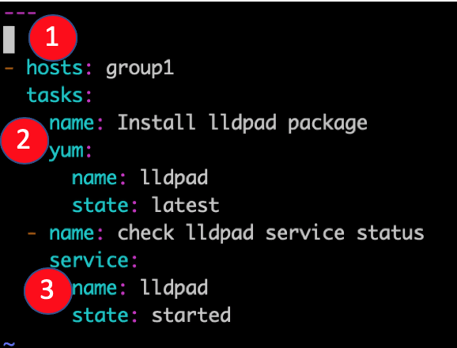

In the above Ansible playbook example, the group1 of hosts in the host’s file is targeted for lldpad package installation using the yum module and afterward the service lldpad created after the installation is then started using the service module used mostly to interact with systemd ensemble.

Explanation:

1. Group of hosts on which the playbook will run
2. Yum module is used in this task for lldpad installation
3. The service module is used to check if the service is up and running after installation

Each ansible playbook works with an inventory file. The inventory file contains a list of servers divided into groups for better control for details like IP Address and SSH port for each host.

The inventory file you can use for this Ansible playbook example looks like below. There are two groups, named group1 and group2 each containing host1 and host2 respectively.

[group1]

host1 ansible_host=192.168.100.2 ansible_ssh_port=22

[group2]

host2 ansible_host=192.168.100.3 ansible_ssh_port=22

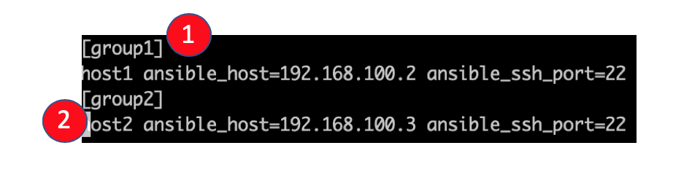

Explanation:

1. Group name
2. Hostname, with IP address and ssh port, in this case, the default one, 22.

### Two plays for two hosts

Another useful Ansible playbook example containing this time two plays for two hosts is the next one. For the first group of hosts, group1, selinux will be enabled. If it is enabled, then a message will appear on the screen of the host.

For the second group of hosts, httpd package will be installed only if the ansible_os_family is RedHat and ansible_system_vendor is HP.

Ansible_os_family and ansible_system_vendor are variables gathered with gather_facts option and can be used like in this conditional example.

---

- hosts: group1

tasks:

- name: Enable SELinux

selinux:

state: enabled

when: ansible_os_family == 'Debian'

register: enable_selinux

- debug:

Imsg: "Selinux Enabled. Please restart the server to apply changes."

when: enable_selinux.changed == true

- hosts: group2

tasks:

- name: Install apache

yum:

name: httpd

state: present

when: ansible_system_vendor == 'HP' and ansible_os_family == 'RedHat'

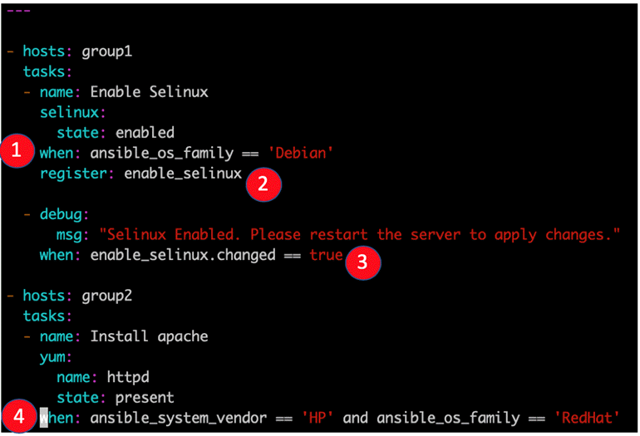

Explanation:

1. Example of the when clause, in this case, when OS type is Debian. The ansible_os_family variable is gathered via gather_facts functionality.
2. The task output is registered for future use, with its name enable_selinux
3. Another example of the when clause. In this case, a message will be displayed for the host user if the SELinux was indeed enabled before.
4. Another example of the when clause consisting of two rules

Besides tasks, there are also some particular tasks called handlers. Handlers must have a unique name throughout the playbook. These work in the same way as a regular task but a handler can be notified via a notifier.

If a handler is not notified during the run of the playbook, it will not run. However, if more than one task notifies a handler, this will run only once after all the tasks are finished.

### Task Calls Upon Another Task

In the example shown below, you can see how a specific task has a notify section which calls upon another task. If the output of the first task is changed, then a handler task will be called. The best example is to have a configuration file changed and afterward restart that specific service.

---

- hosts: group2

tasks:

- name: sshd config file modify port

lineinfile:

path: /etc/ssh/sshd_config

regexp: 'Port 28675'

line: '#Port 22'

notify:

- restart sshd

handlers

- name: restart sshd

service: sshd

name: sshd

state: restarted

In this case, if the first task, “sshd config file modify port” is changed, meaning that if the port is not 28675 in the first place, then it will be modified and the task will notify the handler with the same name to run, and it will restart the sshd service.

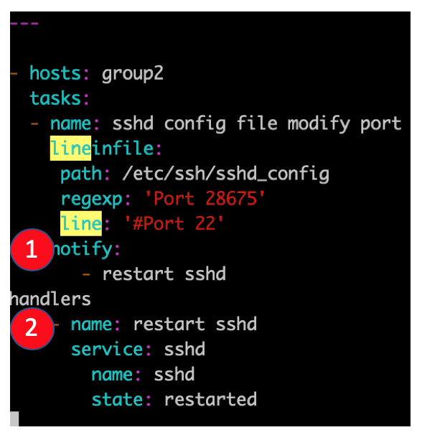

Explanation:

1. Example of a notifier
2. Example of a handler

# Ad-hoc Commands

<https://devopsideas.com/ansible-ad-hoc-commands-usage/>

Ad hoc commands are commands which can be run individually to perform quick functions. These commands need not be performed later.

For example, you have to reboot all your company servers. For this, you will run the Adhoc commands from ‘**/usr/bin/ansible**’.

These ad-hoc commands are not used for configuration management and deployment, because these commands are of one-time usage.

ansible-playbook is used for configuration management and deployment.

One of the simplest ways Ansible can be used is by using ad-hoc commands. These can be used when you want to issue some commands on a server or a bunch of servers. Ad-hoc commands are not stored for future uses but represent a fast way to interact with the desired servers.

## Parallelism and Shell Commands

Reboot your company server in 12 parallel forks at time. For this, we need to set up SSHagent for connection.

$ ssh-agent bash

$ ssh-add ~/.ssh/id_rsa

To run reboot for all your company servers in a group, 'abc', in 12 parallel forks −

$ Ansible abc -a "/sbin/reboot" -f 12

By default, Ansible will run the above Ad-hoc commands form current user account. If you want to change this behavior, you will have to pass the username in Ad-hoc commands as follows −

$ Ansible abc -a "/sbin/reboot" -f 12 -u username

## File Transfer

You can use the Ad-hoc commands for doing **SCP** (Secure Copy Protocol) lots of files in parallel on multiple machines.

## Transferring file to many servers/machines

$ Ansible abc -m copy -a "src = /etc/yum.conf dest = /tmp/yum.conf"

## Creating new directory

$ Ansible abc -m file -a "dest = /path/user1/new mode = 777 owner = user1 group = user1 state = directory"

## Deleting whole directory and files

$ Ansible abc -m file -a "dest = /path/user1/new state = absent"

## Managing Packages

The Ad-hoc commands are available for yum and apt. Following are some Ad-hoc commands using yum.

The following command checks if yum package is installed or not, but does not update it.

$ Ansible abc -m yum -a "name = demo-tomcat-1 state = present"

The following command check the package is not installed.

$ Ansible abc -m yum -a "name = demo-tomcat-1 state = absent"

The following command checks the latest version of package is installed.

$ Ansible abc -m yum -a "name = demo-tomcat-1 state = latest"

## Gathering Facts

Facts can be used for implementing conditional statements in playbook. You can find adhoc information of all your facts through the following Ad-hoc command −

$ Ansible all -m setup

## More Ad-hoc Commands

For this Ansible tutorial, a simple two servers hosts file will be configured, containing host1 and host2.

### Hosts Accessible

You can make sure that the hosts are accessible from the ansible server by issuing a ping command on all hosts.

[root@ansible-server test_ansible]# ansible -i hosts all -m ping

host1 | SUCCESS => {

"changed": false,

"ping": "pong"

}

host2 | SUCCESS => {

"changed": false,

"ping": "pong"

}

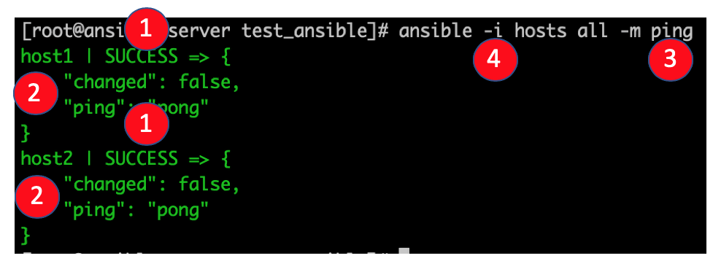

Explanation:

1. Status of the command, in this case, SUCCESS
2. Host on which the command ran
3. The command issued via the -m parameter, in this case, ping
4. With the -i parameter, you can point to the hosts file.

You can issue the same command only on a specific host if needed.

[root@ansible-server test_ansible]# ansible -i hosts all -m ping --limit host2

host2 | SUCCESS => {

"changed": false,

"ping": "pong"

}

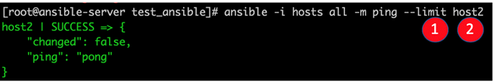

Explanation:

1. Limit parameter can be used to issue commands only on specific hosts in the host’s file
2. Name of the host as defined in the inventory file

### Copy File

If you need to copy a file to multiple destinations rapidly, you can use the copy module in ansible which uses SCP. So the command and its output look like below:

[root@ansible-server test_ansible]# ansible -i hosts all -m copy -a "src=/root/test_ansible/testfile dest=/tmp/testfile"

host1 | SUCCESS => {

"changed": true,

"checksum": "da39a3ee5e6b4b0d3255bfef95601890afd80709",

"dest": "/tmp/testfile",

"gid": 0,

"group": "root",

"md5sum": "d41d8cd98f00b204e9800998ecf8427e",

"mode": "0644",

"owner": "root",

"size": 0,

"src": "/root/.ansible/tmp/ansible-tmp-1562216392.43-256741011164877/source",

"state": "file",

"uid": 0

}

host2 | SUCCESS => {

"changed": true,

"checksum": "da39a3ee5e6b4b0d3255bfef95601890afd80709",

"dest": "/tmp/testfile",

"gid": 0,

"group": "root",

"md5sum": "d41d8cd98f00b204e9800998ecf8427e",

"mode": "0644",

"owner": "root",

"size": 0,

"src": "/root/.ansible/tmp/ansible-tmp-1562216392.6-280302911361278/source",

"state": "file",

"uid": 0

}

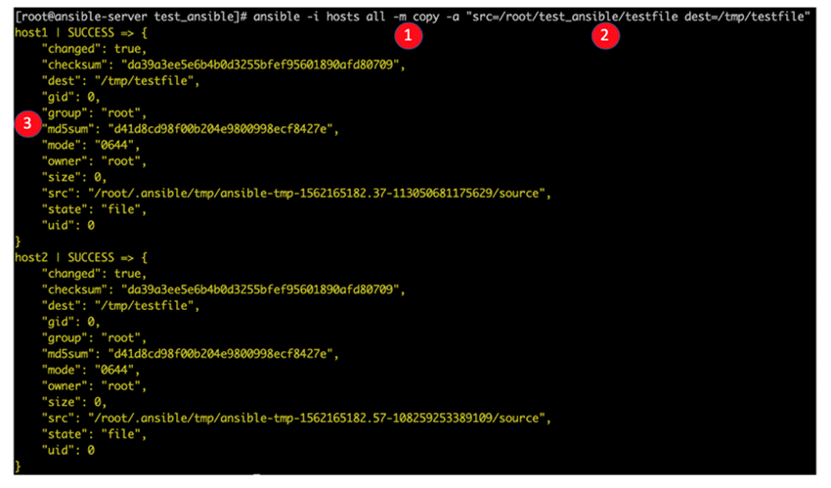

Explanation:

1. Copy module defined
2. Module arguments, in this case, are source absolute path and destination absolute path.
3. Ansible command output reflecting the success of the copy command and other details like the sha1 or md5 checksums for file integrity check and metadata like owner, size, or permissions.It is effortless to have a package installed on a bunch of servers. Ansible has several modules that interact with used installers, like yum, apt, dnf, etc.

### Install a package via the yum module on two Centos hosts

[root@ansible-server test_ansible]# ansible -i hosts all -m yum -a 'name=ncdu state=present'

host1 | SUCCESS => {

"changed": true,

"msg": "",

"rc": 0,

"results": [

"Loaded plugins: fastestmirror\nLoading mirror speeds from cached hostfile\n * base: mirror.netsite.dk\n * elrepo: mirrors.xservers.ro\n * epel: fedora.mirrors.telekom.ro\n * extras: centos.mirrors.telekom.ro\n * remi-php70: remi.schlundtech.de\n * remi-safe: remi.schlundtech.de\n * updates: centos.mirror.iphh.net\nResolving Dependencies\n--> Running transaction check\n---> Package ncdu.x86_64 0:1.14-1.el7 will be installed\n--> Finished Dependency Resolution\n\nDependencies Resolved\n\n================================================================================\n Package Arch Version Repository Size\n================================================================================\nInstalling:\n ncdu x86_64 1.14-1.el7 epel 51 k\n\nTransaction Summary\n================================================================================\nInstall 1 Package\n\nTotal download size: 51 k\nInstalled size: 87 k\nDownloading packages:\nRunning transaction check\nRunning transaction test\nTransaction test succeeded\nRunning transaction\n Installing : ncdu-1.14-1.el7.x86_64 1/1 \n Verifying : ncdu-1.14-1.el7.x86_64 1/1 \n\nInstalled:\n ncdu.x86_64 0:1.14-1.el7 \n\nComplete!\n"

]

}

host2 | SUCCESS => {

"changed": true,

"msg": "",

"rc": 0,

"results": [

"Loaded plugins: fastestmirror\nLoading mirror speeds from cached hostfile\n * base: mirror.netsite.dk\n * elrepo: mirrors.leadhosts.com\n * epel: mirrors.nav.ro\n * extras: centos.mirrors.telekom.ro\n * remi-php70: mirrors.uni-ruse.bg\n * remi-safe: mirrors.uni-ruse.bg\n * updates: centos.mirror.iphh.net\nResolving Dependencies\n--> Running transaction check\n---> Package ncdu.x86_64 0:1.14-1.el7 will be installed\n--> Finished Dependency Resolution\n\nDependencies Resolved\n\n================================================================================\n Package Arch Version Repository Size\n================================================================================\nInstalling:\n ncdu x86_64 1.14-1.el7 epel 51 k\n\nTransaction Summary\n================================================================================\nInstall 1 Package\n\nTotal download size: 51 k\nInstalled size: 87 k\nDownloading packages:\nRunning transaction check\nRunning transaction test\nTransaction test succeeded\nRunning transaction\n Installing : ncdu-1.14-1.el7.x86_64 1/1 \n Verifying : ncdu-1.14-1.el7.x86_64 1/1 \n\nInstalled:\n ncdu.x86_64 0:1.14-1.el7 \n\nComplete!\n"

]

}

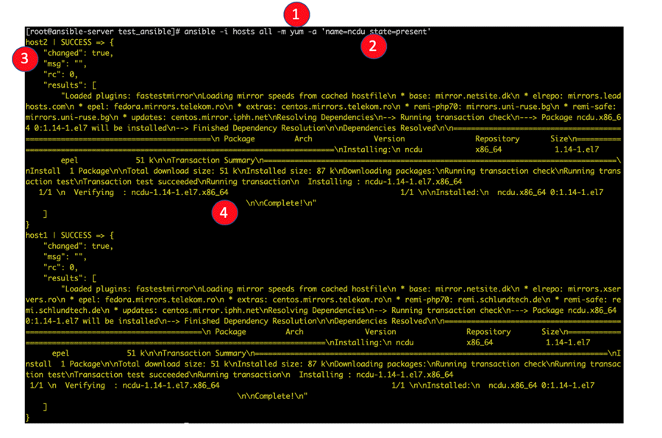

Explanation:

1. Yum module is used in this example
2. It defines the module arguments, and in this case, you will choose the name of the package and its state. If the state is absent, for example, the package will be searched and if found, removed
3. When colored in yellow, you will see the output of the ansible command with the state changed, meaning in this case, that the package was found and installed.
4. Status of the yum install command issued via ansible. In this case the package ncdu.x86_64 0:1.14-1.el7 was installed.

Of course, all of the yum installer options can be used via ansible, including update, install, latest version, or remove.

### Remove the previously installed ncdu package

[root@ansible-server test_ansible]# ansible -i hosts all -m yum -a 'name=ncdu state=absent'

host1 | SUCCESS => {

"changed": true,

"msg": "",

"rc": 0,

"results": [

"Loaded plugins: fastestmirror\nResolving Dependencies\n--> Running transaction check\n---> Package ncdu.x86_64 0:1.14-1.el7 will be erased\n--> Finished Dependency Resolution\n\nDependencies Resolved\n\n================================================================================\n Package Arch Version Repository Size\n================================================================================\nRemoving:\n ncdu x86_64 1.14-1.el7 @epel 87 k\n\nTransaction Summary\n================================================================================\nRemove 1 Package\n\nInstalled size: 87 k\nDownloading packages:\nRunning transaction check\nRunning transaction test\nTransaction test succeeded\nRunning transaction\n Erasing : ncdu-1.14-1.el7.x86_64 1/1 \n Verifying : ncdu-1.14-1.el7.x86_64 1/1 \n\nRemoved:\n ncdu.x86_64 0:1.14-1.el7 \n\nComplete!\n"

]

}

host2 | SUCCESS => {

"changed": true,

"msg": "",

"rc": 0,

"results": [

"Loaded plugins: fastestmirror\nResolving Dependencies\n--> Running transaction check\n---> Package ncdu.x86_64 0:1.14-1.el7 will be erased\n--> Finished Dependency Resolution\n\nDependencies Resolved\n\n================================================================================\n Package Arch Version Repository Size\n================================================================================\nRemoving:\n ncdu x86_64 1.14-1.el7 @epel 87 k\n\nTransaction Summary\n================================================================================\nRemove 1 Package\n\nInstalled size: 87 k\nDownloading packages:\nRunning transaction check\nRunning transaction test\nTransaction test succeeded\nRunning transaction\n Erasing : ncdu-1.14-1.el7.x86_64 1/1 \n Verifying : ncdu-1.14-1.el7.x86_64 1/1 \n\nRemoved:\n ncdu.x86_64 0:1.14-1.el7 \n\nComplete!\n"

]

}

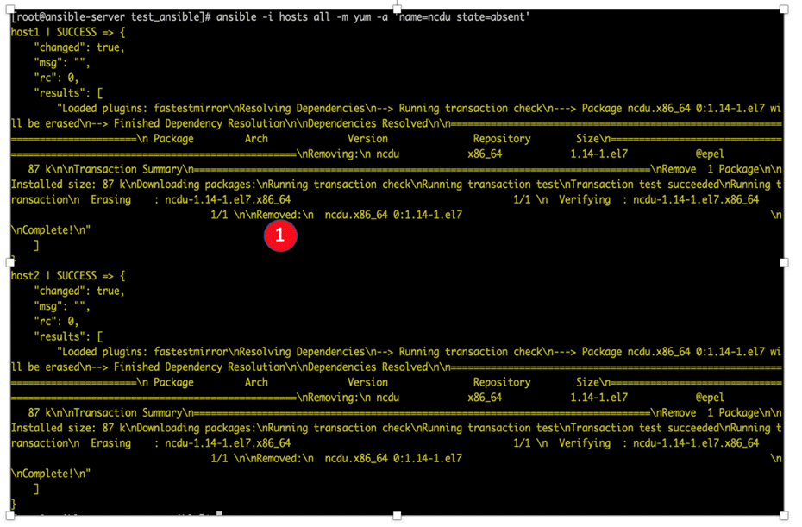

Explanation:

1. The output of the yum command shows that the package was removed.

### Gather some facts about the system

Another useful and essential feature that ansible uses to interact with the client’s server is to gather some facts about the system. So, it fetches hardware, software, and versioning information from the system and stores each value in a variable that can be later on used.

If you need detailed information about the systems to be modified via ansible, the next command can be used. The setup module gathers facts from the system variables.

[root@ansible-server test_ansible]# ansible -i hosts all -m setup

### Dry-run p4.yml playbook

[root@ansible-server test_ansible]# ansible-playbook -i hosts p4.yml --check

### Run p4.yml playbook with password authentication for all hosts

[root@ansible-server test_ansible]# ansible-playbook -i hosts p4.yml -k

# Ansible Roles

Roles provide a framework for fully independent, or interdependent collections of variables, tasks, files, templates, and modules.

In Ansible, the role is the primary mechanism for breaking a playbook into multiple files. This simplifies writing **complex playbooks**, and it makes them easier to reuse. The breaking of playbook allows you to logically break the playbook into reusable components.

Each role is basically limited to a particular functionality or desired output, with all the necessary steps to provide that result either within that role itself or in other roles listed as dependencies.

Roles are not playbooks. Roles are small functionality which can be independently used but have to be used within playbooks. There is no way to directly execute a role. Roles have no explicit setting for which host the role will apply to.

Top-level playbooks are the bridge holding the hosts from your inventory file to roles that should be applied to those hosts.

When dealing with extensive playbooks, it is easier to split the tasks into roles. This also helps in reusing the roles in the future. Roles are a collection of tasks, which can be moved from one playbook to another, can be run independently but only through a playbook file.

Roles are stored in separate directories and have a particular directory structure.

[root@ansible-server test2]# tree

.

`-- role1

|-- defaults

| `-- main.yml

|-- handlers

| `-- main.yml

|-- meta

| `-- main.yml

|-- README.md

|-- tasks

| `-- main.yml

|-- tests

| |-- inventory

| `-- test.yml

`-- vars

`-- main.yml

7 directories, 8 files

The yaml file in the defaults directory contains a list of default variables that are to be used along with the playbook. The handlers directory is used to store handlers. The meta-directory is supposed to have information about the author and role dependencies. In the tasks directory, there is the main yaml file for the role.

The tests directory contains a sample yaml playbook file and a sample inventory file and is mostly used for testing purposes before creating the actual role.

The vars directory contains the yaml file in which all the variables used by the role will be defined. The directory templates and the directory files should contain files and templates that will be used by the tasks in the role.

## Creating a New Role

The directory structure for roles is essential to create a new role.

### Role Structure

Roles have a structured layout on the file system. The default structure can be changed but for now let us stick to defaults (*given above*).

Each role is a directory tree in itself. The role name is the directory name within the /roles directory.

$ ansible-galaxy -h

### Usage

ansible-galaxy [delete|import|info|init|install|list|login|remove|search|setup] [--help] [options] ...

### Options

* **-h, --help** − Show this help message and exit.
* **-v, --verbose** − Verbose mode (-vvv for more, -vvvv to enable connection debugging)
* **--version** − Show program's version number and exit.

## Creating a Role Directory

To create the directory tree for a role, you should use the following command with the last parameter, the role name:

[root@ansible-server test2]# ansible-galaxy init <role-dir-name>

Let’s take an example:

$ ansible-galaxy init ajsrole

ERROR! The API server (https://galaxy.ansible.com/api/) is not responding, please try again later.

$ ansible-galaxy init --force --offline ajsrole

- ajsrole was created successfully

$ tree ajsrole/

ajsrole/

├── defaults

│ └── main.yml

├── files

├── handlers

│ └── main.yml

├── meta

│ └── main.yml

├── README.md

├── tasks

│ └── main.yml

├── templates

├── tests

│ ├── inventory

│ └── test.yml

└── vars

└── main.yml

8 directories, 8 files

Not all the directories will be used in the example and we will show the use of some of them in the example.

## Utilizing Roles in Playbook

This is the code of the playbook we have written for demo purpose. This code is of the playbook ajs_orchestrate.yml. We have defined the hosts: **tomcat-node** and called the two roles – **install-tomcat** and **start-tomcat**.

The problem statement is that we have a war which we need to deploy on a machine via Ansible.

---

- hosts: tomcat-node

roles:

- {role: install-tomcat}

- {role: start-tomcat}

Contents of our directory structure from where we are running the playbook.

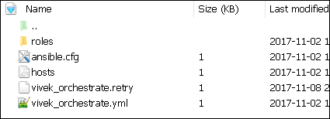

$ ls

ansible.cfg hosts roles ajs_orchestrate.retry ajs_orchestrate.yml

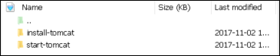

There is a tasks directory under each directory and it contains a main.yml. The main.yml contents of install-tomcat are −

---

#Install ajs artifacts

-

block:

- name: Install Tomcat artifacts

action: >

yum name = "demo-tomcat-1" state = present

register: Output

always:

- debug:

msg:

- "Install Tomcat artifacts task ended with message: {{Output}}"

- "Installed Tomcat artifacts - {{Output.changed}}"

The contents of main.yml of the start tomcat are −

#Start Tomcat

-

block:

- name: Start Tomcat

command: <path of tomcat>/bin/startup.sh"

register: output

become: true

always:

- debug:

msg:

- "Start Tomcat task ended with message: {{output}}"

- "Tomcat started - {{output.changed}}"

The advantage of breaking the playbook into roles is that anyone who wants to use the Install tomcat feature can call the Install Tomcat role.

## Breaking a Playbook into a Role

If not for the roles, the content of the main.yml of the respective role can be copied in the playbook **yml** file. But to have modularity, roles were created.

Any logical entity which can be reused as a reusable function, that entity can be moved to role. The example for this is shown above

Run the command to run the playbook.

-vvv option for verbose output – verbose output

$ cd ajs-playbook/

This is the command to run the playbook

$ sudo ansible-playbook -i hosts ajs_orchestrate.yml –vvv

-----------------------------------------------------------------

### Output

The generated output is as seen on the screen −

Using **/users/demo/ajs-playbook/ansible.cfg** as config file.

PLAYBOOK: ajs_orchestrate.yml *********************************************************

***********************************************************

1 plays in ajs_orchestrate.yml

PLAY [tomcat-node] **********************************************************************

******** *************************************************

TASK [Gathering Facts] *************************************************

****************************** *********************************************

Tuesday 21 November 2017 13:02:05 +0530 (0:00:00.056) 0:00:00.056 ******

Using module file /usr/lib/python2.7/sitepackages/ansible/modules/system/setup.py

<localhost> ESTABLISH LOCAL CONNECTION FOR USER: root

<localhost> EXEC /bin/sh -c 'echo ~ && sleep 0'

<localhost> EXEC /bin/sh -c '( umask 77 && mkdir -p "` echo

/root/.ansible/tmp/ansible-tmp-1511249525.88-259535494116870 `" &&

echo ansible-tmp-1511249525.88-259535494116870="`

echo /root/.ansible/tmp/ansibletmp-1511249525.88-259535494116870 `" ) && sleep 0'

<localhost> PUT /tmp/tmpPEPrkd TO

/root/.ansible/tmp/ansible-tmp-1511249525.88259535494116870/setup.py

<localhost> EXEC /bin/sh -c 'chmod u+x

/root/.ansible/tmp/ansible-tmp1511249525.88-259535494116870/

/root/.ansible/tmp/ansible-tmp-1511249525.88259535494116870/setup.py && sleep 0'

<localhost> EXEC /bin/sh -c '/usr/bin/python

/root/.ansible/tmp/ansible-tmp1511249525.88-259535494116870/setup.py; rm -rf

"/root/.ansible/tmp/ansible-tmp1511249525.88-259535494116870/" > /dev/null 2>&1 && sleep 0'

ok: [server1]

META: ran handlers

TASK [install-tomcat : Install Tomcat artifacts] ***********************************

***************************************************************

task path: /users/demo/ ajs-playbook/roles/install-tomcat/tasks/main.yml:5

Tuesday 21 November 2017 13:02:07 +0530 (0:00:01.515) 0:00:01.572 ******

Using module file /usr/lib/python2.7/sitepackages/ansible/modules/packaging/os/yum.py

<localhost> ESTABLISH LOCAL CONNECTION FOR USER: root

<localhost> EXEC /bin/sh -c 'echo ~ && sleep 0'

<localhost> EXEC /bin/sh -c '( umask 77 && mkdir -p "` echo

/root/.ansible/tmp/ansible-tmp-1511249527.34-40247177825302 `" && echo

ansibletmp-1511249527.34-40247177825302="` echo

/root/.ansible/tmp/ansible-tmp1511249527.34-40247177825302 `" ) && sleep 0'

<localhost> PUT /tmp/tmpu83chg TO

/root/.ansible/tmp/ansible-tmp-1511249527.3440247177825302/yum.py

<localhost> EXEC /bin/sh -c 'chmod u+x

/root/.ansible/tmp/ansible-tmp1511249527.34-40247177825302/

/root/.ansible/tmp/ansible-tmp-1511249527.3440247177825302/yum.py && sleep 0'

<localhost> EXEC /bin/sh -c '/usr/bin/python

/root/.ansible/tmp/ansible-tmp1511249527.34-40247177825302/yum.py; rm -rf

"/root/.ansible/tmp/ansible-tmp1511249527.34-40247177825302/" > /dev/null 2>

&1 && sleep 0'

changed: [server1] => {

"changed": true,

"invocation": {

"module_args": {

"conf_file": null,

"disable_gpg_check": false,

"disablerepo": null,

"enablerepo": null,

"exclude": null,

"install_repoquery": true,

"installroot": "/",

"list": null,

"name": ["demo-tomcat-1"],

"skip_broken": false,

"state": "present",

"update_cache": false,

"validate_certs": true

}

},

"msg": "",

"rc": 0,

"results": [

"Loaded plugins: product-id,

search-disabled-repos,

subscriptionmanager\nThis system is not registered to Red Hat Subscription Management.

You can use subscription-manager to register.\nResolving Dependencies\n-->

Running transaction check\n--->

Package demo-tomcat-1.noarch 0:SNAPSHOT-1 will be installed\n--> Finished Dependency

Resolution\n\nDependencies Resolved\n

\n================================================================================\n

Package Arch Version Repository

Size\n==================================================================\nInstalling:\n

demo-tomcat-1 noarch SNAPSHOT-1 demo-repo1 7.1 M\n\nTransaction

Summary\n==================================================================\nInstall 1

Package\n\nTotal download size: 7.1 M\nInstalled size: 7.9 M\nDownloading

packages:\nRunning transaction

check\nRunning transaction test\nTransaction test succeeded\nRunning transaction\n Installing :

demotomcat-1-SNAPSHOT-1.noarch 1/1 \n Verifying :

demo-tomcat-1-SNAPSHOT-1.noarch 1/1 \n\nInstalled:\n

demo-tomcat-1.noarch 0:SNAPSHOT-1 \n\nComplete!\n"

]

}

TASK [install-tomcat : debug] **********************************************************

***************************************************************************

task path: /users/demo/ ajs-playbook/roles/install-tomcat/tasks/main.yml:11

Tuesday 21 November 2017 13:02:13 +0530 (0:00:06.757) 0:00:08.329 ******

ok: [server1] => {

"changed": false,

"msg": [

"Install Tomcat artifacts task ended with message: {

u'msg': u'', u'changed': True, u'results':

[u'Loaded plugins: product-id,

search-disabledrepos,

subscription-manager\\nThis system is not registered to Red Hat Subscription Management.

You can use subscription-manager to register.\\nResolving Dependencies\\n-->

Running transaction check\\n--->

Package demo-tomcat-1.noarch 0:SNAPSHOT-1 will be installed\\n-->

Finished Dependency Resolution\\n

\\nDependencies

Resolved\\n\\n==================================================================\\n

Package Arch Version Repository

Size\\n========================================================================

=====\\nInstalling:\\n demo-tomcat-1 noarch SNAPSHOT-1 demo-repo1 7.1 M\\n\\nTransaction

Summary\\n=========================================================\\nInstall 1

Package\\n\\nTotal download size: 7.1 M\\nInstalled size: 7.9 M\\nDownloading

packages:\\nRunning

transaction check\\nRunning transaction test\\nTransaction test succeeded\\nRunning

transaction\\n

Installing : demo-tomcat-1-SNAPSHOT-1.noarch 1/1 \\n Verifying :

demo-tomcat-1-SNAPSHOT-1.noarch

1/1 \\n\\nInstalled:\\n demo-tomcat-1.noarch 0:SNAPSHOT-1 \\n\\nComplete!\\n'], u'rc': 0

}",

"Installed Tomcat artifacts - True"

]

}

TASK [install-tomcat : Clean DEMO environment] ****************************************

************************************************************

task path: /users/demo/ ajs-playbook/roles/install-tomcat/tasks/main.yml:19

Tuesday 21 November 2017 13:02:13 +0530 (0:00:00.057) 0:00:08.387 ******

[WARNING]: when statements should not include jinja2 templating delimiters such as {{ }} or

{% %}. Found: {{installationOutput.changed}}

Using module file /usr/lib/python2.7/sitepackages/ansible/modules/files/file.py

<localhost> ESTABLISH LOCAL CONNECTION FOR USER: root

<localhost> EXEC /bin/sh -c 'echo ~ && sleep 0'

<localhost> EXEC /bin/sh -c '( umask 77 && mkdir -p "` echo

/root/.ansible/tmp/ansible-tmp-1511249534.13-128345805983963 `" && echo

ansible-tmp-1511249534.13-128345805983963="` echo

/root/.ansible/tmp/ansibletmp-1511249534.13-128345805983963 `" ) && sleep 0'

<localhost> PUT /tmp/tmp0aXel7 TO

/root/.ansible/tmp/ansible-tmp-1511249534.13128345805983963/file.py

<localhost> EXEC /bin/sh -c 'chmod u+x

/root/.ansible/tmp/ansible-tmp1511249534.13-128345805983963/

/root/.ansible/tmp/ansible-tmp-1511249534.13128345805983963/file.py && sleep 0'

<localhost> EXEC /bin/sh -c '/usr/bin/python

/root/.ansible/tmp/ansible-tmp1511249534.13-128345805983963/file.py; rm -rf

"/root/.ansible/tmp/ansible-tmp1511249534.13-128345805983963/" > /dev/null 2>&1

&& sleep 0'

changed: [server1] => {

"changed": true,

"diff": {

"after": {

"path": "/users/demo/DEMO",

"state": "absent"

},

"before": {

"path": "/users/demo/DEMO",

"state": "directory"

}

},

"invocation": {

"module_args": {

"attributes": null,

"backup": null,

"content": null,

"delimiter": null,

"diff_peek": null,

"directory_mode": null,

"follow": false,

"force": false,

"group": null,

"mode": null,

"original_basename": null,

"owner": null,

"path": "/users/demo/DEMO",

"recurse": false,

"regexp": null,

"remote_src": null,

"selevel": null,

"serole": null,

"setype": null,

"seuser": null,

"src": null,

"state": "absent",

"unsafe_writes": null,

"validate": null

}

},

"path": "/users/demo/DEMO",

"state": "absent"

}

TASK [install-tomcat : debug] ********************************************************

*************************************************************

task path: /users/demo/ ajs-playbook/roles/install-tomcat/tasks/main.yml:29

Tuesday 21 November 2017 13:02:14 +0530 (0:00:00.257) 0:00:08.645 ******

ok: [server1] => {

"changed": false,

"msg": [

"Clean DEMO environment task ended with message:{u'diff': {u'after': {u'path':

u'/users/demo/DEMO', u'state': u'absent'},

u'before': {u'path': u'/users/demo/DEMO', u'state': u'directory'}}, u'state': u'absent',

u'changed': True, u'path': u'/users/demo/DEMO'}",

"check value :True"

]

}

TASK [install-tomcat : Copy Tomcat to user home] *************************************

********************************************************

task path: /users/demo/ ajs-playbook/roles/install-tomcat/tasks/main.yml:37

Tuesday 21 November 2017 13:02:14 +0530 (0:00:00.055) 0:00:08.701 ******

[WARNING]: when statements should not include jinja2 templating delimiters such as {{ }} or

{% %}. Found: {{installationOutput.changed}}

Using module file /usr/lib/python2.7/sitepackages/ansible/modules/commands/command.py

<localhost> ESTABLISH LOCAL CONNECTION FOR USER: root

<localhost> EXEC /bin/sh -c 'echo ~ && sleep 0'

<localhost> EXEC /bin/sh -c '( umask 77 && mkdir -p "` echo

/root/.ansible/tmp/ansible-tmp-1511249534.43-41077200718443 `" && echo

ansibletmp-1511249534.43-41077200718443="` echo

/root/.ansible/tmp/ansible-tmp1511249534.43-41077200718443 `" ) && sleep 0'

<localhost> PUT /tmp/tmp25deWs TO

/root/.ansible/tmp/ansible-tmp-1511249534.4341077200718443/command.py

<localhost> EXEC /bin/sh -c 'chmod u+x

/root/.ansible/tmp/ansible-tmp1511249534.43-41077200718443/

/root/.ansible/tmp/ansible-tmp-1511249534.4341077200718443/command.py && sleep 0'

<localhost> EXEC /bin/sh -c '/usr/bin/python

/root/.ansible/tmp/ansible-tmp1511249534.43-41077200718443/command.py; rm -rf

"/root/.ansible/tmp/ansibletmp-1511249534.43-41077200718443/" > /dev/null 2>&1

&& sleep 0'

changed: [server1] => {

"changed": true,

"cmd": [

"cp",

"-r",

"/opt/ansible/tomcat/demo",

"/users/demo/DEMO/"

],

"delta": "0:00:00.017923",

"end": "2017-11-21 13:02:14.547633",

"invocation": {

"module_args": {

"_raw_params": "cp -r /opt/ansible/tomcat/demo /users/demo/DEMO/",

"_uses_shell": false,

"chdir": null,

"creates": null,

"executable": null,

"removes": null,

"warn": true

}

},

"rc": 0,

"start": "2017-11-21 13:02:14.529710",

"stderr": "",

"stderr_lines": [],

"stdout": "",

"stdout_lines": []

}

TASK [install-tomcat : debug] ********************************************************

**********************************************************

task path: /users/demo/ ajs-playbook/roles/install-tomcat/tasks/main.yml:47

Tuesday 21 November 2017 13:02:14 +0530 (0:00:00.260) 0:00:08.961 ******

ok: [server1] => {

"changed": false,

"msg": "Copy Tomcat to user home task ended with message {

'stderr_lines': [], u'changed': True, u'end': u'2017-11-21 13:02:14.547633', u'stdout':

u'', u'cmd': [u'cp', u'-r', u'/opt/ansible/tomcat/demo', u'/users/demo/DEMO/'], u'rc': 0,

u'start': u'2017-11-21 13:02:14.529710', u'stderr': u'', u'delta': u'0:00:00.017923',

'stdout_lines': []}"

}

TASK [start-tomcat : Start Tomcat] **************************************************

**********************************************************

task path: /users/demo/ ajs-playbook/roles/start-tomcat/tasks/main.yml:5

Tuesday 21 November 2017 13:02:14 +0530 (0:00:00.044) 0:00:09.006 ******

Using module file /usr/lib/python2.7/sitepackages/ansible/modules/commands/command.py

<localhost> ESTABLISH LOCAL CONNECTION FOR USER: root

<localhost> EXEC /bin/sh -c 'echo ~ && sleep 0'

<localhost> EXEC /bin/sh -c '( umask 77 && mkdir -p "` echo

/root/.ansible/tmp/ansible-tmp-1511249534.63-46501211251197 `" && echo

ansibletmp-1511249534.63-46501211251197="` echo

/root/.ansible/tmp/ansible-tmp1511249534.63-46501211251197 `" ) && sleep 0'

<localhost> PUT /tmp/tmp9f06MQ TO

/root/.ansible/tmp/ansible-tmp-1511249534.6346501211251197/command.py

<localhost> EXEC /bin/sh -c 'chmod u+x

/root/.ansible/tmp/ansible-tmp1511249534.63-46501211251197/

/root/.ansible/tmp/ansible-tmp-1511249534.6346501211251197/command.py && sleep 0'

<localhost> EXEC /bin/sh -c '/usr/bin/python

/root/.ansible/tmp/ansible-tmp1511249534.63-46501211251197/command.py; rm -rf

"/root/.ansible/tmp/ansibletmp-1511249534.63-46501211251197/" > /dev/null 2>&1

&& sleep 0'

changed: [server1] => {

"changed": true,

"cmd": [ "/users/demo/DEMO/bin/startup.sh" ],

"delta": "0:00:00.020024",

"end": "2017-11-21 13:02:14.741649",

"invocation": {

"module_args": {

"_raw_params": "/users/demo/DEMO/bin/startup.sh",

"_uses_shell": false,

"chdir": null,

"creates": null,

"executable": null,

"removes": null,

"warn": true

}

},

"rc": 0,

"start": "2017-11-21 13:02:14.721625",

"stderr": "",

"stderr_lines": [],

"stdout": "Tomcat started.",

"stdout_lines": [ "Tomcat started." ]

}

TASK [start-tomcat : debug] *************************************************

**********************************************************************

task path: /users/demo/ ajs-playbook/roles/start-tomcat/tasks/main.yml:10

Tuesday 21 November 2017 13:02:14 +0530 (0:00:00.150) 0:00:09.156 ******

ok: [server1] => {

"changed": false,

"msg": [

"Start Tomcat task ended with message: {'

stderr_lines': [], u'changed': True, u'end': u'2017-11-21 13:02:14.741649', u'stdout':

u'Tomcat started.', u'cmd': [u'/users/demo/DEMO/bin/startup.sh'], u'rc': 0, u'start':

u'2017-11-21 13:02:14.721625', u'stderr': u'', u'delta': u'0:00:00.020024',

'stdout_lines': [u'Tomcat started.']}",

"Tomcat started - True"

]

}

META: ran handlers

META: ran handlers

PLAY RECAP *******************************************************************************

*********************************************************

server1 : ok = 9 changed = 4 unreachable = 0 failed = 0

Tuesday 21 November 2017 13:02:14 +0530 (0:00:00.042) 0:00:09.198 ******

===============================================================================

install-tomcat : Install Tomcat artifacts ------------------------------- 6.76s

/users/demo/ajs-playbook/roles/install-tomcat/tasks/main.yml:5 --------------

Gathering Facts --------------------------------------------------------- 1.52s

------------------------------------------------------------------------------

install-tomcat : Copy Tomcat to user home ------------------------------- 0.26s

/users/demo/ajs-playbook/roles/install-tomcat/tasks/main.yml:37 -------------

install-tomcat : Clean DEMO environment --------------------------------- 0.26s

/users/demo/ajs-playbook/roles/install-tomcat/tasks/main.yml:19 -------------

start-tomcat : Start Tomcat --------------------------------------------- 0.15s

/users/demo/ajs-playbook/roles/start-tomcat/tasks/main.yml:5 ----------------

install-tomcat : debug -------------------------------------------------- 0.06s

/users/demo/ajs-playbook/roles/install-tomcat/tasks/main.yml:11 -------------

install-tomcat : debug -------------------------------------------------- 0.06s

/users/demo/ajs-playbook/roles/install-tomcat/tasks/main.yml:29 -------------

install-tomcat : debug -------------------------------------------------- 0.04s

/users/demo/ajs-playbook/roles/install-tomcat/tasks/main.yml:47 -------------

start-tomcat : debug ---------------------------------------------------- 0.04s

/users/demo/ajs-playbook/roles/start-tomcat/tasks/main.yml:10 ---------------

Hit the following URL and you will be directed to a page as shown below − **http://10.76.0.134:11677/HelloWorld/HelloWorld**

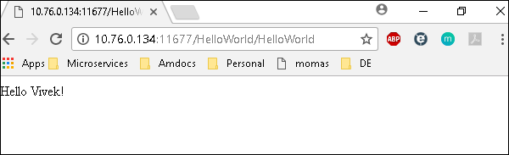

The deployed war just has a servlet which displays “Hello World”. The detailed output shows the time taken by each and every task because of the entry added in ansible.cfg file −

[defaults]

callback_whitelist = profile_tasks

# Ansible Variables

Variables in playbooks are **very similar** to using variables in any programming language. It helps you to use and assign a value to a variable and use that anywhere in the playbook. One can put conditions around the value of the variables and accordingly use them in the playbook.

**Example**

- hosts : <your hosts>

vars:

tomcat_port : 8080

In the above example, we have defined a variable name **tomcat_port** and assigned the value 8080 to that variable and can use that in your playbook wherever needed.

Now taking a reference from the example shared. The following code is from one of the roles (install-tomcat):

block:

- name: Install Tomcat artifacts

action: >

yum name = "demo-tomcat-1" state = present

register: Output

always:

- debug:

msg:

- "Install Tomcat artifacts task ended with message: {{Output}}"

- "Installed Tomcat artifacts - {{Output.changed}}"

Here, the output is the variable used.

Let us walk through all the keywords used in the above code −

* **block** − Ansible syntax to execute a given block.
* **name** − Relevant name of the block - this is used in logging and helps in debugging that which all blocks were successfully executed.
* **action** − The code next to action tag is the task to be executed. The action again is a Ansible keyword used in yaml.
* **register** − The output of the action is registered using the register keyword and Output is the variable name which holds the action output.
* **always** − Again a Ansible keyword , it states that below will always be executed.
* **msg** − Displays the message.

## Usage of variable - {{Output}}

This will read the value of variable Output. Also as it is used in the msg tab, it will print the value of the output variable.

Additionally, you can use the sub properties of the variable as well. Like in the case checking {{Output.changed}} whether the output got changed and accordingly use it.

## Exception Handling in Playbooks

Exception handling in Ansible is similar to exception handling in any programming language. An example of the exception handling in playbook is shown below.

tasks:

- name: Name of the task to be executed

block:

- debug: msg = 'Just a debug message , relevant for logging'

- command: <the command to execute>

rescue:

- debug: msg = 'There was an exception.. '

- command: <Rescue mechanism for the above exception occurred)

always:

- debug: msg = "this will execute in all scenarios. Always will get logged"

Following is the syntax for exception handling.

* **rescue** and **always** are the keywords specific to exception handling.
* Block is where the code is written (anything to be executed on the Unix machine).
* If the command written inside the block feature fails, then the execution reaches rescue block and it gets executed. In case there is no error in the command under block feature, then rescue will not be executed.
* **Always** gets executed in all cases.
* So, if we compare the same with java, then it is similar to try, catch and finally block.
* Here, **Block** is similar to **try block** where you write the code to be executed and **rescue** is similar to **catch block** and **always** is similar to **finally**.

## Loops

Below is the example to demonstrate the usage of Loops in Ansible.

The tasks is to copy the set of all the war files from one directory to tomcat webapps folder.

Most of the commands used in the example below are already covered before. Here, we will concentrate on the usage of loops.

Initially in the 'shell' command we have done ls *.war. So, it will list all the war files in the directory.

Output of that command is taken in a variable named output.

To loop, the 'with_items' syntax is being used.

with_items: "{{output.stdout_lines}}" --> output.stdout_lines gives us the line by line output and then we loop on the output with the with_items command of Ansible.

Attaching the example output just to make one understand how we used the stdout_lines in the with_items command.

---

#Tsting

- hosts: tomcat-node

tasks:

- name: Install Apache

shell: "ls *.war"

register: output

args:

chdir: /opt/ansible/tomcat/demo/webapps

- file:

src: '/opt/ansible/tomcat/demo/webapps/{{ item }}'

dest: '/users/demo/ajay/{{ item }}'

state: link

with_items: "{{output.stdout_lines}}"



## Blocks

The playbook in totality is broken into blocks. The smallest piece of steps to execute is written in block. Writing the specific instruction in blocks helps to segregate functionality and handle it with exception handling if needed. Example of blocks is covered in variable usage, exception handling and loops above.

## Conditionals

Conditionals are used where one needs to run a specific step based on a condition.

---

#Tsting

- hosts: all

vars:

test1: "Hello Ajay"

tasks:

- name: Testing Ansible variable

debug:

msg: "Equals"

when: test1 == "Hello Ajay"

In this case, Equals will be printed as the test1 variable is equal as mentioned in the when condition. “**when”** can be used with a logical OR and logical AND condition as in all the programming languages.



Just change the value of test1 variable from Hello Ajay to say Hello World and see the output.



# Ansible Facts

<https://docs.ansible.com/ansible/latest/playbook_guide/playbooks_vars_facts.html>

<https://www.middlewareinventory.com/blog/ansible-facts-list-how-to-use-ansible-facts/>

# Ansible Modules

<https://docs.ansible.com/ansible/latest/dev_guide/developing_modules_general.html#developing-modules-general>

<https://docs.ansible.com/ansible/latest/dev_guide/developing_modules.html#developing-modules>

<https://opensource.com/article/19/9/must-know-ansible-modules>

<https://www.whizlabs.com/blog/ansible-modules/>

# Ansible - Advanced Execution

## How to Limit Execution by Tasks

This is a very important execution strategy where one needs to execute only one execution and not the entire playbook. **For example**, suppose you only want to stop a server (in case a production issue comes) and then post applying a patch you would like to only start the server.

Here in original playbook stop and start were a part of different roles in the same playbook but this can be handled with the usage of tags. We can provide different tags to different roles (which in turn will have tasks) and hence based on the tags provided by the executor only that specified role/task gets executed. So for the above example provided, we can add tags like the following −

- {role: start-tomcat, tags: ['install']}}

The following command helps in using tags −

ansible-playbook -i hosts <your yaml> --tags "install" -vvv

With the above command, only the start-tomcat role will be called. The tag provided is case-sensitive. Ensure exact match is being passed to the command.

## How to Limit Execution by Hosts

There are two ways to achieve the execution of specific steps on specific hosts. For a specific role, one defines the hosts - as to which specific hosts that specific role should be run.

**Example**

- hosts: <A>

environment: "{{your env}}"

pre_tasks:

- debug: msg = "Started deployment.

Current time is {{ansible_date_time.date}} {{ansible_date_time.time}} "

roles:

- {role: <your role>, tags: ['<respective tag>']}

post_tasks:

- debug: msg = "Completed deployment.

Current time is {{ansible_date_time.date}} {{ansible_date_time.time}}"

- hosts: <B>

pre_tasks:

- debug: msg = "started....

Current time is {{ansible_date_time.date}} {{ansible_date_time.time}} "

roles:

- {role: <your role>, tags: ['<respective tag>']}

post_tasks:

- debug: msg = "Completed the task..

Current time is {{ansible_date_time.date}} {{ansible_date_time.time}}"

As per the above example, depending on the hosts provided, the respective roles will only be called. Now my hosts A and B are defined in the hosts (inventory file).

### Alternate Solution

A different solution might be defining the playbook's hosts using a variable, then passing in a specific host address via **--extra-vars** −

# file: user.yml (playbook)

---

- hosts: '{{ target }}'

user: ...

playbook contd….

### Running the Playbook

ansible-playbook user.yml --extra-vars "target = "<your host variable>"

If {{ target }} isn't defined, the playbook does nothing. A group from the hosts file can also be passed through if need be. This does not harm if the extra vars is not provided.

### Playbook targeting a single host

$ ansible-playbook user.yml --extra-vars "target = <your hosts variable>" --listhosts

# Ansible Troubleshooting

## Debug and Register

These two are the modules available in Ansible. For debugging purpose, we need to use the two modules judiciously. Examples are demonstrated below.

## Use Verbosity

With the Ansible command, one can provide the verbosity level. You can run the commands with verbosity level one (-v) or two (-vv).

## Important Points

In this section, we will go through a few examples to understand a few concepts.

If you are not quoting an argument that starts with a variable. For example,

vars:

age_path: {{vivek.name}}/demo/

{{vivek.name}}

This will throw an error.

### Solution

vars:

age_path: "{{vivek.name}}/demo/" – marked in yellow is the fix.

How to use register -> Copy this code into a yml file say test.yml and run it

---

#Tsting

- hosts: tomcat-node

tasks:

- shell: /usr/bin/uptime

register: myvar

- name: Just debugging usage

debug: var = myvar

When I run this code via the command Ansible-playbook -i hosts test.yml, I get the output as shown below.

If you see the yaml , we have registered the output of a command into a variable – **myvar** and just printed the output.

The text marked yellow, tells us about property of the variable –myvar that can be used for further flow control. This way we can find out about the properties that are exposed of a particular variable. The following debug command helps in this.

$ ansible-playbook -i hosts test.yml

PLAY [tomcat-node] ***************************************************************

**************** ****************************************************************

*************** ******************************

TASK [Gathering Facts] *****************************************************************

************** *****************************************************************

************** **************************

Monday 05 February 2018 17:33:14 +0530 (0:00:00.051) 0:00:00.051 *******

ok: [server1]

TASK [command] ******************************************************************

************* ******************************************************************

************* **********************************

Monday 05 February 2018 17:33:16 +0530 (0:00:01.697) 0:00:01.748 *******

changed: [server1]

TASK [Just debugging usage] ******************************************************************

************* ******************************************************************

************* *********************

Monday 05 February 2018 17:33:16 +0530 (0:00:00.226) 0:00:01.974 *******

ok: [server1] => {

"myvar": {

"changed": true,

"cmd": "/usr/bin/uptime",

"delta": "0:00:00.011306",

"end": "2018-02-05 17:33:16.424647",

"rc": 0,

"start": "2018-02-05 17:33:16.413341",

"stderr": "",

"stderr_lines": [],

"stdout": " 17:33:16 up 7 days, 35 min, 1 user, load average: 0.18, 0.15, 0.14",

"stdout_lines": [

" 17:33:16 up 7 days, 35 min, 1 user, load average: 0.18, 0.15, 0.14"

]

}

}

PLAY RECAP ****************************************************************************

**********************************************************************************

**************************************

server1 : ok = 3 changed = 1 unreachable = 0 failed = 0

## Common Playbook Issues

In this section, we will learn about the a few common playbook issues. The issues are −

* Quoting
* Indentation

Playbook is written in yaml format and the above two are the most common issues in yaml/playbook.

Yaml does not support tab based indentation and supports space based indentation, so one needs to be careful about the same.

**Note** − once you are done with writing the yaml , open this site (<https://editor.swagger.io/>) and copy paste your yaml on the left hand side to ensure that the yaml compiles properly. This is just a tip.

# Hands-on Lab

Ansible works against multiple managed nodes or “hosts” in your infrastructure at the same time, using a list or group of lists known as inventory. For our first challenge, we are going to create an inventory to be used in the following challenges.

The inventory tells what nodes are out there to be used by Ansible, what credentials need to be used to connect to them, how the nodes are grouped, and other necessary variables.

An example inventory:

[all:vars]

ansible_user=rhel

ansible_password=SomethingSomething

ansible_port=22

[web]

websrv1

websrv2

[db]

db_1 ansible_host=11.22.33.44

db_2 ansible_host=44.55.66.77

Playbooks are files which describe the desired configurations or steps to implement on managed hosts. Playbooks can change lengthy, complex administrative tasks into easily repeatable routines with predictable and successful outcomes.

A playbook can have multiple plays and a play can have one or multiple tasks. In a task a module is called, like the modules in the previous chapter. The goal of a play is to map a group of hosts. The goal of a task is to implement modules against those hosts.

Playbooks are text files written in YAML format and therefore need:

* to start with three dashes (---)
* proper indentation using spaces and not tabs!

There are some important concepts:

* hosts: the managed hosts to perform the tasks on
* tasks: the operations to be performed by invoking Ansible modules and passing them the necessary options.
* become: privilege escalation in Playbooks, same as using -b in the ad hoc command.

Good Playbooks are idempotent, so if a Playbook is run once to put the hosts in the correct state, it should be safe to run it a second time and it should make no further changes to the hosts.

In this challenge you create a playbook to set up an Apache web server in three steps:

1. Install httpd package
2. Enable/start httpd service
3. Copy over an web.html file to each web host

The Playbook makes sure the package containing the Apache web server is installed.

There is a best practice on the preferred directory structures for playbooks. We strongly encourage you to read and understand these practices as you develop your Ansible ninja skills. That said, our playbook today is very basic and creating a complex structure will just confuse things.

Instead, we are going to use the simple directory structure for our playbook and add just a couple of files to it.

## Create an inventory

Ansible works against multiple managed nodes or “hosts” in your infrastructure at the same time, using a list or group of lists known as inventory. For our first challenge, we are going to create an inventory to be used in the following challenges.

**Steps**:

On your control host, we are using a simple directory structure in our home directory for the inventory and future playbooks, the directory ansible-files.

Open the editor tab, open the directory ansible-files and in that directory create the file hosts with the content:

[web]

node1

node2

## Creating a Directory Structure and your Playbook

Next, we will write the playbook. In the editor, create a file called apache.yml in the directory ansible-files with the following content.

---

- name: Apache server installed

hosts: node1

become: yes

This shows one of Ansible’s strengths: The Playbook syntax is easy to read and understand. In this Playbook:

* A name is given for the play via name:
* The host to run the playbook against is defined via hosts:
* We enable user privilege escalation with become:

Now that we’ve defined the play, let’s add a task to get something done. We will add a task in which yum will ensure that the Apache package is installed in the latest version. Modify the file so that it looks like the following listing:

---

- name: Apache server installed

hosts: node1

become: yes

tasks:

- name: latest Apache version installed

yum:

name: httpd

state: latest

In the added lines:

* We started the tasks part with the keyword tasks:
* A task is named and the module for the task is referenced. Here it uses the yum module.
* Parameters for the module are added:
  + name: to identify the package name
  + state: to define the wanted state of the package

## Run it

In the last challenge we created the playbook. Now it is time to launch it!

We do this with the command ansible-playbook - one of the central commands of Ansible on the command line!

During the task you might be wondering how ansible-playbook actually knows where to find the hosts file - this is configured in the file /home/rhel/.ansible.cfg which was pre-created in this environment. If you have time have a look at it, it should be fairly self-explanatory.

**Steps**:

Ansible Playbooks are executed using the ansible-playbook command on the control node. We also must tell Ansible where to find the inventory. Before you run a new Playbook it’s a good idea to check for syntax errors. On the control host, change into the ansible-files directory and execute the syntax check:

cd ansible-files

ansible-playbook --syntax-check apache.yml

Now you should be ready to run your playbook:

ansible-playbook apache.yml

You might have to accept the SSH fingerprint during this first connection to the host.

The output should not report any errors but provide an overview of the tasks executed and a play recap summarizing what has been done. There is also a task called “Gathering Facts” listed there: this is a built-in task that runs automatically at the beginning of each play. It collects information about the managed nodes. Exercises later on will cover this in more detail.

Connect to node1 via SSH to make sure Apache has been installed:

ssh node1

Use the command rpm -qi httpd to verify httpd is installed:

rpm -qi httpd

The output lists the name, version, and other details about the package.

Run the Playbook a second time and compare the output: The output changed from “changed” to “ok”, and the color changed from yellow to green. Also, the “PLAY RECAP” is different now. This makes it easy to spot what Ansible actually did.

## Extend the Playbook

By default, Ansible executes each task in order, one at a time, against all machines matched by the host pattern. Each task executes a module with specific arguments. When a task has executed on all target machines, Ansible moves on to the next task.

When you run a playbook, Ansible returns information about connections, the name lines of all your plays and tasks, whether each task has succeeded or failed on each machine, and whether each task has made a change on each machine. At the bottom of the playbook execution, Ansible provides a summary of the nodes that were targeted and how they performed. General failures and fatal “unreachable” communication attempts are kept separate in the counts.

**Steps**:

To add another task to the playbook, open the editor and open the file apache.yml again. Add the following task at the end of the file:

- name: Apache enabled and running

service:

name: httpd

enabled: true

Make sure that the task is indented the same way as the previous task!

Switch to the control tab, and launch the playbook again in the corresponding directory ansible-files:

ansible-playbook apache.yml

Note how the first task just reports OK, while the second reports the status changed.

## Extend the playbook more: copy files

Besides pure interactions on the target node there is also the possibility to copy data between the controlling instance and the managed nodes. The copy module can be used to transfer data.

**Steps**:

In the editor, create a directory files underneath the directory ansible-files. Inside the files directory, create a html file called web.html with the following content

<body>

<h1>Apache is running fine, thanks to Ansible!</h1>

</body>

Now go back to the file apache.yml and add a task to copy this file to the managed node:

- name: copy web.html

copy:

src: web.html

dest: /var/www/html/index.html

Note here that the source does not mention the directory files! The files directory is a default place that is searched for a given source automatically.

On the control host, change to the directory ansible-files execute the playbook again:

cd ansible-files

ansible-playbook apache.yml

As you see, the file is deployed.

## From 1 to Many

The real power of Ansible is to apply the same set of tasks reliably to many hosts.

So, what about changing the apache.yml Playbook to run on node2 and node3?

To do that, the playbook will not target an individual node in the future, but instead a group of nodes. Ansible automatically identifies all hosts in the group via the inventory.

As a best practice Ansible in real life applications playbooks are usually written addressing the group all - the limitation to certain nodes or groups is enforced at execution time via command line flags or via tools like Ansible controller.

**Steps**:

In the editor, open the apache.yml file and Change the hosts line value from node1 to web. That way during the next run of the playbook, instead of one host, Ansible targets an entire group.

Run the playbook afterwards on the control host with:

cd ansible-files

ansible-playbook apache.yml

Once the execution was successful, ssh to node2 and verify that the service is indeed running:

systemctl status httpd

## Adding Variables to the Mix

Ansible supports variables to store values that can be used in Playbooks. Variables can be defined in a variety of places and have a clear precedence. Ansible substitutes the variable with its value when a task is executed.

Variables are referenced in Ansible Playbooks by placing the variable name in double curly braces:

Here comes a variable {{ variable1 }}

Variables and their values can be defined in various places: the inventory, additional files, on the command line, etc.

The recommended practice to provide variables in the inventory is to define them in files located in two directories named host_vars and group_vars:

* To define variables for a group “servers”, a YAML file named group_vars/servers.yml with the variable definitions is created.
* To define variables specifically for a host node1, the file host_vars/node1.yml with the variable definitions is created.

Host variables take precedence over group variables (more about precedence can be found in the [docs](https://docs.ansible.com/ansible/latest/user_guide/playbooks_variables.html#variable-precedence-where-should-i-put-a-variable)).

**Steps**:

We want to save variables for certain hosts, and for the full group.

In the editor, in the directory ansible-files, create two directories, group_vars and host_vars:

We are going to set values for the variable stage. Create the file ~/ansible-files/group_vars/web.yml with this content:

---

stage: dev

Create the file ~/ansible-files/host_vars/node1.yml with this content:

---

stage: prod

Based on the stage, the playbook should copy a different file. Let's create two stage files. First the file ~/ansible-files/files/prod_web.html with the content:

<body>

<h1>This is a production webserver, take care!</h1>

</body>

Second create the file ~/ansible-files/files/dev_web.html with the content:

<body>

<h1>This is a development webserver, have fun!</h1>

</body>

Modify the copy task of the existing apache.yml playbook to this:

- name: copy web.html

copy:

src: "{{ stage }}_web.html"

dest: /var/www/html/index.html

**Note**: You could copy the html files into /usr/share/nginx/html which is the default location for the web server’s index.html to overwrite it and then try the curl command (*given below*).

On the control host, run the playbook:

cd ansible-files

ansible-playbook apache.yml

Test and compare the results:

curl http://node1

curl http://node2

## Decide what to do - using conditionals

In a playbook, you may want to execute different tasks, or have different goals, depending on the value of a fact (data about the remote system), a variable, or the result of a previous task. You may want the value of some variables to depend on the value of other variables. Or you may want to create additional groups of hosts based on whether the hosts match other criteria. You can do all of these things with conditionals.

The simplest conditional statement applies to a single task. Create the task, then add a when statement that applies a test: when: ansible_selinux.status == "enabled".

**Steps**:

Imagine we are extending our setup: the web servers will get an MTA to be able to send status mails, and we add a backend database.

To do that, open the hosts file in the ansible-files directory in your editor. Change the file to add another entry:

[web]

node1

node2

[database]

node3

Next, we will write a playbook installing the services depending on what group the node is in. In the directory ansible-files, create the file extended_services.yml. First, we add the task to install the MTA Postfix on all node of the group web:

---

- name: Install extended services

hosts: all

become: true

tasks:

- name: Install MTA in web group

yum:

name: postfix

state: latest

when: inventory_hostname in groups["web"]

Next, add a task installing the database on the node of the group database:

- name: Install database in corresponding group

yum:

name: postgresql

state: latest

when: inventory_hostname in groups["database"]

On the control host, execute the playbook:

cd ansible-files

ansible-playbook extended_services.yml

## Using Loops

Loops enable us to repeat the same task over and over again. For example, lets say you want to create multiple users. By using an Ansible loop, you can do that in a single task.

Loops can also iterate over more than just basic lists. For example, if you have a list of users with their corresponding group, loop can iterate over them as well.

Find out more about loops in the [Ansible Loops documentation](https://docs.ansible.com/ansible/latest/user_guide/playbooks_loops.html).

**Steps**:

To show the loops feature we will generate three new users on node2. For that, open the editor and create the file loop_users.yml. We will use the user module to generate the user accounts.

---

- name: Ensure users

hosts: node2

become: true

tasks:

- name: Ensure three users are present

user:

name: "{{ item }}"

state: present

loop:

- dev_user

- qa_user

- prod_user

On the control host, run the playbook:

cd ansible-files

ansible-playbook loop_users.yml

Understand the playbook and the output:

* The names are not provided to the user module directly. Instead, there is only a variable called {{ item }} for the parameter name.
* The loop keyword lists the actual usernames. Those replace the {{ item }} during the actual execution of the playbook.
* During execution the task is only listed once, but there are three changes listed underneath it.

## Templates

Ansible uses [Jinja2](http://jinja.pocoo.org/)templating to modify files before they are distributed to managed hosts. Jinja2 is one of the most used template engines for Python.

When a template for a file has been created, it can be deployed to the managed hosts using the template module, which supports the transfer of a local file from the control node to the managed hosts.

A typical ending for a file to indicate that it is a template file is .j2. Though this is strictly speaking not necessary, it is established practice.

**Steps**:

First, in the editor, create the directory templates to hold template resources underneath ~/ansible-files/.

In there, create the file motd-facts.j2:

Welcome to {{ ansible_hostname }}.

{{ ansible_distribution }} {{ ansible_distribution_version}}

deployed on {{ ansible_architecture }} architecture.

The template file contains the basic text that will later be copied over. It also contains variables which will be replaced on the target machines individually.

Next, we need a playbook to use this template. In the ~/ansible-files/ directory create the Playbook motd-facts.yml:

---

- name: Fill motd file with host data

hosts: node2

become: true

tasks:

- template:

src: motd-facts.j2

dest: /etc/motd

owner: root

group: root

mode: 0644

Execute it on the control host:

cd ansible-files

ansible-playbook motd-facts.yml

Login to node2 via SSH and check the message of the day content. It will be displayed as soon as you successfully ssh to the node.

# References

<https://docs.ansible.com/ansible/latest/tips_tricks/sample_setup.html#sample-setup>

<https://www.digitalocean.com/community/cheatsheets/how-to-use-ansible-cheat-sheet-guide>

<https://www.guru99.com/ansible-tutorial.html#1>

<https://www.tutorialspoint.com/ansible/index.htm>

<https://phoenixnap.com/kb/install-ansible-on-windows>

<https://docs.ansible.com/ansible/latest/user_guide/quickstart.html>

<https://www.ansible.com/products/ansible-training?hsLang=en-us>

Videos:

<https://www.youtube.com/watch?v=EcnqJbxBcM0> (Very good)